Name:_______________________________

Atomic Orbital Representations and the Orbitron

Learning Objectives:
- Determine the rules for possible quantum numbers for an atomic orbital.
- Determine the number of angular and radial nodes in an atomic orbital.
- Explain how angular and radial nodes relate to orbital shape and the radial distribution graphs.

Atomic Orbitals
Review: In Reflect on the Bohr model of the hydrogen atom where there was only one quantum number, n. In the Bohr model how did the principal quantum number n relate to:
  - the distance of an electron from the nucleus

  - the energy of an electron

Go to the website: https://winter.group.shef.ac.uk/orbitron/ to access the “Orbitron.” The Orbitron provides various representations of atomic orbitals.
- Exploring the Orbitron (Model 1):
  - On the left hand side, click on 1s. The image you’ll initially see is looks like the familiar ball of an s orbital. The ball is an isosurface, in other words, the surface of the shape represents points for which the electron density for that orbital is the same.
  - Above the picture, click on “dots.” High density of dots in a region denotes high electron density.
  - Now on the left hand side, click on 2p. Look as the isosurface picture and the dots picture of the orbital.

  - In which representation (isosurface or dots) is it easier to determine the overall shape of the orbital?

  - In which representation (isosurface or dots) is it easier to tell that you are looking at the probability of finding an electron rather than the exact location of an electron?

  - In both the isosurface and dots representation of the 2p orbital, two colors were used, but in the 1s orbital only one color was used? Why?

- Review: In general chemistry we learned about four different quantum numbers. Match each quantum number to what it describes:

a. Principle quantum number, n | describes the shape of the region of space in which an electron may be found.
b. angular momentum quantum number, ℓ | describes the orientation of the electron spin or magnetic moment
c. magnetic quantum number, m_{ℓ} | describes the size of the atomic orbital.
d. spin quantum number, m_{s} | describes the orientation in space and distinguishes from each other orbitals that are within the same sublevel.

Model 2: Below is a chart with allowed quantum numbers:

n | l | letter:  s, p, d, or f | possible m_{l} | number of orbitals
1 | 0 | s | 0 | 1
2 | 0 | s | 0 | 1
 | 1 | p | -1, 0, 1 | 3
3 | 0 | s | 0 | 1
 | 1 | p | -1, 0, 1 | 3
 | 2 | d | -2, -1, 0, 1, 2 | 5
4 | 0 | s | 0 | 1
 | 1 | p | -1, 0, 1 | 3
 | 2 | d | -2, -1, 0, 1, 2 | 5
 | 3 | f | -3,-2, -1, 0, 1, 2, 3 | 7

- Looking at Model 2:
  - If n=3, what are the possible values of l?

  - If l=2, what are the possible values of m_{l}?

- Based on Model 2, determine the quantum number rules:
  - Allowed values of n:

  - Allowed values of l:

  - Allowed values of m_{l}:

  - The possible values of m_{s} are +½ and –½. Do you remember what we typically call these values?

- Orbitals with l = 4 are given the label g.
  - What is the minimum value of n at which g orbitals will first appear?

  - If you were to extend Model 2 to include g orbtials, what would you fill in for “number of orbitals”? Explain your answer.

Information: Linear combinations of the solutions to the Schrödiner equation give the familiar shapes we are used to. Go back to the Orbitron to explore more.

- Once again click on 2p and look at the isosurface representation.
  - Look at the p_{z} orbital on the top. Can the e⁻ be in the xy plane?

  - Click on the > symbol on the side to show the angular nodes. How does the node relate to your answer in part a?

  - How many planar angular nodes does each p orbital have?

- Look at other orbitals
  - Click on the 3d orbitals. (Ignore the d_{z2} orbital that looks like two ice cream cones and a donut with the z axis passing through the center of the donut). Click the > symbol. How many planar angular nodes does each 3d orbital have?

  - Click on the 4f orbitals. (Again, ignore the f orbital with donuts on the z axis for now). Click the > symbol. How many planar angular nodes does each 4f orbital have?

  - Look back at the table of allowed quantum numbers (Model 2). How does the number of angular nodes relate to the quantum number l ?

  - Click on the 1s orbital again. Why do you not see any angular nodes where you click on the >?

- Go back to the Orbitron and click on 1s again. Now click on the “radial distribution function.” Another representation we can use to examine orbitals is the radial distribution. Below is a radial distribution similar to what is seen in the Orbitron except that it quantifies the distance from the nucleus.

Model 3: Radial distribution of electrons in a 1s orbital:
Probability of finding the hydrogen electron in 1s orbital at radius r. | 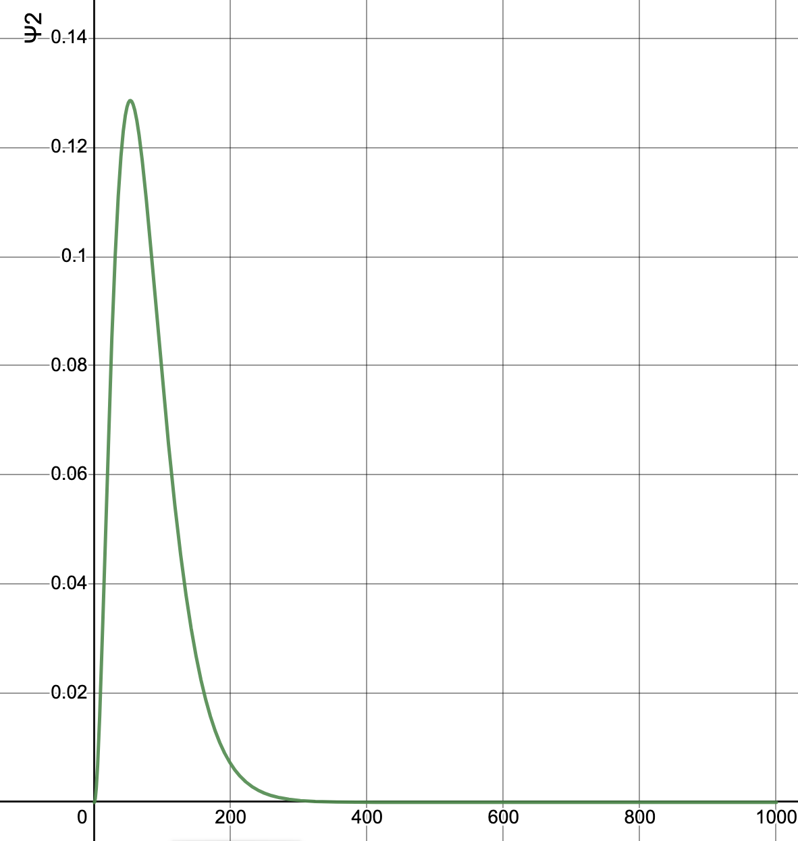
Radius (pm)
s-Orbital Radial Distribution Functions is shared under a CC BY-NC-SA 4.0 license and was authored, remixed, and/or curated by LibreTexts

  - In Model 3, what is the x axis?

  - In Model 3, what is the y axis?

  - Why is the probability of finding the electron 0 at the distance of 0 pm?

  - According to the graph in Model 3, at about what distance from the nucleus are you most likely to find the electron?

  - Is it possible to find the electron at 250 pm? Is it very likely to be found at 250 pm?

- Now click on 2s and radial distribution.
  - How does the radial distribution for the 2s differ from the radial distribution to the 1s?

  - Compare the radial distribution for the 2s to the isosurface representation for the 2s where the 2s has been cut in half like an orange.
    - Why are there two colors in the isosurface (in the cut in half 2s)?

    - What does it mean that there is a minimum where the probability is zero in the radial distribution?

- Now, compare the radial distribution for the 3s to the isosurface representation for the 3s where the 3s has been cut in half like an orange. It is what you expected? Explain.

- Predict how many humps you would see in the radial distribution for the 7s orbital. Now check your answer using the Orbitron.

- Look at the 2p iososurface orbital again.

  - Click the > symbol twice. How many planar angular nodes does each 2p orbital have?

  - Now look at the radial distribution. Are there any nodes? If so, how many?

- Look at the 3p iososurface orbital.

  - Click the > symbol twice. How many planar angular nodes does each 3p orbital have?

  - How many radial (spherical) nodes does each 3p orbital have?

  - Now look at the radial distribution. Are there any nodes? If so, how many?

- Look at the 4p iososurface orbital.

  - Click the > symbol twice. How many planar angular nodes does each 4p orbital have?

  - How many radial (spherical) nodes does each 4p orbital have?

  - Now look at the radial distribution. Are there any nodes? If so, how many?

- Does the radial distribution indicate the number of angular nodes, the number of radial nodes, or something else? Explain how you know.

- Predict how many radial nodes a 5p orbital would have. Check your answer using the Orbitron.

- Complete the chart for n=1, n=2, and n=3. Refer to your answers above or use the simulator again. (Don’t fill out n=4 yet)

Model 4: Number of nodes in orbitals
n | l | letter:  s, p, d, or f | number of angular nodes | number of radial nodes | total number of nodes
1 | 0 | s
2 | 0 | s
 | 1 | p
3 | 0 | s
 | 1 | p
 | 2 | d
4 | 0 | s
 | 1 | p
 | 2 | d
 | 3 | f

  - In Model 4, you should have that when n= 3 and l=1, the total number of nodes is 2. How did you determine this answer.

  - Using the values in Model 4, what is the rule for the total number of nodes an orbital will have?

  - How can you find the number of radial nodes in an orbital?

  - Using the rules you developed in part b and c, fill in the chart for n=4

  - Using the Orbitron, check your answers in the chart for 4p and 4d (again ignore the d orbital with the donuts, d_{z2} for now.)
    - Do you answers match the Orbitron? If not, revise your chart.

    - We’re used to seeing the 2p orbital with the two lobes different colors. Why are the lobes of the 4p orbital shown changing color twice?

- Consider the 3d orbital again.
  - How many angular nodes does it have?

  - Before we skipped looking at the 3d_{z2} orbital. Go back to the Orbitron and look at the isosurface and nodes for the 3d_{z2} orbital. It has “conical angular nodes.” Explain why these nodes would be called conical angular nodes.

- Below is a radial probability distribution from the Orbitron.
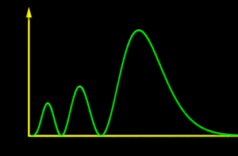

  - How many radial nodes are shown?

  - Could this be a 5f orbital? Explain your reasoning.

- Go back to the Orbitron and look at the 4f orbital with the donuts at the top of the page (4f_{z3}). One of the angular nodes is very difficult to see in the Orbitron isosurface representation.
  - How many angular nodes should a 4f orbital have?

  - What two nodes do you see?

  - Based on what you have learned about where nodes are in orbitals, describe where the 3rd angular node should be.

