Name:__________________________
Atomic Orbital Representations and the Orbitron
Summary Sheet
- Which of the following is a set of quantum numbers that are NOT allowed?
  - n=4, l=3, m_{l}=-3, m_{s}=1/2
  - n=2, l=2, m_{l}=1, m_{s}=-1/2
  - n=3, l=0, m_{l}=0, m_{s}=-1/2
  - All are allowed.

- Explain your answer to question 1.

- Define the following:
  - angular node

  - radial node

- Consider a 6d orbital
  - How many angular nodes does the orbital have?

  - How many radial nodes does the orbital have?

  - How many nodes does the orbital have in total?

- Could the following be a radial distribution graph for a 3s orbital? Explain your reasoning.

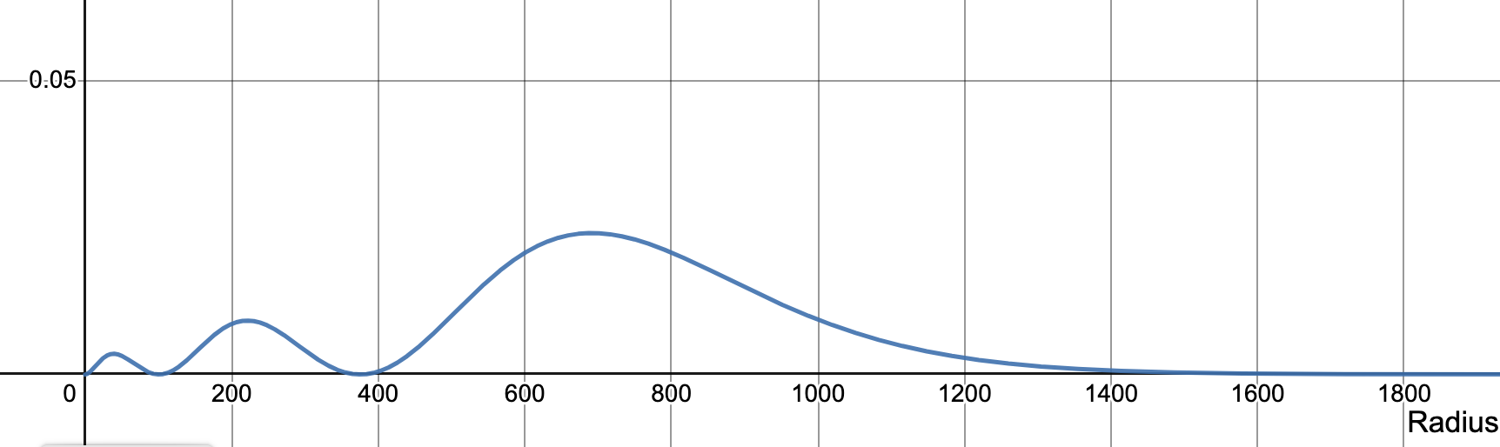
s-Orbital Radial Distribution Functions is shared under a CC BY-NC-SA 4.0 license and was authored, remixed, and/or curated by LibreTexts

