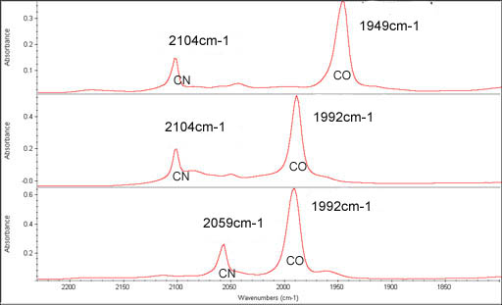
Figure II-12: Infrared spectra of isotopic labeled trans-[Fe^{II}(CN)₄(CO)₂]²⁻ in DMF
Upper spectrum is trans-[Fe^{II}(CN)₄(¹³CO)₂]²⁻, middle one is trans-[Fe^{II}(CN)₄(CO)₂]²⁻, lower one is trans-[Fe^{II}(¹³CN)₄(CO)₂]²⁻

