**Metal-Metal Bonding**

Created by George G. Stanley, Department of Chemistry, Louisiana State University (gstanley@lsu.edu) and posted on VIPEr on August 14, 2017. Copyright Geroge G. Stanley, 2017. This work is licensed under the Creative Commons Attribution-NonCommercial-ShareAlike CC BY-NC-SA. To view a copy of this license visit {http://creativecommons.org/licenses/by-nc-sa/4.0/}.

There are three general classes of M-M bonding:

**Covalent: Electron precise bonds. M-M bond counts as one e- from each metal center. Most common type of M-M bonding.**

**Dative: Where one metal uses a filled *d* orbital “lone pair” to coordinate to an empty orbital on a second, more unsaturated metal. Most dative bonding situations can also be electron-counted as covalent bonds.**

**Symmetry: Weak metal-metal interactions caused by molecular orbital symmetry interactions of filled & empty M-M bonding and/or antibonding orbitals. Typically seen for d8 metals. Not at all common.**

Overlap of *d* orbitals to make different types of covalent M-M bonding interactions (strongest to weakest):



A qualitative MO diagram for the interaction of two square planar metal centers showing the M-M bond forming interactions:



As one fills the lower energy M-M bonding orbitals, one makes one M-M bond for each pair of electrons added (one per metal). But once you add more than 8 e- the antibonding orbitals begin to fill and this starts canceling out M-M bonds.

|  |  |
| --- | --- |
| **Electron Count** | **Resulting M-M Bond** |
| **d1 - d1** | **Single bond** |
| **d2 - d2** | **Double bond** |
| **d3 - d3** | **Triple bond** |
| **d4 - d4** | **Quadruple bond** *optimum* |
| **d5 - d5** | **Triple bond** |
| **d6 - d6** | **Double bond *(M-L bonding usually dominates)*** |
| **d7 - d7** | **Single bond** |
| **d8 - d8** | **No bond *(symmetry interaction)*** |

Note that the table on the previous page specifically refers to two square-planar metals interacting as shown in the MO diagram. Metal centers with other geometries can often adopt M-M bond orders different from that shown in the table. Electron-counting can often provide some guidance on this. Although, if you don’t have any d electrons, you generally can’t have any M-M bonding. Nor can you have a higher M-M bond order than the # of d electrons being shared between the metal centers. For example, two d2 metals could only form a maximum of a M=M double bond.

Some Covalent Multiple Bonded Examples:



**Quadruple Bonds (Cotton)**

d4-d4 electronic configurations often lead to the formation of quadruple M-M bonds. Prof. F. Albert Cotton at Texas A&M is famous for his discovery and extensive studies of M-M quadruple bonds (and other M-M bonded systems).

Insert picture of Al Cotton here (<https://pubs.acs.org/cen/news/85/i09/8509notw5.html>) *C&EN* **2007**, *85(9)*, 11.

F. Albert Cotton

Texas A&M University

 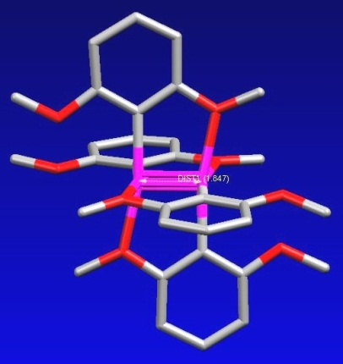

*View down Re-Re axis showing eclipsed geometry*

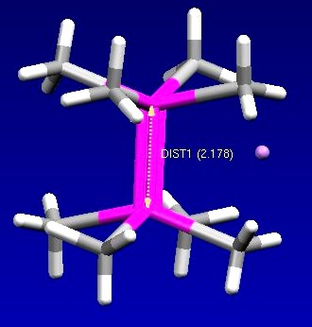  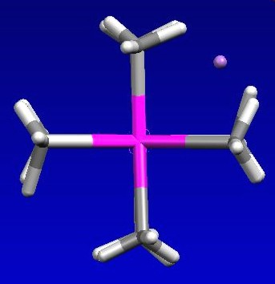

An important orbital feature of quadruple bonds is that they have eclipsed D4h-like ligand conformations. This is clearly illustrated above for the non-bridged [Re2(CH3)8]2 complex. There is clear steric repulsion between the methyl groups that could be relieved by rotation to a staggered geometry. But the -bond component of the quadruple bond favors an eclipsed orientation and imposes a rotational barrier for rotations about the quadruple bond. Triple bonds do not have this rotational barrier (free rotation!), thus the M≡M triple bonded complexes on the previous page have staggered geometries.

Dative M-M Bonds (unsymmetrical M-M bonded complexes)

When a metal center with at least two ***d*** electrons and a moderately high electron count (16 or 18e-) is adjacent to a metal that is unsaturated and electron-deficient, the more electron-rich metal center can donate a lone pair of ***d*** electrons to the unsaturated metal to form what is called a dative M-M bond. This is usually indicated by using an arrow () instead of a line for a covalent bond.

Consider the following bimetallic nickel complex:



There are two ways of viewing this electronically (see table below) symmetrically dividing the +2 charge on the nickels needed to balance the two anionic phosphide ligands giving you two d9 Ni(+1) oxidation state metals, a covalent Ni-Ni bond, and 16 and 18e- metal centers.

|  |  |  |  |  |
| --- | --- | --- | --- | --- |
| **Covalent M-M Bonding** | |  | **Dative** | |
| **Left Ni** | **Right Ni** |  | **Left Ni** | **Right Ni** |
| Ni(+1) d9  [-PR2] 2e-  -PR2 2e-  CO 2e-  M-M 1e- | Ni(+1) d9  [-PR2] 2e-  -PR2 2e-  2CO 4e-  M-M 1e- |  | Ni(+2) d8  2[-PR2] 4e-  CO 2e-  Ni←Ni(0) 2e- | Ni(0) d10  2-PR2 4e-  2CO 4e- |
| **Total 16e-** | **Total 18e-** |  | **Total 16e-** | **Total 18e-** |

The other method is to note that the one nickel has tetrahedral coordination geometry, just like a d10 Ni(0) center, while the other nickel has a planar geometry similar to a d8 Ni(+2) center. One can “assign” the two negatively charged phosphide ligands with the Ni(+2) center and have them acting as “neutral” 2e- donors to the Ni(0) center. This then gives one an 18e- Ni(0) center and a three-coordinate 14e- Ni(+2) center. Let the electron-rich, 18e- d10 Ni(0) center donate one of its’ lone pairs to the unsaturated 14e- d8 Ni(+2) bringing it up to 16e-, which is a normal electron-count for a square-planar d8 Ni(+2) atom.

Note that we get the same electron count and some sort of Ni-Ni bond via either method. So you generally don’t have to worry about which method you use. Obviously, the covalent method is simpler.

The reason that many consider the dative M-M bond method to be more “accurate” is that if both nickel atoms are classified as Ni(+1), why don’t both have the same geometry? One could explain the differences in geometry & structural features simply because one Ni has an extra CO coordinated and we will have an electronically unsymmetrical complex regardless of the oxidation state assignments.

**Problem: Electron-count the following complex using both the covalent and dative M-M bonding methods:**



**Problem: Electron-count the following complex. What is the order of the Re-Re bond? Why wouldn’t it be appropriate to use the dative bond method for this complex?**



Weak M-M Interactions by Symmetry

Based on the MO diagram at the beginning of this section, d8-d8 systems shouldn’t have any M-M bonding due to the filling of all the M-M antibonding orbitals, which cancels out the M-M bonding orbitals.

Insert picture of Harry Gray here <https://en.wikipedia.org/wiki/Harry_B._Gray>

**Harry Gray**

Caltech

But Harry Gray and others noted that more than a few bi- or polymetallic d8 complexes do show the presence of weak M-M bonding interactions, both in solution and the solid-state.

For example, the Rh and Ir tetrakis(isocyanide) complexes, [M(CNR)4]+, form oligomeric M-M bonded stacks in solution and in the solid-state, in spite of the fact that there should be no covalent M-M bonds.



Gray proposed in 1974 that these persistent, but weak M-M interactions were caused by a molecular orbital symmetry interaction between the filled -M-M bonding and *-anti-bonding orbitals with the empty pz  and * orbitals. The empty orbitals are pushed up in energy and the filled orbitals down in energy by this symmetry interaction. This generates a weak M-M bond – strong enough, however, to allow these complexes to form M-M bonds even in solution. This orbital effect is shown in the MO diagram to the right, which does not show the lowering of the filled orbitals or the raising in energy of the upper empty set.

