Carbonyl Ligands
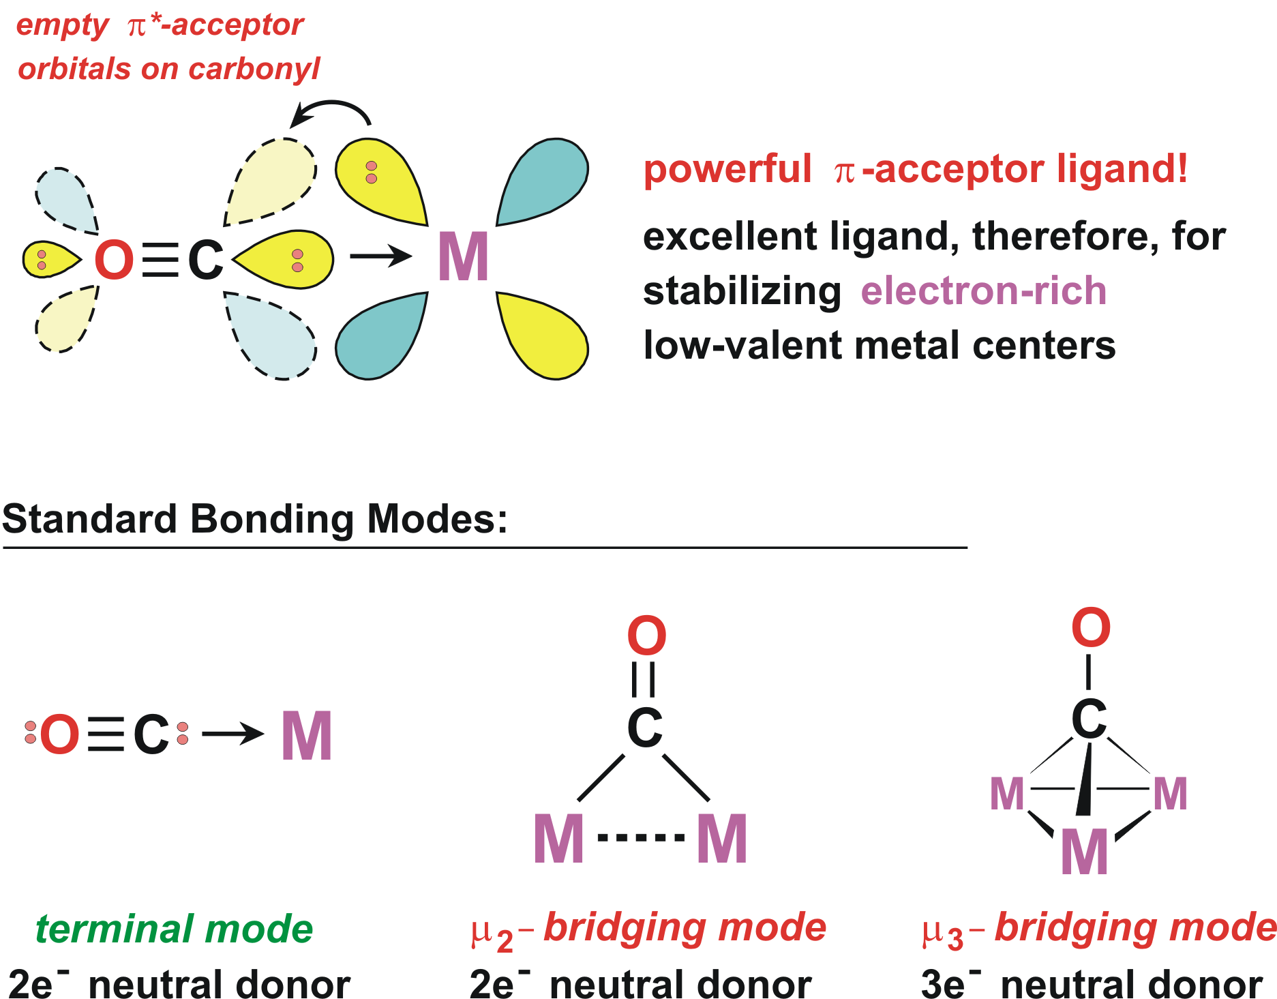
Metal carbonyls form one of the oldest (and important) classes of organometallic complexes. Most metal carbonyls are toxic!
Examples of neutral, binary metal carbonyls:
4 | 5 | 6 | 7 | 8 | 9 | 10 | 11
Ti | V(CO)6 | Cr(CO)6 | Mn2(CO)10 | Fe(CO)5  Fe2(CO)9  Fe3(CO)12 | Co2(CO)8  Co4(CO)12 | Ni(CO)4 | Cu
Zr | Nb | Mo(CO)6 | Tc2(CO)10 | Ru(CO)5  Ru3(CO)12 | Rh4(CO)12  Rh6(CO)16 | Pd | Ag
Hf | Ta | W(CO)6 | Re2(CO)10 | Os(CO)5  Os3(CO)12 | Ir4(CO)12 | Pt | Au
Physical Properties of Selected Metal Carbonyls
 | Color | mp °C | Sym | IR νCO cm−1 | Misc
V(CO)6 | blue-black | 70(d) | Oh | 1976 | paramagnetic, S = 1/2
Cr(CO)6 | white | subl | Oh | 2000 | Cr-CO = 1.91 Å, air-stable
Mo(CO)6 | white | subl | Oh | 2004 | Mo-CO = 2.06 Å, air-stable
W(CO)6 | white | subl | Oh | 1998 | W-CO = 2.06 Å, air-stable in solid state.
Mn2(CO)10 | yellow | 154 | D4d | 2044, 2013, 1983 | Mn-Mn = 2.89 Å, bond is easily broken.
Tc2(CO)10 | white | 160 | D4d | 2065, 2017, 1984 | Tc-Tc = 3.03 Å
Re2(CO)10 | white | 177 | D4d | 2070, 2014, 1976 | Re-Re = 3.04 Å
Fe(CO)5 | yellow | -20 | D3h | 2034, 2013 | bp = 103°C, toxic, Fe-CO (ax) = 1.81 Å, Fe-CO (eq) = 1.83 Å, hν produces Fe2(CO)9
Fe2(CO)9 | gold plates | d | D3h | 2082, 2019, 1829 | Fe-Fe = 2.46 Å, insoluble in most solvents except for THF where is dissociates to produce Fe(CO)4 + Fe(CO)5
Fe3(CO)12 | green | d | low | complex
Ru(CO)5 | colorless | -16 | D3h | 2035, 1999 | unstable, forms Ru3(CO)12
Ru3(CO)12 | orange | 150(d) | D3h
Os(CO)5 | colorless | 2 | D3h | 2034, 1991 | v. unstable, forms Os3(CO)12
Os3(CO)12 | yellow |  | D3h
Co2(CO)8 | orange-red | 51(d) | D3d | 2107, 2069, 2042, 2031, 2023, 1991 | solid state structure has 2 μ-CO’s (1886, 1857 cm−1). Solution structure is unbridged. Co-Co = 2.54 Å in solid-state.
Rh4(CO)12 | red |  | C3v |  | 3 μ-CO’s around one triangular Rh3 face.
Ni(CO)4 | colorless | -25 | Td | 2057 | bp 34°C, highly toxic, CO’s quite labile, Ni-CO = 1.84Å
Molecular Orbital Diagram for CO:
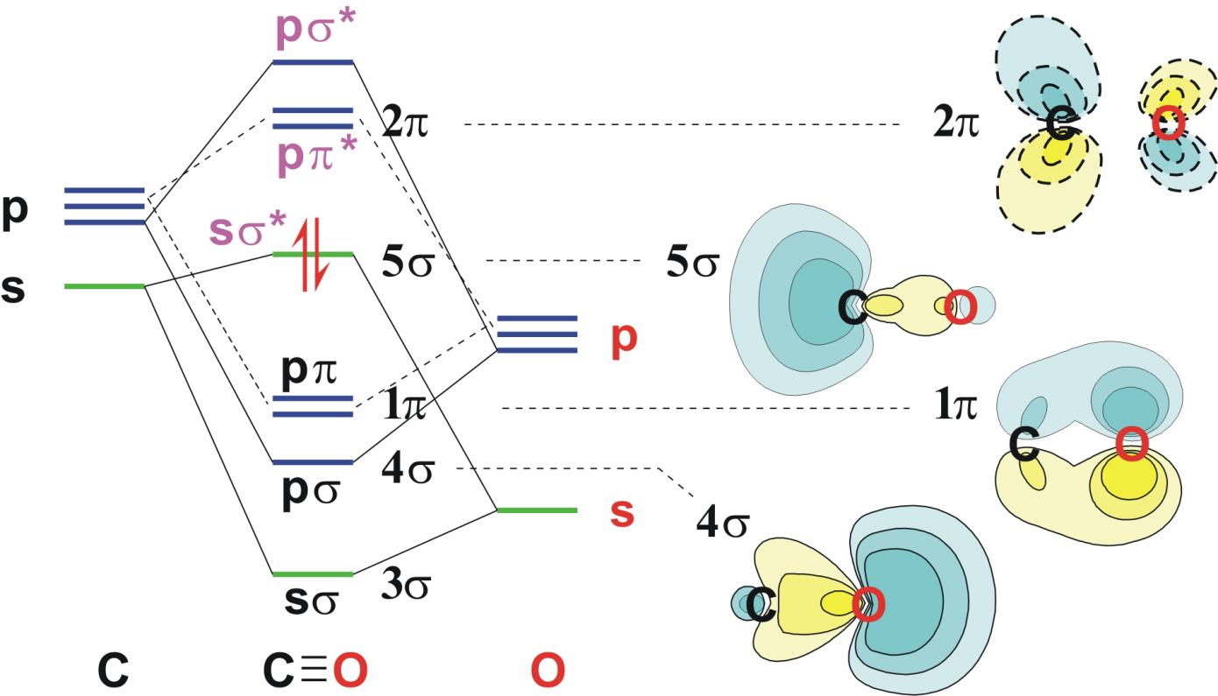
A simple MO diagram for CO is shown above. The highest occupied molecular orbital (HOMO) is indicated by the pair of electrons. This is the 5σ lone pair orbital mainly centered on the carbon and weakly antibonding with respect to the C-O bond (although that isn’t too clear from the orbital contour plot). The weak C-O antibonding nature of this MO, however, is clearly seen in the experimental data presented below. The LUMO is strongly π* antibonding and is low enough in energy to act as a good acceptor orbital for interacting with filled d-orbitals on metals.

Experimental Data Supporting Nature of MO’s in CO
Species | Config | C-O Å | νCO cm−1 | Comment
CO | (5σ)2 | 1.13 | 2143
CO+ | (5σ)1 | 1.11 | 2184 | 5σ MO is weakly antibonding
CO* | (5σ)1(2π)1 | S 1.24 | 1489 | 2π MO is strongly antibonding
 |  | T 1.21 | 1715
Three types (two of which are important) of CO-Metal bonding interactions:
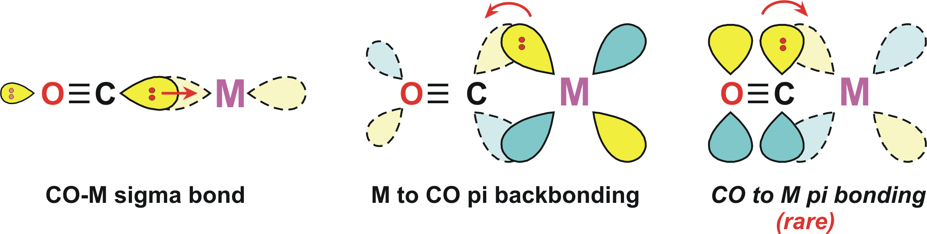
M-C bond: increases increases increases
C-O bond: increases decreases decreases
νCO freq: increases decreases decreases

Carbonyl IR Stretching Frequencies
- The position of the carbonyl bands in the IR depends mainly on the bonding mode of the CO (terminal, bridging) and the amount of electron density on the metal being π-backbonded to the CO.
- The number (and intensity) of the carbonyl bands one observes depends on the number of CO ligands present and the symmetry of the metal complex. There are also secondary effects such as Fermi resonance and overtone interactions that can complicate carbonyl IR spectra.

Bonding Modes:
As one goes from a terminal CO-bonding mode to μ2-bridging and finally μ3-bridging, there is a relatively dramatic drop in the CO stretching frequency seen in the IR.
Note that these ranges are typical for “neutral” transition metal complexes with an average amount of electron density on the metal center (see discussion below). Bridging carbonyls tend to have weaker and broader IR bands, ~50% less intense than terminal bands.

Effect of Electron Density on Metal:
dx | Complex | νCO cm−1
 | free CO | 2143
d10 | [Ag(CO)]+ | 2204
 | Ni(CO)4 | 2060
 | [Co(CO)4]− | 1890
 | [Fe(CO)4]2− | 1790
 | [Mn(CO)6]+ | 2090
d6 | Cr(CO)6 | 2000
 | [V(CO)6]− | 1860
As the electron density on a metal center increases, more π-backbonding to the CO ligand(s) takes place. This futher weakens the C-O bond by pumping more electron density into the formally empty carbonyl π* orbital and increases the M-CO bond strength making it more double-bond-like (resonance structure M=C=O). This can clearly be seen on the table to the right that illustrates the effect of charge and electronegativity on the amount of metal to CO π-backbonding and the CO IR stretching frequency.
Shown below is another example of the dramatic effect on the νCO IR stretching frequencies on reducing Fe2(μ-PPh2)2(CO)6 by 2 electrons to form the dianionic complex [Fe2(μ-PPh2)2(CO)6]2−. The average νCO frequency shifts almost 150 cm−1 to lower energy on reduction.
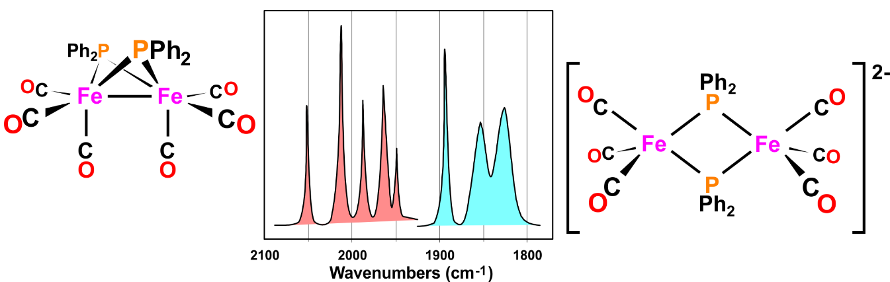
The carbonyl region in the IR spectrum can be very distinctive and useful for help in assigning structures and for indicating the relative amount of electron density present on the metal (dppm = Ph2PCH2PPh2, Ph groups not shown on structural drawings below):
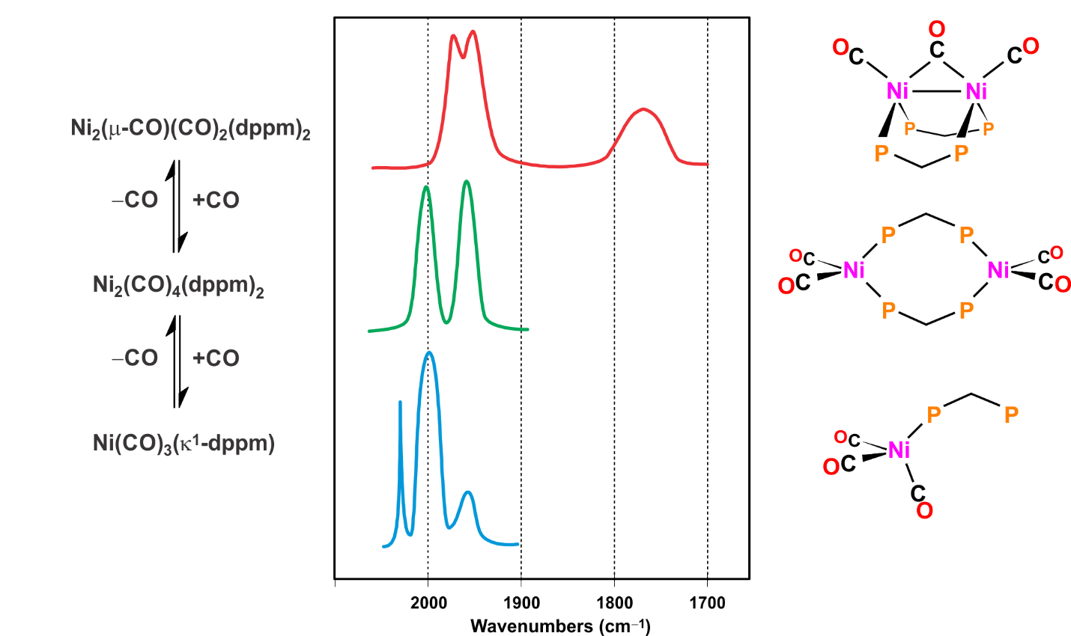
The bottom IR spectrum above represents an equilibrium mixture of mostly Ni(CO)₃(κ¹-dppm) and some Ni₂(CO)₄(dppm)₂.
Ligand Donation Effects:
Complex | νCO cm−1
Mo(CO)3(PF3)3 | 2090, 2055
Mo(CO)3(PCl3)3 | 2040, 1991
Mo(CO)3[P(OMe)3]3 | 1977, 1888
Mo(CO)3(PPh3)3 | 1934, 1835
Mo(CO)3(NCCH3)3 | 1915, 1783
Mo(CO)3(triamine)3 | 1898, 1758
Mo(CO)3(pyridine)3 | 1888, 1746
The ability of the ligands on a metal to donate electron density to the metal center certainly has considerable effect on the absolute amount of electron density on that metal. This, in turn, naturally effects the νCO IR stretching frequencies in metal carbonyl complexes. Ligands that are trans to a carbonyl can have a particularly large effect on the ability of the CO ligand to effectively π-backbond to the metal. For example 2 trans π-backbonding ligands will partially compete for the same d-orbital electron density, weakening each others net M-L π-backbonding.
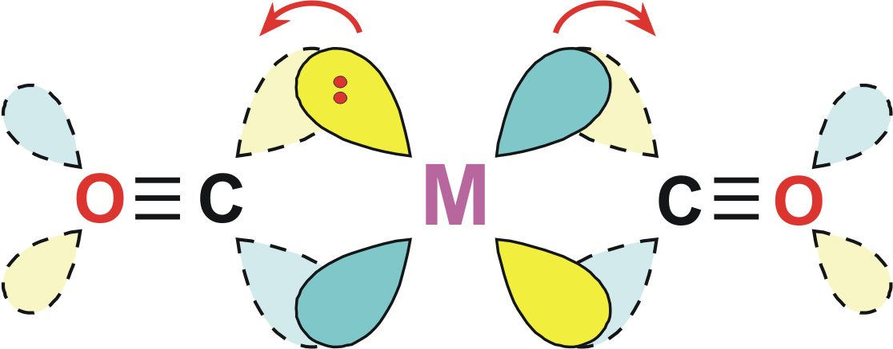
When the trans ligand is a σ-donating ligand, this can increase the M-CO bond strength (more M=C=O character) by allowing unimpeded metal to CO π-backbonding. Pyridine and amines are not that strong σ-donors, but they are even worse π-backbonding ligands. So the CO has virtually no competition for π-backdonation.

Based on CO IR stretching frequencies, the following ligands can be ranked from best π-acceptor to worst:
NO+ > CO > PF3 > RN≡C > PCl3 > P(OR)3 > PR3 > RC≡N > NH3
Semi-Bridging Carbonyls:
Unsymmetrical bridging form. π* system accepts electron density from second metal center. Usually accompanied by distortions away from a linear M-CO (180°) or a symmetrically bridging CO (120°). Typical M-CO angle around 150° (but with considerable variations).
Example: Substituting 2 carbonyls in Fe2(μ-CO)3(CO)6 with a bipy ligand leads to a considerable change in the structure, particularly in the bridging CO region. The better σ-donating bipy ligand increases the e− density on that Fe atom. This generates an asymmetrically charged complex. The higher partial negative charge on the bipy-substituted Fe center can be reduced by dumping some of it specifically into the π* orbital of one of the bridging carbonyls, turning it into a semi-bridging CO.

σ/π Bridging CO:
This is where the CO not only acts as a traditional σ-donor/π-acceptor to one or more metal centers, but also as a π-donor to additional metals. This will occur for more electron deficent metal complexes where the metal centers have less need to π-backbond to the carbonyl, but have the empty orbitals to accept electron density from the carbonyl π-system. The CO ligand here can act as a 4 or 6 electron donor!

Problem: Consider the example below, do you think that the bridging CO should act more as a π-donor or π-acceptor?

Problem: Which of the following metal carbonyl IR spectra represents the compound with the least amount of electron density on the metal center? Briefly discuss the reasoning for your choice. Which compound will lose CO the easiest?

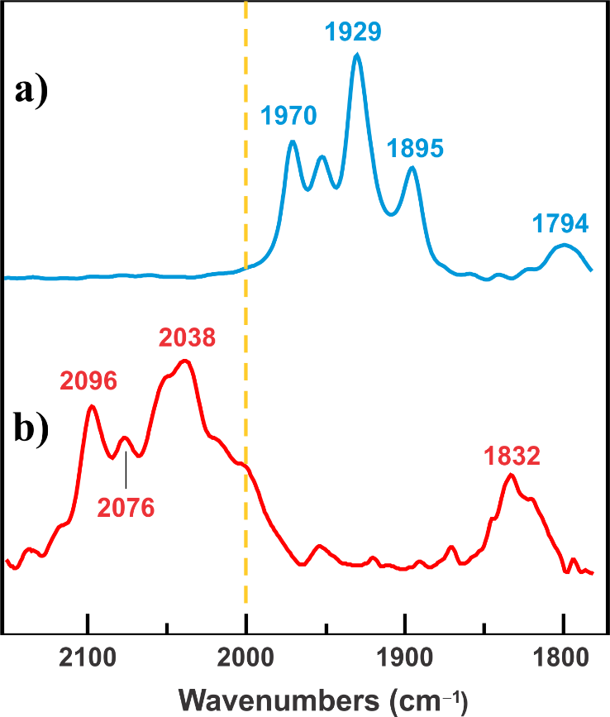

Problem: Which of the following metal carbonyl compounds will have the highest νCO stretching frequency in the IR? Why? Will this be the most electron-rich or deficient compound?

