Chem 4571

***Organometallic  
Chemistry***

**Lecture Notes**

**Prof. George G. Stanley**

**Department of Chemistry**

**Louisiana State University**

**614 Choppin Hall**

**(225)-578-3471**

#### E-Mail: gstanley@lsu.edu

**Spring, 2017**

**(updated 5/26/2016)**

**2008 update: electron density discussion, square-planar electronic effects, orbital info added to chapter 1; bonding comparison between PCl3 and PMe3 added to phosphine chapter. 2012 update: additional problems, minor corrections. 2014 updates: minor corrections. 2015 updates: minor corrections, new examples of formal charge vs. calculated charges via DFT calculations (early chapters). 2016 update: minor corrections & making note chapters & PowerPoint slides correspond better.**

Created by George G. Stanley, Department of Chemistry, Louisiana State University (gstanley@lsu.edu) and posted on VIPEr on July 19, 2016. Copyright Geroge G. Stanley, 2016. This work is licensed under the Creative Commons Attribution-NonCommercial-ShareAlike CC BY-NC-SA. To view a copy of this license visit {http://creativecommons.org/licenses/by-nc-sa/4.0/}.

**Fundamentals You Need to Know:**

1. **Electronegative/Electropositive concepts**

Where do the partial positive and negative charges in a molecule reside? This is important for determining how much electron (e-) density will be donated from a ligand to a metal and where a nucleophile or electrophile will likely attack for chemical reactions.

1. **Electrostatics vs. Electronegativity**
2. **Lewis dot structures and valence electron counts**

Important for determining the number of electrons on a ligand and what the charge of the ligand is. We almost always deal with ligands with even #’s of electrons. If a ligand has an odd # of electrons we add additional electrons to get to an even #, usually to form a closed shell electron configuration with a formal negative charge(s). Common Exceptions = Boron & Aluminum.

1. **Oxidation States**
2. **Organic line notation for drawing structures**



**Electron Density Terminology 101:**

**Electron Density:** The presence of energetically accessible valence electrons around an atom. Electrons are represented by a probability distribution spread out over a region of space defined by the nature of the orbital: *s*, *p*, *d*, *f*, and/or hybrid orbitals such *sp3*, *sp2*, *sp*, etc.

Atoms with quite a few valence electrons such as Pt(0) *d*10 and/or contracted orbitals have a ***high electron density***. Atoms with fewer valence electrons (e.g., Na+) and/or diffuse orbitals (electrons spread out over a larger region of space) can be considered to have ***low electron densities***. Do not confuse electron density with electronegativity or how electron-rich or poor an atom is classified.

**Electron-rich:** Atoms that are willing to readily donate electrons or electron pairs to other atoms are considered electron rich. Ease of ionization is another property associated with electron-rich atoms. The willingness to share or donate electron pairs is related to lower electronegativity, number of valence electrons, good donor groups on the atom in question, negative charges, or some combination of these factors. Using organic terminology I would consider an electron-rich atom to be a good nucleophile (electron pair donating).

**Electron-deficient (poor):** Atoms that are NOT willing to donate or share electron pairs to other atoms are called electron deficient (poor). These atoms typically have lower lying empty orbitals that can accept electron pairs from other atoms. The un-willingness to donate or share electron pairs could be caused by high electronegativity, cationic charge(s), lack of valence electrons, or some combination of these. I would consider many (but certainly not all) electron-deficient atoms/molecules to be good electrophiles (electron-pair accepting) and certainly poor donors.

**Examples:**

**Fluoride anion, F:** This anion has high electron density due to the negative charge, filled octet of electrons, and small size. BUT I would NOT consider it to be electron-rich, meaning a good electron donor. The extremely high electronegativity of a fluorine atom means that it desperately wants to pick up an extra electron to form the fluoride anion, which is extremely stable. The filled valence orbitals are fairly low in energy for F and generally poor donors. It is certainly not electron-deficient as it doesn’t have any low-lying empty orbitals and does not want to accept any more electrons. It isn’t electron-rich either since it is a very poor nucleophile and generally a poor ligand for most metals (except those in high oxidation states). It is almost impossible to chemically oxidize F.

**Methyl anion, CH3:** This anion is very electron-rich and a powerful nucleophile. The electron-richness comes from the lower electro­negativity of carbon and the high energy of the anionic *sp3*-hybidized lone pair that makes it a strong donor group. It is also very easily oxidized, pointing to the presence of a high-energy lone pair orbital.

**PROBLEM: Which is more e- rich? Why?**

1. **Ti(+2), d2 *-or-* Pt(+2), d8**
2. **Al(CH3)3 *-or-* N(CH3)3**
3. **CF3 *-or-* N(CH3)2**

**PMe3 vs. P(OMe)3**: The methyl groups are considered to be electron donating making the P center more electron-rich. The methoxy groups are  electron-withdrawing due to the electronegative oxygen atoms, making the P center more electron deficient. The results from Density Functional Theory (DFT) calculations on both are shown below. Note the higher energy of the P lone pair (highest occupied molecular orbital, HOMO), greater spatial extent (generally better overlap with metal d-orbitals), and lower positive charge on P for PMe3 relative to P(OMe)3.

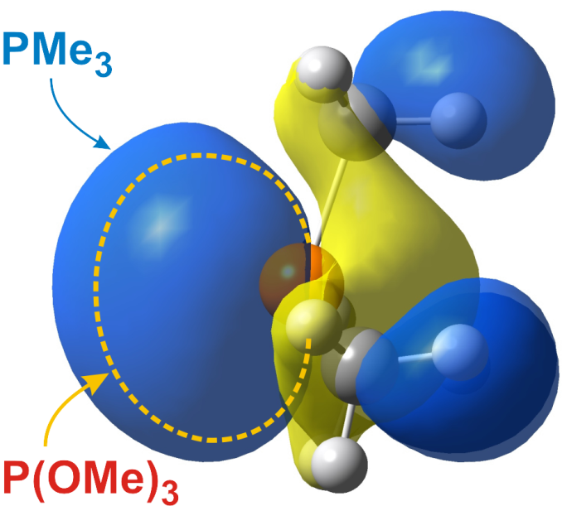

**PMe3**

**HOMO = 5.03 eV**

**Charge on P = +0.22**

**P(OMe)3**

**HOMO = 7.40 eV**

**Charge on P = +0.75**

**MO plot of the lone pair orbital (HOMO) for PMe3. Dashed outline indicates the spatial extent of the lone pair for P(OMe)3.**



**General Trends for the Transition Metals**

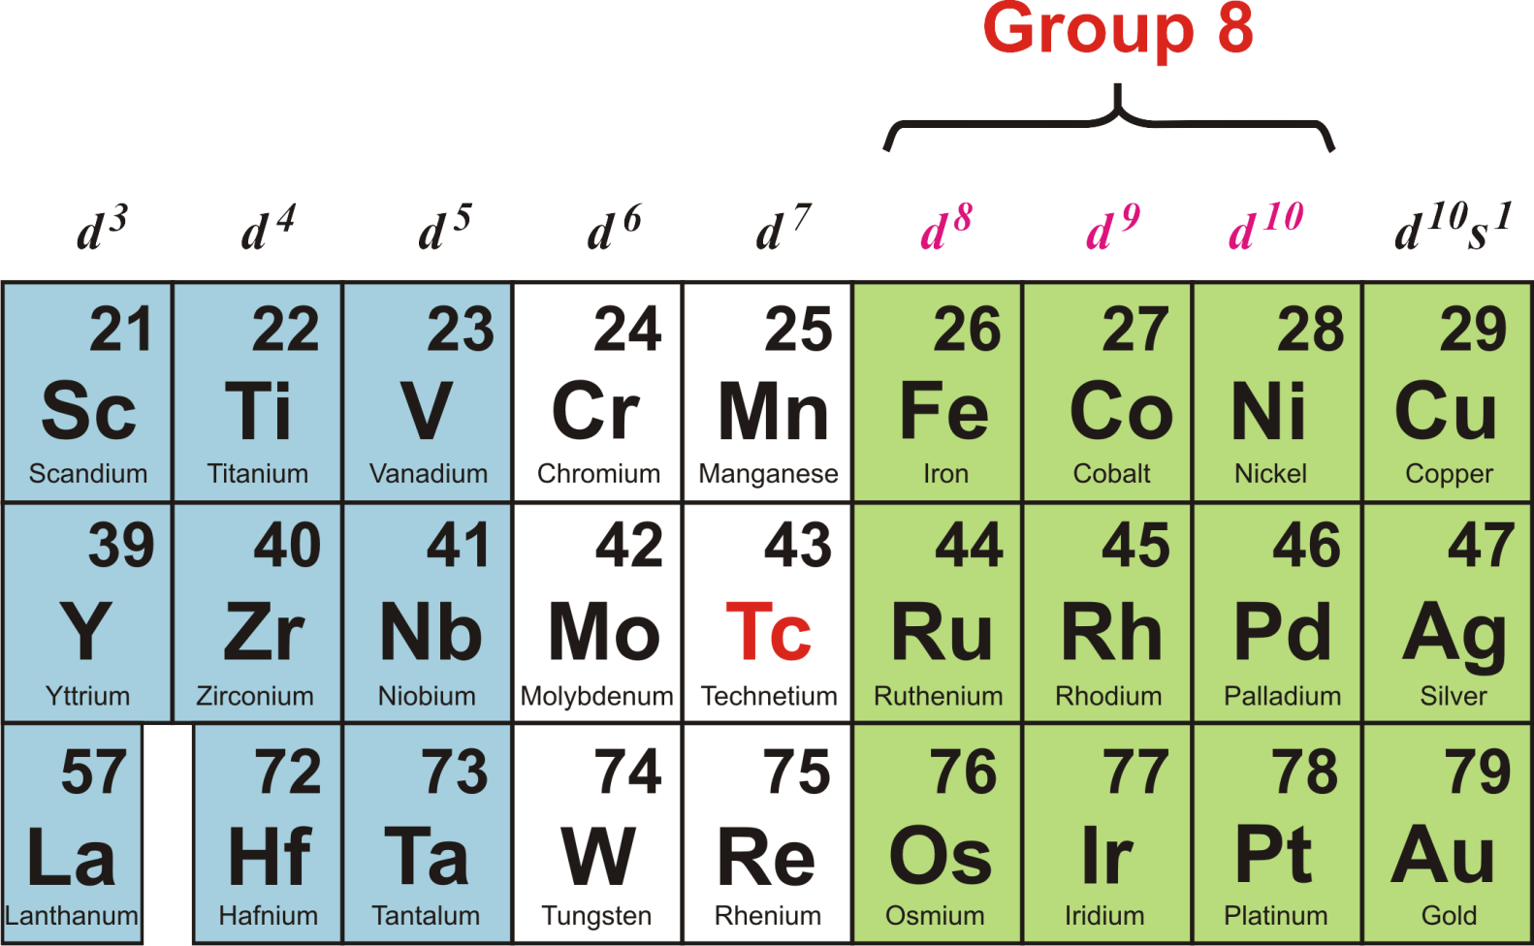

**Early Transition Metals Late Transition Metals**

***low electronegativities higher electronegativities***

***higher oxidation states lower oxidation states***

***“harder” metal centers “softer” metal centers***

***OXOPHILLIC!!***

**Transition Metal Catalysis**

[*catalyst*]

**A + B  C**

**A catalyst is a substance that increases the rate of rxn without itself being consumed (but it is involved!) in the reaction. After the rxn is finished you should be able to recover the catalyst from the rxn mixture unchanged. A catalyst speeds up the rate at which a chemical reaction reaches equilibrium. The overall thermodynamics of the rxn is *NOT* changed by the catalyst. Therefore, very endothermic (*non-spontaneous*) reactions are usually NOT suitable for catalytic applications.**

**A catalyst provides a lower energy pathway for the production of products from reactants, thus allowing the rxn to proceed *faster*. It lowers the activation energy for a rxn (kinetics) – it does NOT change the thermodynamics of a rxn.**



**A catalyst provides an alternate mechanism (or pathway) for the reactants to be transformed into products. The catalyzed mechanism has an activation energy that is lower than the original uncatalyzed rxn. An excellent catalyst will lower the activation energy the most.**

**An example of a Pt-catalyzed reaction is shown below:**



**Note that there are different numbers of ligands (a generic name for anything that bonds to a metal center) on the metal. Too many is bad, too few is bad. How can you tell how many to use?? Electron counting is the key, which is presented later in this chapter. Some Important Ligand Nomenclature**

**Chelate Effect**: “chelate” is from the Greek meaning “claw” or to grab on to. The chelate effect or chelation is one of the most important ligand effects in transition metal coordination chemistry. Since most metal-ligand bonds are relatively weak compared to C-C bonds, M-L bonds can often be broken rather easily, leading to dissociation of the ligand from the metal. Consider the two metal ligand complexes shown below:



The second metal complex is much less likely to lose one of the ligands due to the bridging group that holds the ligands in proximity to the metal center. From a kinetic viewpoint, if one of the ligands dissociates, it will remain close enough to the metal center to have a high probability of re-coordinating before another ligand can get in an bind. From a thermodynamic viewpoint, by tethering two donor ligands together, one removes the entropic driving force for dissociating a ligand and thus making more particles in solution (more disorder).

The chelate effect can be extremely dramatic. There are cases known where the presence of a chelate will change the equilibrium constant by a factor of 1010 favoring the coordinated form of the ligand to the metal over the dissociated form. Naturally, the longer and more flexible the bridging group in a chelating ligand, the less dramatic the chelating effect. It is possible to design ligands with sterically enforced chelates.

Some chelating ligand examples (line drawings and crystal structure shown in “tube” style; atom coloring: carbon = grey, oxygen = red, nitrogen = light blue; sulfur = yellow; metal = magenta):

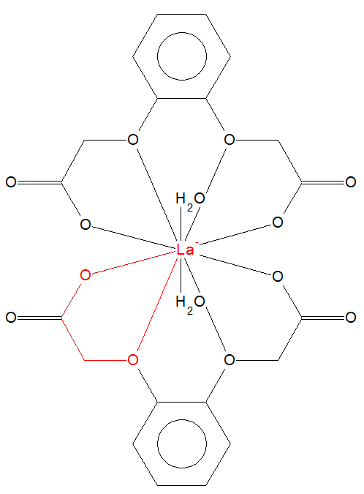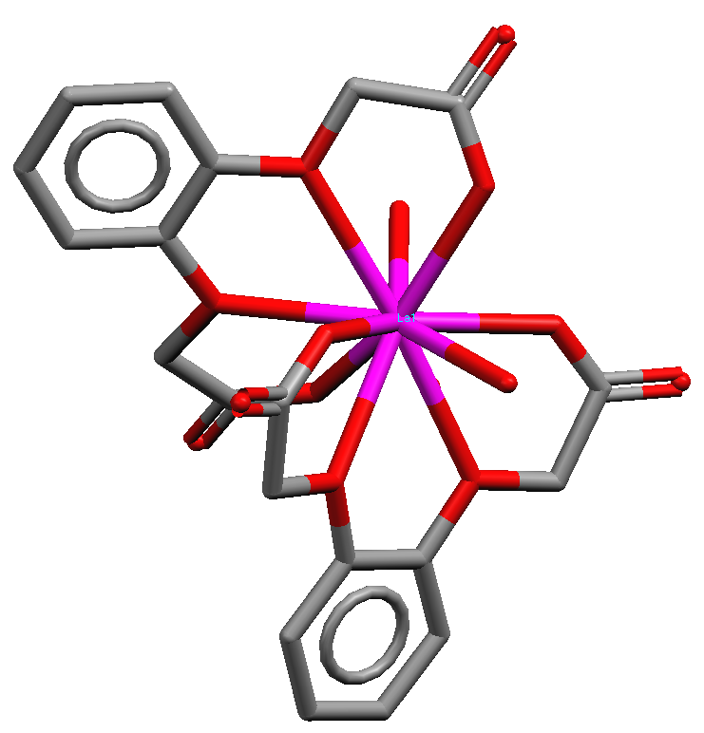

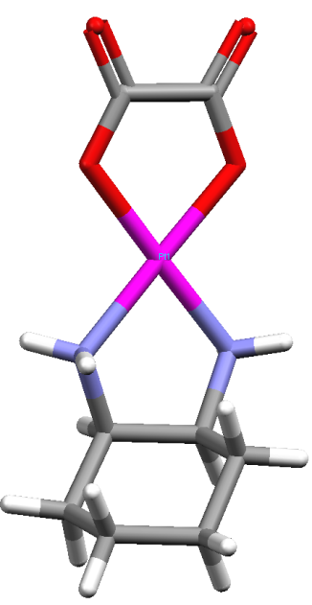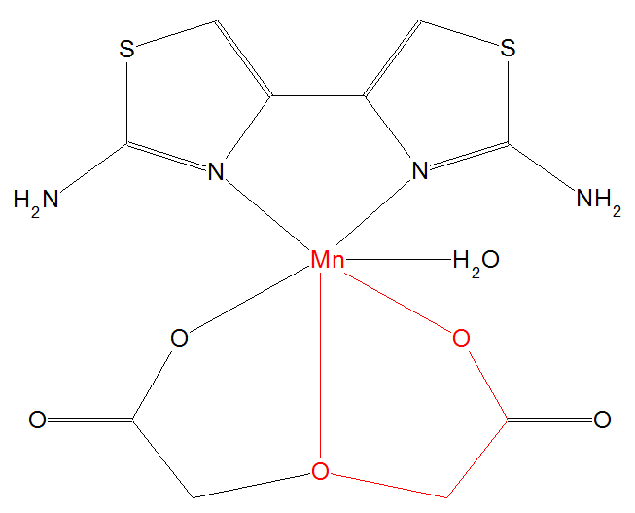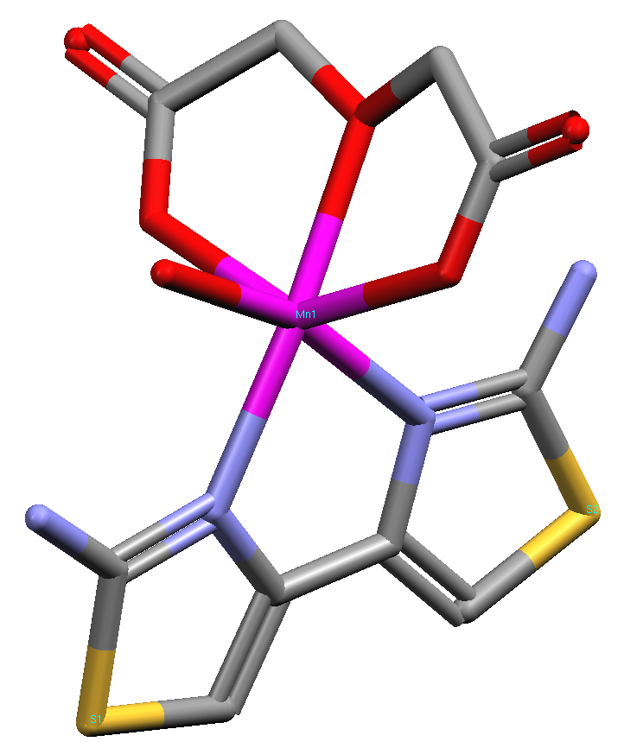

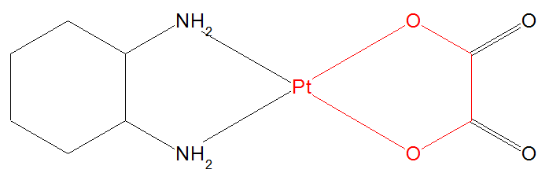

*x*

“eta-*x*” was originally developed to indicate how many carbons of a -system were coordinated to a metal center. **Hapticity** is another word used to describe the bonding mode of a ligand to a metal center. You will occasionally see h*x* used instead of *x*, although this usually an error caused by forgetting to turn a regular font **h** into the ***symbol*** font on most word processors in order to get a Greek ****. An 5-cyclopentadienyl ligand, for example, has all five carbons of the ring bonding to the transition metal center.

***x* values for carbon ligands where the x value is odd usually indicate *anionic* carbon ligands (e.g., 5-Cp, 1-CH3, 1-allyl or 3-allyl, 1-CH=CH2). The # of electrons donated (ionic method of electron counting) by the ligand is usually equal to *x* + 1. Even *x* values usually indicate *neutral* carbon -system ligands (e.g., 6-C6H6, 2-CH2=CH2, 4-butadiene, 4-cyclooctadiene). The # of electrons donated by the ligand in the even (*neutral*) case is usually just equal to *x*.**

|  |  |  |  |
| --- | --- | --- | --- |
|  |  |  |  |
| 5-Cp | 3-Cp | 3-allyl | 1-allyl |

This nomenclature was, for a time, generalized by some in the organometallic field to include non-carbon ligands when there is some question as to the bonding mode (or hapticity) of the ligand donor atoms to the metal. For example, the bisphosphine Ph2PCH2CH2PPh2 (dppe) is normally a chelating ligand, but there are metal complexes known where only one of the phosphine atoms is coordinated to the metal center and the other is “dangling.”

The nomenclature for such a singly coordinated bisphosphine ligand would be: M(1-dppe) -- meaning that only one of the two possible phosphorus donor atoms is bonded to the metal. Note that in cases like this, having an odd hapticity does NOT mean that the ligand is anionic (it is, however, a 2 electron donor!). When dppe is coordinated in its normal chelating mode, one usually omits the 2-designation, as this is considered redundant.



1-dppe or 1-dppe

*x*

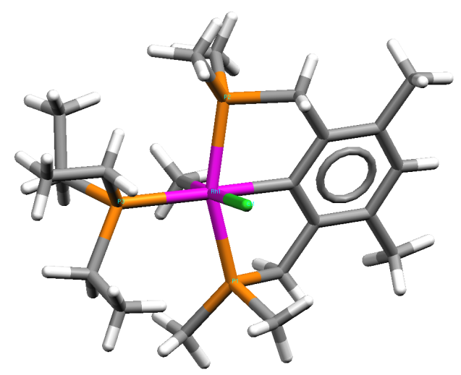Note that most authors now use *****x* instead of *****x* when referring to non-carbon ligands. I will generally use the kappa notation.

The bis-chelating (tridentate) ligand shown to the right (green = Cl; orange = P, white = H) almost always coordinates in a 3-fashion. Because this is the normal coordination mode, most authors would not use the 3-designation. The -nomenclature would not be used here for the single carbon atom that bonds since there is no ambiguity as to which carbon atom will coordinate (using an anioic sp2 type orbital).

*x*

“mu-*x*” is the nomenclature used to indicate the presence of a **bridging ligand** between two or more metal centers. The *x* refers to the number of metal centers being bridged by the ligand. Usually most authors omit *x* = 2 and just use  to indicate that the ligand is bridging the simplest case of two metals. There are three different general classes of bridging ligands:

1. Single atom bridges
2. Two donor atoms separated by a bridging group (typically organic)
3. Two donor atoms directly bonding to one another

Two bridging ligand examples (green = chloride; orange = phosphorus):

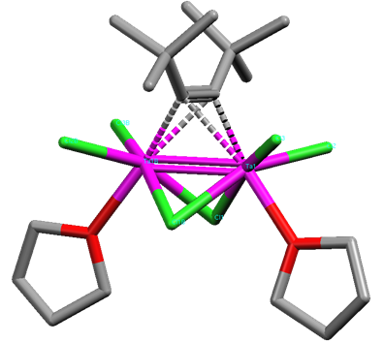

**Ta2(-*t*-Bu-C≡C-*t*-Bu)(-Cl)2Cl2(THF)2**

This complex has three bridging ligands: two single atom chlorides & an alkyne. Hydrogen atoms not shown.

**Mo2(-CH2P(Me)2CH2)4**

This complex has four bridging diylide ligands (see page intro 36 for more info). Hydrogen atoms not shown.

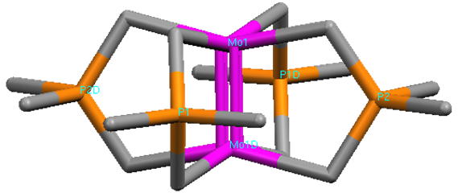

**Problem: Which of the following ligands will chelate the *strongest* to a generic metal center? Why?**



**Nomenclature:** There is no set method of naming or ordering the listing of metal and ligands in a metal/ligand complex that most authors follow. There are IUPAC formalisms, but hardly any inorganic or organometallic chemists follow them.

There are some qualitative rules that most authors seem to use in American Chemical Society (ACS) publications:

1. in formulas with Cp (cyclopentadienyl) ligands, the Cp usually comes first, followed by the metal center: Cp2TiCl2
2. other anionic multi-electron donating ligands are also often listed in front of the metal, e.g., trispyrazolylborate anion (Tp)
3. in formulas with hydride ligands, the hydride is sometimes listed first. Rules # 1 & 2, however, take precedence over this rule: HRh(CO)(PPh3)2 and Cp2TiH2
4. bridging ligands are usually placed next to the metals in question, then followed by the other ligands (note that rules 1 & 2 take precedence): Co2(-CO)2(CO)6 , Rh2(-Cl)2(CO)4 , Cp2Fe2(-CO)2(CO)2
5. anionic ligands are often listed before neutral ligands: RhCl(PPh3)3, CpRuCl(=CHCO2Et)(PPh3) (neutral carbene ligand), PtIMe2(C≡CR)(bipy).

**Common Coordination Geometries**

**6-Coordinate: *Octahedral* (90° & 180° angles)**



**5-Coordinate: *Trigonal Bypyramidal or Square Pyramidial***  **(90° & 120°) (~100° & 90°)**



**4-Coordinate: *Square Planar or Tetrahedral***

**(90° & 180°) (109°)**



**Square planar geometry is generally limited to Rh, Ir, Ni, Pd, Pt, and Au in the *d*8 electronic state when coordinated to 2e- donor ligands. Problem: Sketch structures for the following:**

**a)** CpRuCl(=CHCO2Et)(PPh3)

**b)** Co2(-CO)2(CO)6 (Co-Co bond, several possible structures)

**c)** *trans***-**HRh(CO)(PPh3)2 [Rh(+1) = d8]

**d)** Ir2(-Cl)2(CO)4 [Ir(+1) = d8]

**e)** Cp2TiCl2

**Bonding and Orbitals**



**Orbital Overlap Efficiency**

The strength of a chemical bond (covalent or dative) is related to the amount of overlap between two atomic (or hybrid) orbitals. When dealing with -bonds the **overlap efficiency** is important. This is illustrated below for the -systems of ethylene (H2C=CH2) and silylene (H2Si=SiH2). The Si=Si double bond is very weak and reactive because the amount of overlap (green areas) between the two *p*-orbitals is small relative to the parts that do not overlap. The overlap efficiency can be thought of as the orbital overlap area divided by the non-overlapping area. The smaller this ratio, the weaker the bonding.

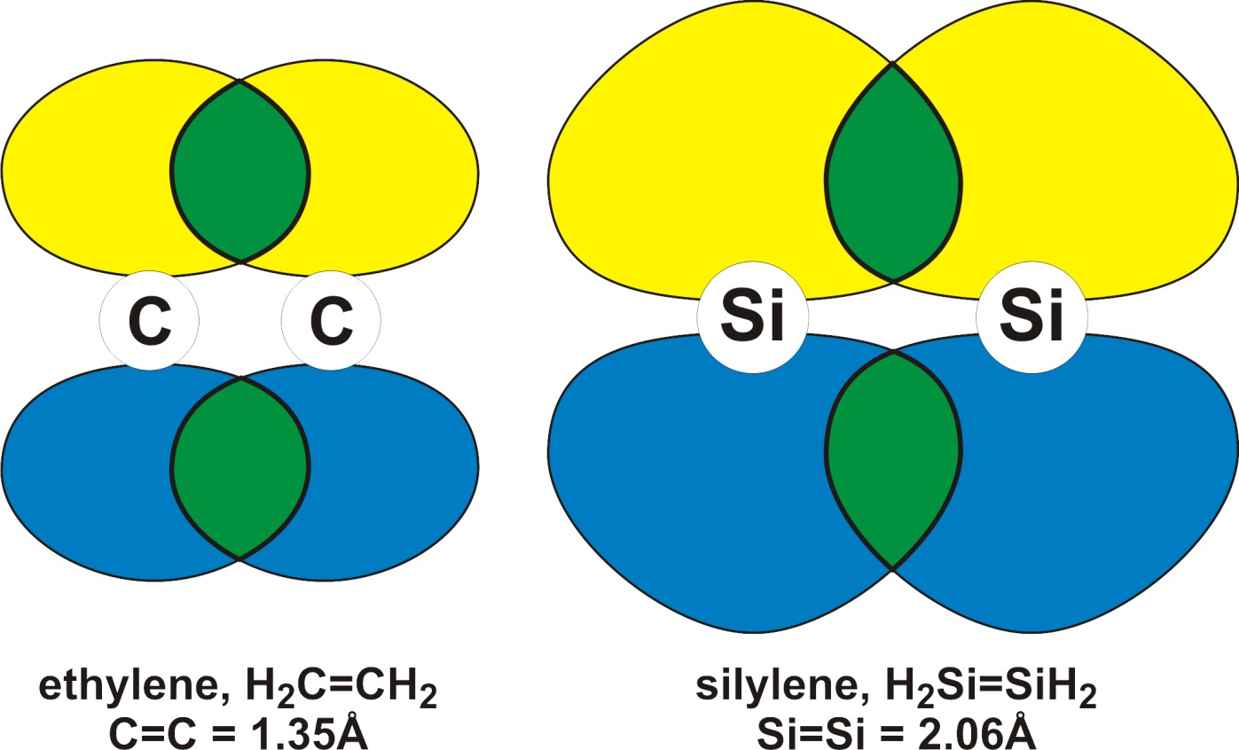

For -bonds the overlap efficiency is close to 1.0 (100% overlap), which nicely explains why -bonds are *usually* stronger than -bonds.

Overlap efficiency also applies to -bonds between atoms. Bond strengths can vary as the bond overlap spreads out over a larger region of space. This is not simple to qualitatively predict. For example, the dihalogen bond strengths increase, then decrease as follow: F2 < Cl2 > Br2 > I2. They steadily decrease as one goes from C-C > Si-C > Ge-C > Sn-C > Pb-C. For most transition metal M-M single bonds the trend is fairly consistent: first row < second row < third row. But for M-M quadruple bonds one has: Cr-Cr << Mo-Mo > W-W.

In the case of strong multiple bonding and shorter bond distances one can get TOO much overlap between -bonding orbitals. This can lead to destabilizing anti-bonding type interactions that weaken the -bond.

N2 is a good example of this:

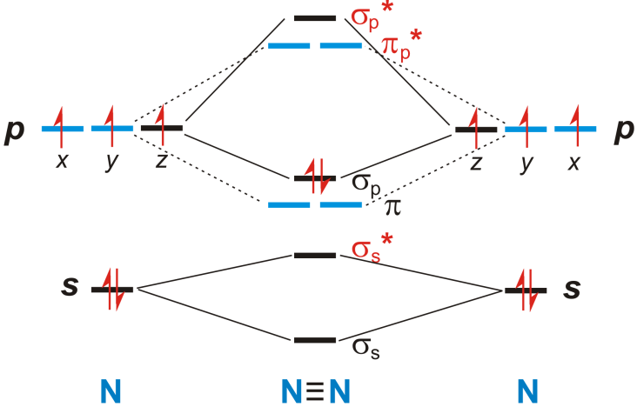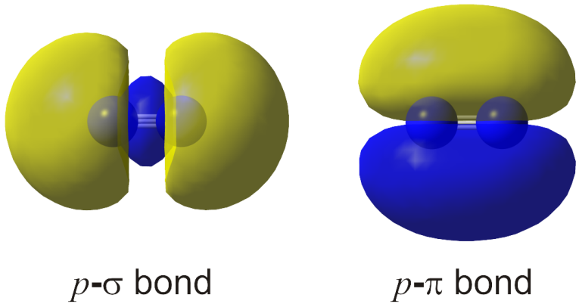

The *p*- orbital is higher in energy (& the HOMO) than the -bonding orbitals. Bringing two *p*- orbitals together to the N≡N bond distance leads to anti-bonding interactions due to the *p*-lobe extending over into the other phased orbital region as shown qualitatively below:

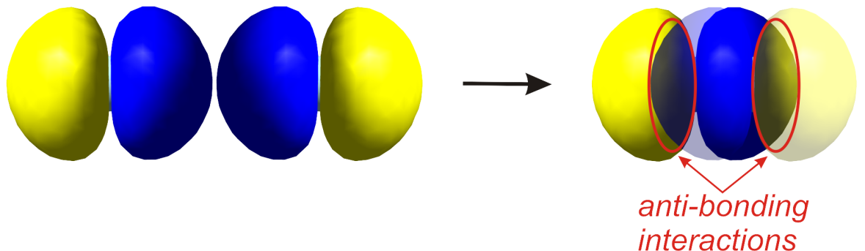

To minimize this unfavorable antibonding interaction N2 forms a *sp* hybrid orbital combination that reduces the -bonding overlap in favor of the two stronger (overall) -bonds.

**Square Planar**

Square planar complexes typically have ***d8*** (sometimes ***d9***) electronic configurations and are usually limited to the following elements: **Rh, Ir, Ni, Pd, Pt, Cu, & Au**.

Of these the first and second-row metals add a fifth ligand more readily than the third-row analogs. The reason that Ir, Pt, and Au are less likely to add a fifth ligand is due to the blocking effect of the filled 5*d*z2 orbital that is more spatially extended than the 3 or 4*d*z2 orbitals. The 6*p*z orbital is also more contracted than one would expect due to relativistic effects that allow better penetration of the *s* and *p* orbitals to the highly charged nucleus lowering their energy. The *d* and *f* orbitals are shielded better, which raises their energies relative to the *s* and *p* orbitals. This effect really turns on for Pt and Au, less so for Ir that does have more of a tendency to pick up a fifth ligand.

The relative orbital extents of the filled *d*z2 and empty *p*z orbitals from DFT calculations on MH2(NH3)2 model complexes for Ni, Pd, and Pt are shown below.

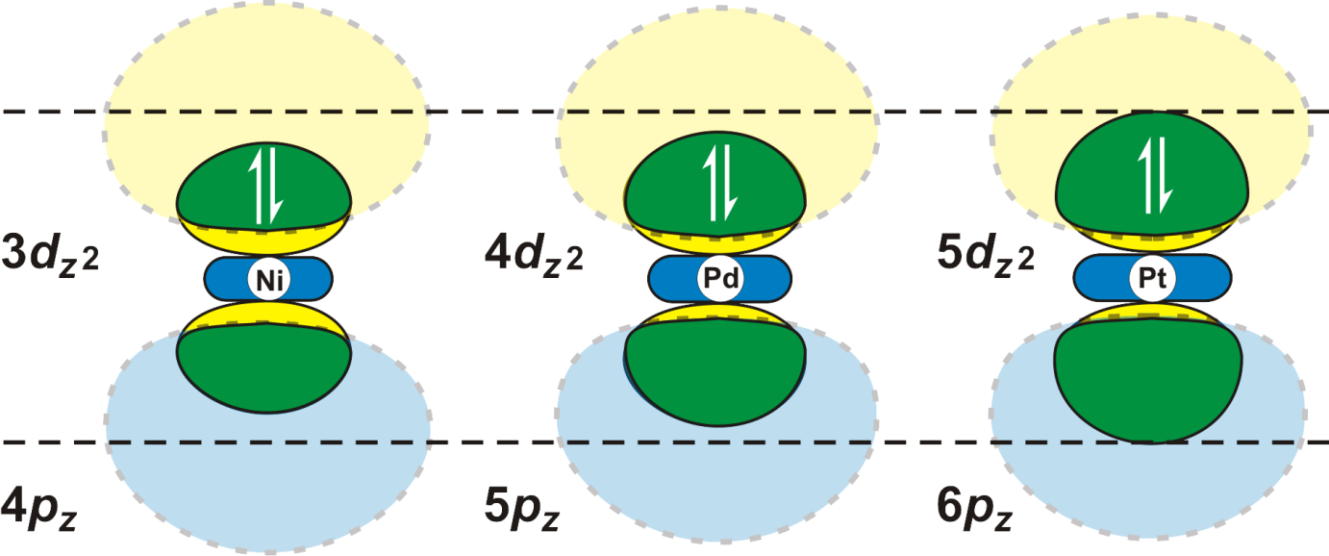

**Octahedral Orbital Diagram**

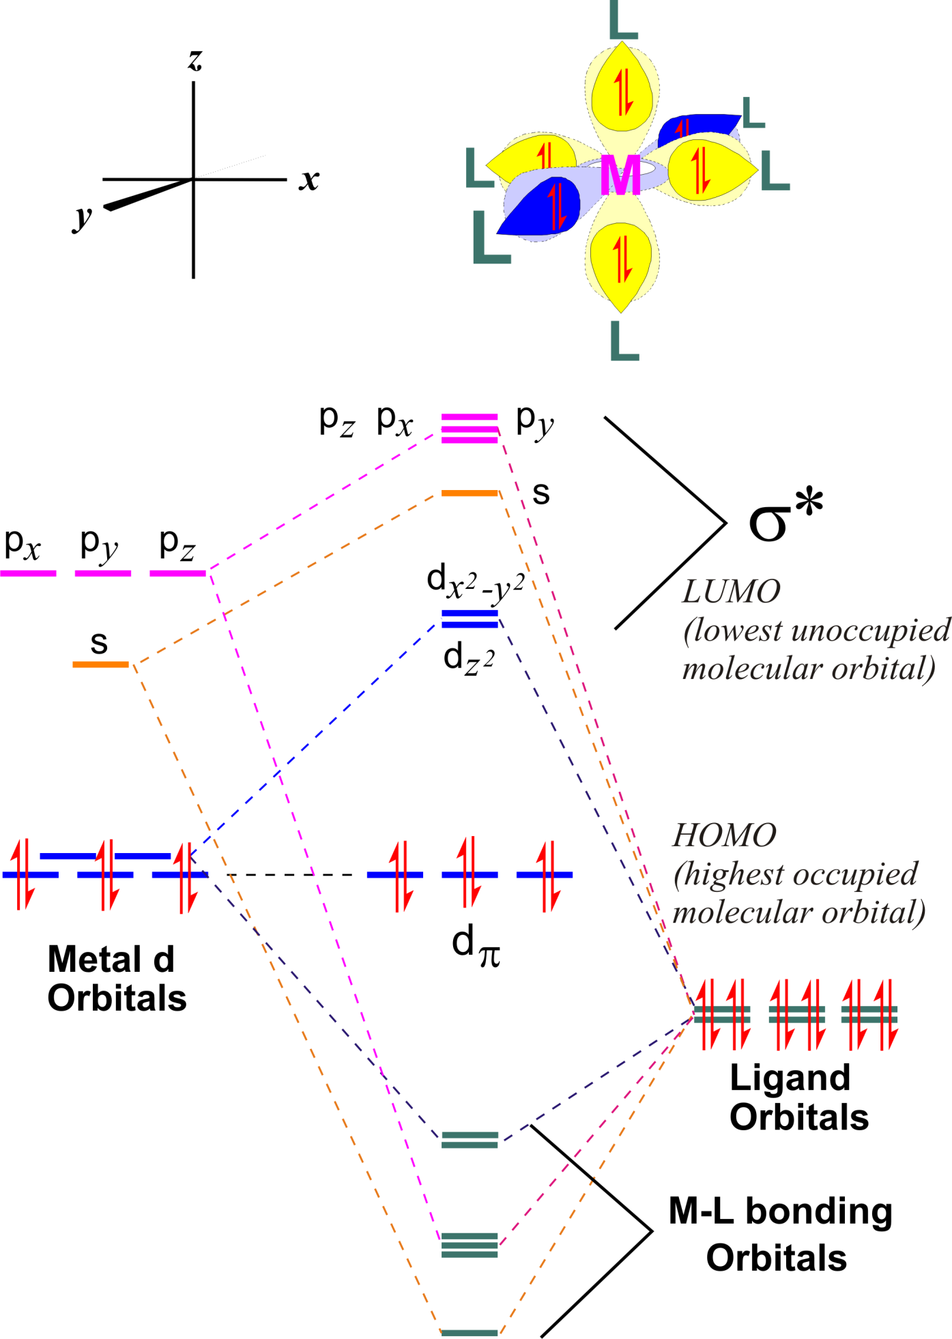

**18 Electron *"Rule"***

**Organic compounds, of course, follow the 8 electron rule: there can only be a maximum of 8 valence electrons around a carbon center.**

**The vast majority of stable diamagnetic organometallic compounds have 16 or 18 valence electrons due to the presence of the five *d* orbitals which can hold 10 more electrons relative to C, O, N, etc.**

***Electron counting* is the process of determining the number of valence electrons about a metal center in a given transition metal complex.**

**To determine the electron count for a metal complex:**

**1) Determine the oxidation state of the transition metal center(s) and the metal centers resulting *d*-electron count. To do this one must:**

**a) note any overall charge on the metal complex**

**b) know the charges of the ligands bound to the metal   
 center (ionic ligand method)**

**c) know the number of electrons being donated to the metal   
 center from each ligand (ionic ligand method)**

**2) Add up the electron counts for the metal center and ligands**

Complexes with 18 e- counts are referred to as *saturated*, because there are no empty low-lying orbitals to which another incoming ligand can coordinate. Complexes with counts lower than 18e- are called *unsaturated* and can electronically bind additional ligands if they are sterically allowed.

Lots of General Exceptions to the 18e “Rule”

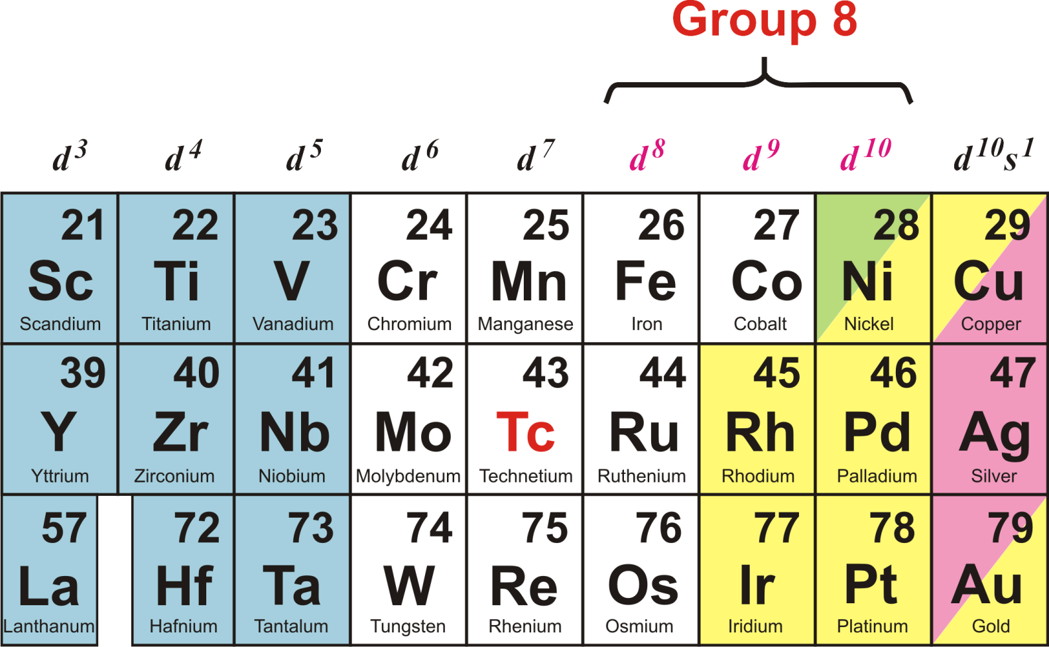

|  |  |  |
| --- | --- | --- |
| **Early Transition Metals** | **Middle Transition Metals** | **Late Transition  Metals** |
| **16e- and sub-16e- configurations are common** | **18e- configurations are common** | **16e- and sub-16e- configurations are common** |
| **Coordination geometries higher than 6 relatively common** | **Coordination geometries of 6 are common** | **Coordination geometries of 5 and lower are common: *d8* = square planar** |

***d6***

***Ligands, Bonding Types, Charges, and Electron Donor Numbers***

|  |  |  |  |
| --- | --- | --- | --- |
| **Ligand Name** | **Bonding Type** | **Formal Charge** | **Electrons Donated** |
| **Molecular Hydrogen: H2** |  | 0 | 2 |
| **Hydride: H** | **M-H** | -1 | 2 |
| **Hydride: H** |  | -1 | 2 |
| **Halide: X** | **M-X** | -1 | 2 |
| **Halide: X   bridging** |  | -1 | 4 (2 to each M) |
| **Halide: X  3 bridging** |  | -1 | 6 (2 to each M) |
| **Alkoxide, thiolate: OR, SR** | **M- OR** | -1 | 2 or 4 |
| **Alkoxide, thiolate: OR, SR   bridging** |  | -1 | 4 (2 to each M) |
| **Alkoxide, thiolate: OR, SR  3 bridging** |  | -1 | 6  (2 to each M) |
| **Peroxide: O22 2** |  | -2 | 4 |
| **Peroxide: O22 2 bridging** |  | -2 | 4 (2 to each M) |
| **Oxide, sulfide: O2, S2** |  | -2 | 4 6 |
| **Oxide, sulfide: O2, S2   bridging** |  | -2 | 4 (2 to  each M) |
| **Oxide, sulfide: O2, S2  3 bridging** |  | -2 | 6 (2 to  each M) |
| **Amine, phosphine, arsine: NR3, PR3, AsR3** | **M-NR3 M-PR3** | 0 | 2 |
| **Amide, phosphide: NR2, PR2** |  | -1 | 2  4 |
| **Amide, phosphide: NR2, PR2  bridging:** |  | -1 | 4 (2 to each M) |
| **Imido: NR2** |  | -2 | 4 (bent)  6 (linear) |
| **Imido: NR2** ** bridging** |  | -2 | 4 or 6 (2 or 3 to each M) |
| **Imido: NR2** **3 bridging** |  | -2 | 6  (2 to each M) |
| **Nitride, phosphide:  N3, P3** | **M≡N:** | -3 | 6 |
| **Nitride, phosphide:  N3, P3**, ** bridging** |  | -3 | 4 or 6 (2 or 3 to each M) |
| **Nitride, phosphide:  N3, P3**, **3 bridging** |  | -3 | 6 |
| **Nitrosyl: N≡O+** ***linear form*** |  | **+1** | 2 |
| **Nitrosyl: N≡O** ***bent form*** |  | -1 | 2 |
| **Nitrosyl: N≡O+** ** bridging** |  | +1 | 1 to each metal |
| **Nitrosyl: N≡O+** **3 bridging** |  | +1 | 1 to each metal |
| **Carbonyl: C≡O** |  | 0 | 2 |
| **Carbonyl: C≡O ,2 mode** |  | 0 | 2 to each metal |
| **Carbonyl: C≡O  bridging** |  | 0 | 1 to each metal |
| **Carbonyl: C≡O 3 bridging** |  | 0 | 1 to each metal |
| **Isocyanide: C≡N-R** |  | 0 | 2 |
| **Isocyanide: C≡N-R  bridging** |  | 0 | 1 to each metal |
| **Alkene: R2C=CR2** **2 bonding mode** |  | 0 | 2 |
| **Alkyne: RC≡CR 2 bonding mode** |  | 0 | 2 or 4 |
| **Alkyne: RC≡CR  bridging** |  | 0 | 2 to each metal |
| **Dienes: R2C=CH-CH=CR2** **4 bonding mode** |  | 0 | 4 |
| **Dienes: R2C=CH-CH=CR2** ** bridging** |  | 0 | 2 to each metal |
| **Benzene: C6H6** **6 bonding mode** |  | 0 | 6 |
| **Ketones, aldehydes:  2 bonding mode** |  | 0 | 2 |
| **Alkyl: CH3, CH2R** **1 bonding mode** |  | -1 | 2 |
| **Alkyl: CH3, CH2R** |  | -1 | 2 (1 to each M) *assuming no agostic M-H interactions* |
| **Aryl: C6H5** **1 terminal** |  | -1 | 2 |
| **Alkenyl (vinyl), alkynyl: CH=CH2, C≡CH** **1 terminal** |  | -1 | 2 |
| **Alkenyl (vinyl): CH=CH2** **2 terminal** |  | -1 | 4 |
| **Alkenyl (vinyl), alkynyl: CH=CH2, C≡CH** **,2 terminal** |  | -1 | 4 (2 to each M) |
| **Cyclopropenyl: C3H3 3 terminal** |  | +1  -1 | 2  4 |
| **Allyl: C3H5  3 terminal** |  | -1 | 4 |
| **Allyl: C3H5  1 terminal** |  | -1 | 2 |
| **Pentadienyl: C5H7  5 terminal** |  | -1 | 6 |
| **Pentadienyl: C5H7  3 terminal** |  | -1 | 4 |
| **Pentadienyl: C5H7  1 terminal** |  | -1 | 2 |
| **Cyclopentadienyl: C5H5  5** |  | -1 | 6 |
| **Cyclopentadienyl: C5H5  3** |  | -1 | 4 |
| **Carbene: =CYR *where Y is a substituent capable of*  *interaction with the carbene carbon atom*** |  | 0 | 2 |
| **Alkylidene: =CR22 *where no substituents capable of*  *bonding to the carbene carbon atom are present*** |  | -2 | 4 |
| **Carbene: =CYR or =CR22** ** bridging** |  | -2 | 2 to each metal |
| **Carbyne or Alkyidyne: ≡CR3** |  | -3 | 6 |
| **Carbyne or Alkyidyne: ≡CR3 3 bridging** |  | -3 | 2 to each metal |

**How do I Figure Out Ligand Charges & Donor #’s ??  
(without memorizing that !#&!@%$* entire list)**

**Please note that we are using the *Ionic Method* of electron-counting. 95% of inorganic/organometallic chemists use the ionic method. The ionic method assigns formal charges to the metal and ligands in order to keep the ligands with an even # of electrons and (usually) a filled valence shell. There is also the neutral method that considers everything to be neutral. Synthetically, the ionic method makes more sense and is the one that we will use.**

First, you should learn the charges and donor # for the *common* ligands (this will significantly speed up your counting):

**Cationic 2e- donor: NO** **(nitrosyl), cyclopropyl (or anionic 4e-)**

**Neutral 2e- donors: PR3 (phosphines), CO (carbonyl), R2C=CR2 (alkenes), RCCR (alkynes, can also donate   
4 e-), NCR (nitriles), CNR (isocyanides)**

**Anionic 2e- donors: Cl** **(chloride), Br** **(bromide), I** **(iodide), CH3** **(methyl), CR3** **(alkyl), Ph** **(phenyl), H** **(hydride)   
*The following can also donate 4 e- if needed, but initially count them as 2e- donors (unless they are acting as bridging ligands):* OR** **(alkoxide), SR** **(thiolate), NR2** **(inorganic amide), PR2** **(phosphide)**

**Anionic 4e- donors: C3H5** **(allyl), O2** **(oxide), S2** **(sulfide), NR2** **(imido), CR22** **(alkylidene)  
*and from the previous list:* OR** **(alkoxide), SR** **(thiolate), NR2** **(inorganic amide), PR2**

**Anionic 6e- donors: Cp** **(cyclopentadienyl), Tp** **(trispyrazolyl-borate), N3** **(nitride), CR3** **(carbyne)**

**Ligands, Charges and Lone Pair Donation:**

Consider a methane molecule that has a full valence of four hydrogen atoms and no charge or lone pairs. Remove one of the hydrogen atoms as a neutral atom and add an electron to fill the resulting half empty orbital. This generates a [CH3] anion that has one lone pair to donate to an empty orbital on a metal center. Keep up the H-atom removal process adding an electron each time and you will generate a [CH2]2, [CH]3, and eventually a [C]4.



One can repeat this process for NH3:



And H2O:



**Ligand Charges & Metal Oxidation States vs. Calculated Charges**

Shown below are three metal complexes with their formal charges and calculated Mullikin charges from DFT calculations on each:

|  |  |  |
| --- | --- | --- |
| **Complex** | **Formal Charges** | **Calculated Charges** |
|  | **Co(+1) = + 1.0**  **H– = – 1.0**  **CO = 0**  **PMe3 = 0**  **PF3 = 0** | **Co(+1) = + 0.468**  **H– = – 0.252**  **CO = – 0.332**  **PMe3 = + 0.149**  **P only = + 0.266**  **PF3 = + 0.023**  **P only = + 1.000** |
|  | **Ir(+3) = + 3.0**  **3 C– = – 1.0**  **3 N = 0** | **Ir(+3) = + 1.550**  **3 C– = – 0.464**  **3 N = – 0.539**  **(only showing charges for the donor atoms coordinated to the Ir center)** |
|  | **Rh(+1) = + 1.0**  **CO = 0**  **3 PH3 = 0** | **Rh(+1) = – 0.419**  **CO = + 0.041**  **PH3 = + 0.447**  **dhpe = + 0.929** |

**Simple Example:**



**1) There is no overall charge on the complex**

**2) There is one anionic ligand (CH3****, methyl group)**

3) Since there is no overall charge on the complex (it is neutral), and since we have one anionic ligand present, the Re metal atom must have a +1 charge to compensate for the one negatively charged ligand. The +1 charge on the metal is also its oxidation state. So the Re is the in the +1 oxidation state. We denote this in three different ways: Re(+1), Re(I), or ReI. I prefer the Re(+1) nomenclature because it is clearer. Most chemistry journals, however, prefer the Roman numeral notation in parenthesis after the element.

**Now we can do our electron counting:**

|  |  |
| --- | --- |
| **Re(+1)** | **d6** |
| **2 PR3** | **4e-** |
| 2 CO | **4e-** |
| **CH3** | **2e-** |
| **CH2=CH2** | **2e-** |
| **Total:** | **18e-** |

**Next Electron-Counting Example:**

**1) There is a +2 charge on the complex**



2) The CNCH3 (methyl isocyanide) ligand is neutral, but lets check the Lewis Dot structure to make sure that is correct:



Nitrogen is normally trivalent, that is, it wants to have 3 chemical bonds to it. When it has 4 bonds, one more than usual, the nitrogen atom is assigned a formal *positive* charge. Carbon, on the other hand, is tetravalent and almost always wants 4 bonds. In isocyanides, however, we only have 3 bonds to the C. To keep an even number of electrons around the C we add an extra electron and the carbon gains a formal *negative* charge.

3) Because there is a +2 charge on the complex and there are all neutral ligands present, the Mo has a +2 charge & oxidation state.

**Now we can do our electron counting:**

|  |  |
| --- | --- |
| **Mo(+2)** | **d4** |
| **7 CNCH3** | **14e-** |
| **Total:** | **18e-** |

**More Complicated Ligand Analysis:**



**How do we figure out the charge and electron donor ability of this weird ligand (a** **phosphorus diylide)??**

**1) Remove the metal atoms and examine the ligand by itself:**



**Phosphorus is trivalent and since it has four bonds to it, there is a formal positive charge assigned to the atom. Each carbon is currently neutral and has an odd electron.**

**2) We always want the ligand in the *ionic method* of ligand electron counting to have an *even # of electrons*. IF the ligand atom has an odd # of electrons, add enough electrons to get to an even # (and usually a filled valence shell). This usually means adding one electron. In this specific case we have two carbon atoms each which needs an additional electron to give a lone pair that can donate to the metal center:**



**Adding two electrons to this ligand generates two anionic carbon donor centers. *But remember that we have a positive charge on the phosphorus atom*, which although not involved in bonding to the metal, is part of the overall charge of the ligand. So two negative charges and one positive charge (on the phosphorus) yields a *net negative charge* on this ligand. Each carbon can donate 2 e- to each metal center.**

**This strange ligand is called a phosphorus di-ylide and is a strongly donating ligand for bridging two metal centers.**

**More Complicated Metal Compound Analysis:**



**1) There is no overall charge on the complex**

**2) There is one anionic ligand (3-C3H5****, allyl).**



***Rule of Thumb:* -based carbon ligands that have *odd* number attachments to the metal center are usually *anionic* (except for CO and CNR [isocyanide] ligands) and donate one more electron than the number of carbons bonded to the metal center. So our 3-C3H5****, allyl ligand is anionic and donates 4e- to the metal center.**

**The C5H5Me ligand is NOT a simple anionic cyclopentadienyl ligand. It is a neutral ligand with two alkenes that each act as neutral 2e- donors to the metal:**



**If you work out the Lewis Dot structure for this ligand you get an even # of electrons so there is no need to add an electron to get an anionic ligand. Note that it is EASY to forget that there is a H on the Cp carbon that has the methyl group attached if you are not thinking about organic line notation.**

3) Because the complex is neutral and there is one anionic ligand present, the Rh atom must have a +1 charge to compensate for the one negatively charged ligand. So the Rh atom is in the +1 oxidation state.

**Now we can electron-count:**

|  |  |
| --- | --- |
| **Rh(+1)** | **d8** |
| **PR3** | **2e-** |
| 4-C5H5Me | **4e-** |
| **3**-**C3H5** | **4e-** |
| **Total:** | **18e-** |

**Metal-Metal Bonded Example:**



**At this point we will consider metal-metal (M-M) bonds to be simple covalent bonds with each metal contributing 1e- to the bond. Most M-M bonded complexes are symmetrical, which means that one only has to e- count one metal center. If the metals are different, however, one does need to figure out each metal center.**

**The simple rule for M-M bonding is that if you have two metal atoms next to one another and each has an odd electron-count, you pair the odd electrons to make a M-M bond. This is electron-counted as a 1e- donation from one metal to the other.**

**This example also has -Cl ligands. Bridging ligands with at least 2 lone pairs almost always donate 2e- to each metal center.**

**Oxidation state determination: There are a total of two anionic ligands for two metal centers (overall complex is neutral). Thus each metal center needs to have a +1 oxidation state to balance the anionic ligands.**

**Very Common Mistake: Students determining the oxidation state for complexes with 2 or more metal centers often add up all the anionic ligands and then figure out the oxidation state for only one of the metal centers based on this. You need to take into account the charge (if any) on the complex and divide up the anionic ligand charges between all the metal centers present. Each metal in the complex shown above is in the +1 oxidation state – NOT +2.**

**Now we can electron-count:**

Note that each bridging chloride is donating 2e- to each Mo center. Although we only “allocate” one negative charge for figuring out the oxidation state of the Mo atom, one needs to include in the electron-counting the fact that both chlorides are donating electrons to each metal center.

|  |  |
| --- | --- |
| **Mo(+1)** | **d5** |
| **2PR3** | **4e-** |
| CO | **4e-** |
| **2**-**Cl** | **4e-** |
| ***Sub-total:*** | ***17e-*** |
| **Mo-Mo** | **1e-** |
| **TOTAL:** | **18e-** |

**This structure is called an edge-sharing bioctahedron (i.e., two octahedral metal centers sharing a common edge).**

**Another Metal-Metal Bonded Example:**



**Ligand analysis: The chelating N ligand is a bis-imine, is neutral, with each N atom donating 2e-. There are two different bridging ligands – an anionic CH3 (methyl group) and a dianionic CH22 (carbene or alkylidene). The CH3 only has one lone pair of electrons, so it has to split these between the two metals (1e- to each). The CH22 alkylidene ligand, on the other hand, has 2 lone pairs so it can donate 2e- to each metal center.**

**Oxidation state analysis: There are a total of 3 negative charges on the ligands (anionic methyl, dianionic alkylidene) and a positive charge on the complex. Therefore the two Pd centers must have a TOTAL of a +4 charge, or a +2 charge (oxidation state) on each.**

|  |  |
| --- | --- |
| **Pd(+2)** | **d8** |
| **2 imines** | **4e-** |
| -CH3 | **1e-** |
| ****-**CH22** | **2e-** |
| ***Sub-total:*** | ***15e-*** |
| **Pd-Pd** | **1e-** |
| **TOTAL:** | **16e-** |

**Note that Pd(+2) is generally happy with a 16e- configuration. Problems in Electron Counting**

 

 

 

 

 

 

 

 

 

 

 

 

**Why is Electron Counting Important??**

One of the complexes drawn in the cycle below is highly unlikely and studies have shown that it does not exist (as far as we can tell).

Insert Fig. 24-B-2 from Cotton & Wilkinson, 3rd Edition (1972)

(note, the figure has been updated in the 6th ed, (1999), Fig. 22-7)