Your assignment is to present to the class the following paper: “Chain transfer agents for the catalytic ring opening metathesis polymerization of norbornenes” (https://pubs.rsc.org/en/content/articlelanding/2022/sc/d2sc04078f). You are provided the manuscript as well as the supporting information. Below are questions similar to those you are used to from literature discussions this semester. You should use these to guide the construction of your presentation. Make sure that you provide a background on the field generally. The questions below are useful for guiding this, may not be comprehensive (i.e., you may delve into areas not directly addressed by the questions). Questions may not necessarily be in the order in which topics should be presented. When a technique that is new to you is employed, you should assume that it is new to the rest of the class as well, and briefly explain it. You are encouraged to use figures. You may copy/paste figures from the materials provided, or from other sources in the interest of time. Ensure that any figure not generated by you or from this manuscript has a citation. You are encouraged to reach out to Prof. Farrell for help. However, you should first put a reasonable amount of effort into answering your questions yourself by doing your own research.
The objective of this assignment is to enhance your skills of reading and digesting scientific literature, as well as exposing the class to an area of research we are not able to cover in one semester of this course.
- Give an overview of catalysis. What are key features of catalysts? What is a catalytic cycle?
- Olefin metathesis:
  - What is olefin metathesis? Provide a scheme and describe the mechanism. Discuss specifically why an olefin might coordinate to the metal using Lewis Acid/Base concepts.
  - What is ROMP, a subset of olefin metathesis? What is the driving force behind it?
  - The paper discusses molybdenum and ruthenium catalysts, and the authors elect to use ruthenium. What is an advantage of ruthenium over molybdenum?
  - The table below shows a Schrock-type molybdenum catalyst, and three “generations” of Grubbs-type catalysts. Show these, and give the electron count, valence number, and d^{n} for each.
Schrock-Type | Grubbs’ 1st Generation (G1) | Grubbs’ 2nd Generation (G2) | Grubbs’ 3rd Generation (G3)
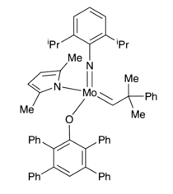 | 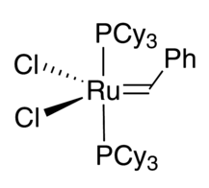 | 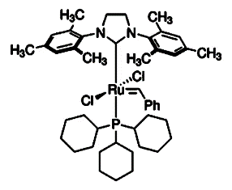 | 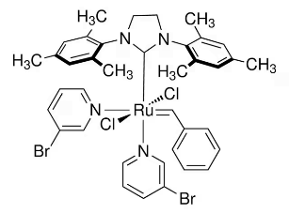
  - The authors use G3, which is known for its fast initiation. When discussing the compounds above, describe why G3 is fast initiating. Hint: Consider the mechanism for initiation.
- Telechelic polymers:
  - What is a telechelic polymer?
  - How are homotelechelic and heterotelechelic polymers different?
  - When would a homotelechelic polymer be desirable?
- Chain transfer:
  - The authors proposed to use 1,3-dienes as chain transfer agents. Why did they think this would work? What else do Grubbs-type catalysts react with, and how are they similar? Lewis Acid/Base chemistry should play a role here too!
  - How did the authors first demonstrate a proof of concept that 1,3-dienes would react with G3? Show spectra to support this.
  - Why does the terminal alkene of the CTA react, rather than the internal one?
  - The authors showed “end-capping” with the 1,3-diene. What is this? How did they demonstrate this conclusively?
  - How did the authors demonstrate catalytic regioselective chain-transfer ROMP? Discuss how this was shown conclusively.
- What is a Hammett analysis? What did this demonstrate?
- The authors claim that the reaction is kinetically controlled. What does this mean, and how can they tell?
- Star polymers:
  - What is a star polymer?
  - Why is ROMP to make star polymers preferable to other methods?
- Copolymerization:
  - What is a block copolymer?
  - What type of polymerizations were used in the copolymerizations?
- Conclude with some big picture take-aways from this paper.
  - What concepts from this course did you need to consider?
  - What is the big achievement that warrants publication in Chemical Science, a high impact journal?

