Phi Bonds in Actinide Complexes
To prepare for discussion, write out the answers to these questions and bring them to class.
Read the following article before class.
Kelley, Morgan P.; Popov, Ivan A.; Jung, Julie; Batista Enrique R.; Yang, Ping,”δ and φ back-donation in An^{IV} metallacycles”, Nat. Commun. 2020, 11, 1558. DOI: 10.1038/s41467-020-15197-w

f Orbital Appreciation

- The actinide elements are characterized by the filling of the 5f electron shell. What are the possible n, ℓ, and m_{ℓ} quantum numbers for the 5f electrons?

- The shapes of the seven f orbitals are shown below.

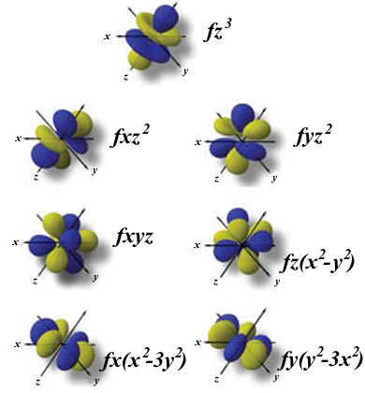

Ángel Terrón, Ángel García-Raso y Miquel Barceló-Oliver / CC BY-SA (https://creativecommons.org/licenses/by-sa/3.0)

- How many angular (planar or conical) nodes do the f orbitals have?

- For each orbital above, describe the shape of the angular nodes mathematically. For example, the wavefunction will equal zero for the fx(x² – 3y²) orbital when x = 0 (the yz plane), when x = y (the vertical plane along the line x = y), and when x = –y (the vertical plane along the line x = –y).

(c) How many radial (spherical) nodes does a 5f orbital have?

Electron Configurations

3. The lanthanide and actinide series are the elements that follow lanthanum and actinium in the periodic table.
(a) The ground state electron configuration of La is [Xe]6s²5d¹. What is the most common oxidation state of La?
(b) Which element will have the ground state configuration of [Xe]6s²4f¹⁴5d¹?
(c) What is the most common oxidation state of Lu?
(d) Europium is one of the few lanthanides that has a divalent oxidation state. Explain why.
(e) Which lanthanide would you predict to have an accessible tetravalent oxidation state and why?
(f) What is the ground state electron configuration of Ac, actinium?
(g) What is the ground state electron configuration of U, uranium?
4. The 5f shell has a larger radial extent than the 4f shell, and electrons in the 5f shell are more readily ionized, unlike the electrons in the 4f shell. Therefore, while +3 is a common oxidation state for the actinides (like that of the lanthanides), a broader range of oxidation states are available. What are all of the possible oxidation states for uranium?
5. Is there an element with the symbol An? What does An stand for?

Lanthanide / Actinide Contraction

[insert graph of lanthanide and actinide ionic radii]

Ionic radii from: Shannon, R. D. Revised effective ionic radii and systematic studies of interatomic distances in halides and chalcogenides. Acta Crystallogr. Sect. A 1976, 32 (5), 751-767.

[insert graph of atomic radii]

Atomic radii from: https://www.rsc.org/periodic-table/

[insert graph of oxidation states]

Oxidation states taken from: Seaborg, G. T. Overview of the Actinide and Lanthanide (the f) Elements. Radiochim. Acta 1993, 61 (3-4), 115-122. Most stable indicated with a ✓ and unstable indicated with an 🇽.

6. Explain in your own words why the lanthanide and actinide contractions occur?

7. Using the atomic and ionic radii graphs above, when does the lanthanide contraction follow a trend?

8. Using the atomic and ionic radii graphs above, under what condition(s) is the actinide contraction predictable (follow a trend)?

Bonding

9. (a) Sketch the five types of d orbitals below, using the axes systems provided.
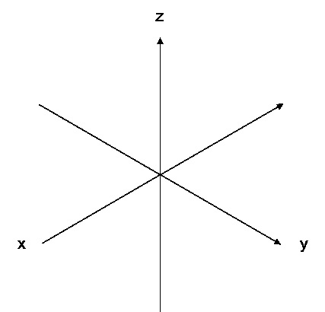
d_{xy} d_{yz} d_{yz}

d_{x2-y2} d_{z2}

(b) Assume that the z axis is the bonding axis between two metals. Show how two orbitals of each type will overlap along the z axis to form M-M bonds. The d_{z2} orbital is done for you as an example.
d_{z2} + This interaction is σ symmetry.

d_{xz} + (side to side)

d_{xy} and d_{x2 – y2} + (face to face)

(c) Recall that the symmetry of a bonding interaction is determined by how many times the bonding molecular orbital changes sign when the MO is rotated around the bonding axis.
For the σ interaction shown in part (b), the molecular orbital does not change sign at all when rotated.
What happens to the sign of the bonding molecular orbital’s wavefunction in the π and δ types of bonding interactions?

10. What does “back bonding” mean? Is the ligand donating electrons to the metal, or is the metal donating electrons to the ligand? What type of orbital symmetry is usually involved in back bonding?
11. (a) Figure 2c shows an arrangement of a metal f_{xyz} AO and a π* orbital on an alkene. If the metal f_{xyz} orbital is occupied (i.e. contains electrons) and the π* orbital is a LUMO (i.e. does not contain electrons), add arrows showing how a bonding interaction could be formed between these sets of orbitals. Does the shading of the orbitals matter?
(b) Compare the image in Figure 2c to the calculated MOs in Figure 5c. How are the two images related to each other?
(c) Consider your previous answers, and look closely at the overlap shown in Figure 1d, which depicts a φ bonding interaction. What differences are apparent between Figure 1c and 1d? How many sign changes would be apparent if this MO was rotated along the bond axis?

Nomenclature

12. The authors list several compounds that use the Greek letters eta (η) and mu (μ). Describe what these symbols mean in the context of metal-ligand coordination chemistry.

Ex. (η⁵-C₅Me₅)₂An[η⁴-C₄(SiMe₃)₂] and (μ-C₇H₈)[U(N[R]Ar)₂]₂

