**Learning Objectives:**

1. Describe what happens when two waves (or wavefunctions) add together.
2. Draw the resulting wavefunctions from the overlap of *s* atomic orbitals.
3. Describe covalent bonding in terms of electrons populating molecular orbitals.
4. Explain what an antibonding orbital is.
5. Use the concept of bond order to explain why He2 does not exist.

**Part I: Atomic Orbitals as Wavefunctions**

Previously, we described the orbitals that electrons occupy in atoms by their mathematical *wavefunctions*, . When forming a bond between atoms, those wavefunctions “overlap.” This worksheet will help us to understand what happens when orbitals overlap.

1. The analogy between water waves and wavefunctions is often quite useful. What happens when two water waves “join forces” – when their crests meet? Specifically, what happens to the *amplitude* of the wave?
2. What happens when the crest of one wave overlaps with the “trough” of another wave?
3. 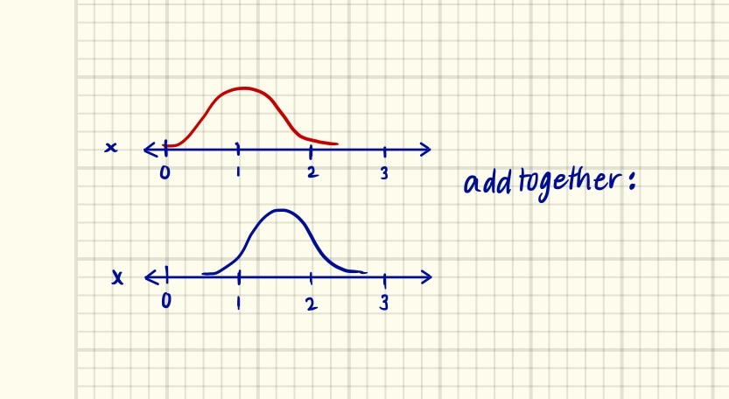Let’s visualize this same phenomenon with mathematical waves. First, let’s position two waves so that they “add” together. What would the resulting wave look like?
4. 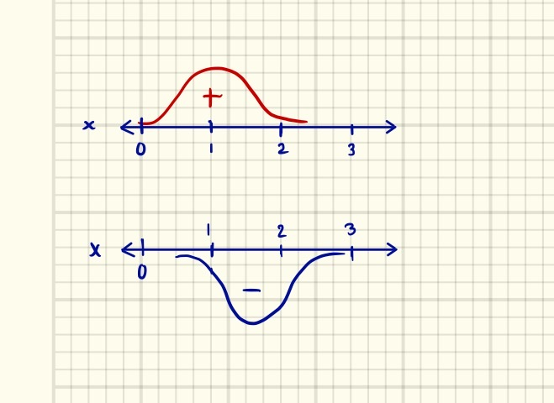Now, let’s position the waves so that parts of them cancel; what does the new wave look like?

**Part II: Wavefunctions in Combination**

While there are many similarities between water waves, sound waves, light waves, and the wavefunctions that describe atomic orbitals, there ***is*** one key difference. Whenever we combine or overlap two wavefunctions, we must *both add and subtract them*. This is sometimes called the Law of Conservation of Orbitals.

1. When we bring two hydrogen atoms approximately 74 pm apart from one another, what happens? (That’s the distance between the nuclei in the molecule H2.)
2. With the two nuclei at 74 pm apart, draw the two hydrogen atoms’ 1s orbitals. The atomic radius of hydrogen is 53 pm.
3. Recall that a wavefunction can have either a + or a – sign; it can have two possible *phases*. Often, we represent these phases as shaded or unshaded regions in an orbital picture. Draw the *two possible* combinations of the hydrogen 1s orbitals.
4. Wherever waves of the same phase overlap, they get bigger – this is called *constructive interference*. Whenever waves of opposite phases overlap, they cancel each other out – *destructive interference*. Can you see why we might draw these two combinations as we do here?

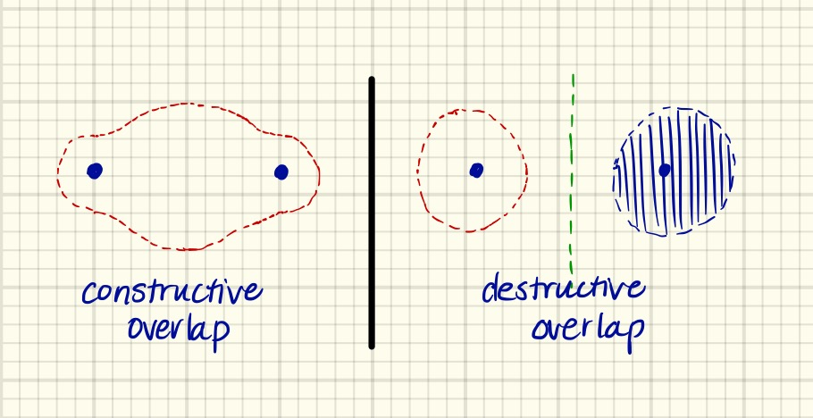

1. How many *nodes* are in each of the molecular orbitals drawn above? What does this imply about the *energies* of these two molecular orbitals?

**Part III. What are these “Molecular Orbital” Things?**

We have now developed a sense for what these “molecular orbitals” look like, but what *are* they?

1. Describe what an *orbital* is.

2. In a “bonding” molecular orbital, the most likely region to find an electron is *between* the two nuclei. Describe all the Coulombic forces present in this arrangement of nuclei and electrons. What is the *net* electrostatic force?



3. In an “antibonding” molecular orbital, the most likely region to find an electron is *outside* the two nuclei. Describe all the Coulombic forces present in this arrangement of nuclei and electrons. What is the *net* electrostatic force?



**Part IV. Molecular Orbital (“Correlation”) Diagrams**

Chemists typically show the relative energies of these molecular orbitals in an energy diagram, much like the energy diagrams we use to explain electron configurations. The molecular orbital diagram of H2 is shown below. Note that there is no x-axis; this is an “energy-only” diagram.

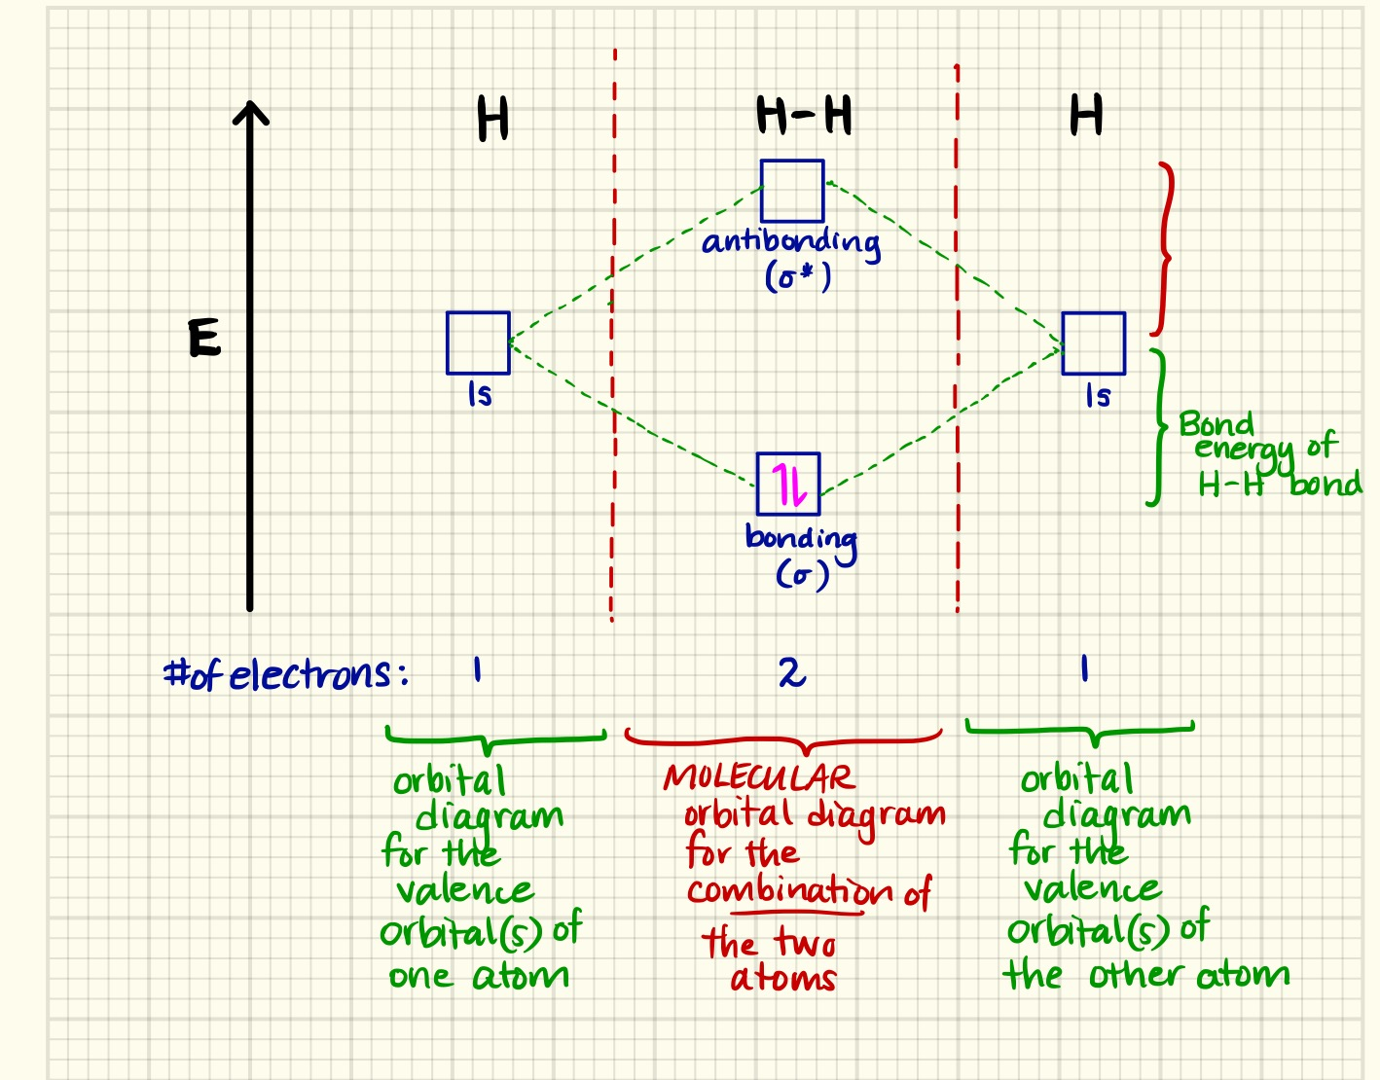

1. Why is the *bonding* orbital lower in energy than the respective 1s atomic orbitals?

2. Why is the *antibonding* orbital higher in energy than the respective 1s atomic orbitals?

3. Why are there two electrons in this diagram?

4. We define the *bond order* between two atoms as:

$$Bond Order= \frac{\left(\# e^{-} in bonding orbitals\right)-(\# e^{-} in antibonding orbitals)}{2}$$

What is the bond order in H2? What *would* the bond order be for He2? What does that say about the stability of He2?