Growth of Colloidal Crystals

In fall 2022, Joanna Aizenberg was awarded the ACS Award in Colloid Chemistry for her outstanding contributions to fundamental and applied colloid chemistry in developing large-scale, highly ordered porous colloidal materials with unique photonic, catalytic, and sensing properties. In this assignment you will learn about her recent work as you examine her 2021 paper “Microscopic origins of the crystallographically preferred growth in evaporation-induced
colloidal crystals” Proceedings of the National Academy of Science, 2021, 118, e2107588118.

- According to Wikipedia, a colloid is “a mixture in which one substance consisting of microscopically dispersed insoluble particles is suspended throughout another substance.”

- Identify the substances involved in the colloidal solution from which the crystals are grown in this research. Hint: You may need to consult the Materials and Methods section at the end of the article.

microscopically dispersed insoluble particles: ___________________________

other substance (in solution phase): ___________________________________

other substance (in final crystal): ____________________________________

- How large were the microscopic particles?

- The colloidal crystals grew in the face centered cubic crystal structure as the solvent slowly evaporated (see Figure 1).

- Draw the z-layer diagram for a face centered cubic crystal.

- Which metals are commonly found in the fcc crystal structure? How do these colloidal crystals compare to metals in terms of the size of the packing spheres?

- Review of Miller indices! Sketch one example of each low-index family of planes for the fcc system on the unit cell and axis system provided. The x, y, and z directions are defined below, and the origin is indicated by a dot at the corner of each unit cell. Indicate the name (using Miller indices) of the set of planes that you sketch in each case.

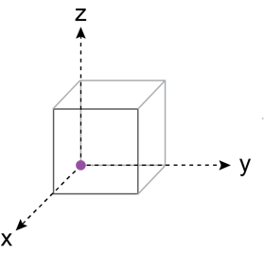
Axis definition:

Family of planes | Sketch one example set | Miller indices for the example you sketched
{100} | 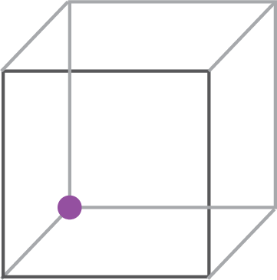
{110}

{111}

- What do the authors mean by the M, G, and N axis system? Use a sketch in your answer.

- Based on the definitions you figured out in question 4 and referring to Figure 1A, is the crystal growing out from the substrate, up, down, left or right?

- Two-dimensional slices of the fcc extended crystal structure are shown below. Name each of them.

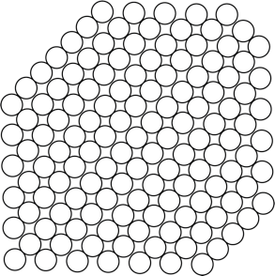

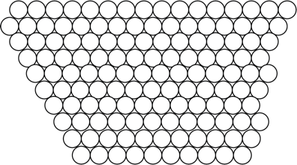

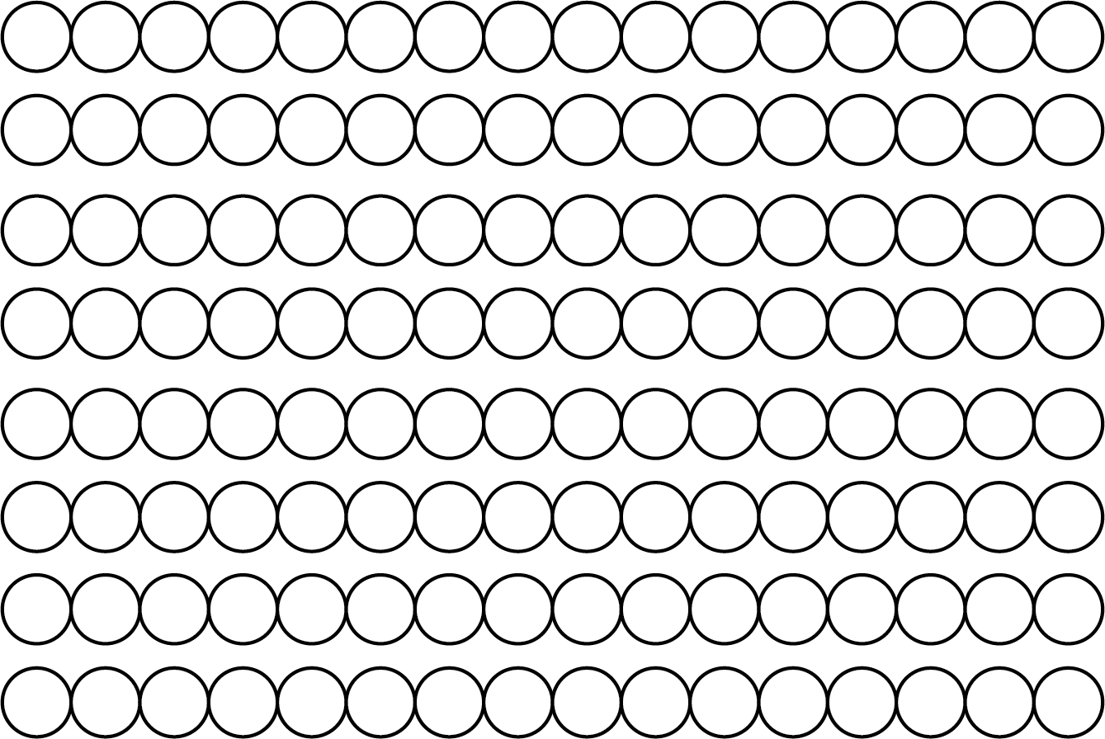

- Which of the planes shown in question 5 is parallel to the substrate?

- Examine Figures 2A-C and Figure 3A.
- How would you assign a “time” axis to these figures? ie, how is the crystal growing over time? How long does it take to grow a crystal? (Hint: Check the Materials and Methods section at the end of the article.)

- What conclusions can you draw from these figures about the evolution of the crystal over time?

