Examination and Classification of Molecular Symmetry
Purpose
In this lab, you will explore the symmetry properties of molecules.

Learning goals
After completing this exercise, a student will be able to …
locate symmetry elements (axes of rotation, planes of reflection, and centers of inversion) in molecules.
predict the movement of individual atoms in a molecule when carrying a molecule through a symmetry operation.
identify all of the symmetry operations that are present in a molecule.
assign a simple molecule to a point group.
Introduction
A molecule is said to have symmetry if you can perform an operation on it and the starting and ending states of the molecule are indistinguishable from each other. For example, rotating a kickball. The operation that you perform is called a symmetry operation. Symmetry operations occur with respect to a geometric element, called a symmetry element. For example, rotation (operation) around an axis (element).

Symmetry Operation: A specific manipulation (e.g., rotation, reflection, inversion) on an object in space that generates an object that is indistinguishable from the starting state.

Symmetry Element: A physical geometric element (i.e., point, plane or axis) that a symmetry operation is performed with respect to.

The symmetry of an object is classified by identifying all the symmetry operations and elements that lead to an object that is indistinguishable from its starting state. Below is a list of all the possible symmetry operations and elements for an object in 3D space.

Notation Operation Notation Element

E Do nothing E The identity operator, equivalent to the number one for multiplication.

C_{n}^{m} Rotation around an axis. C_{n} A rotation axis upon which a Angle of the rotation molecule rotated n times
= m*(360°/n) return to the starting state. The axis with the largest n for a molecule is called the principal rotation axis.

σ Reflection through a plane. σ_{v} A vertical reflection plane, contains
highest C_{n}
σ_{h} A horizontal reflection plane, ⊥ to highest C_{n}
σ_{d} A dihedral plane, which is a vertical reflection plane that bisects the angle between C₂′ axes (C₂′ and C₂″ axes are ⊥ to the highest C_{n}. C₂′ axes contain atoms)

i Reflection through a point i Inversion Center, molecule is reflected through this point.

S_{n}^{m} Rotation around a C_{n} axis S_{n} Improper rotation axis, can be
followed by reflection thought of as a rotation axis and a
through a σ_{h}. Angle of the ⊥ reflection plane.
rotation = m*(360°/n)

You will work with a partner for this lab, but each of you should hand in your own report. For this lab you will be building models, drawing sketches, and answering questions about the symmetry of the molecules that you studied. Do all of your work in your notebook. Your lab report will consist of the sketches and answers to questions requested below. For your lab report, please answer them in the order that they are asked in this handout. If your notebook is neat and in order, you may photocopy your notebook and hand it in as your report. Otherwise copy your work neatly and in order on separate paper for your report.

Exercise 1: Identifying symmetry elements
For this exercise, you will build models of molecules, identify symmetry elements in models, and draw them in sketches:
- Build a three dimensional model for NH₃. Identify the location of the C₃ axis, and three 𝜎_{v} reflection planes. Sketch each of these symmetry elements on their own representation of NH₃.
- Build a three dimensional model for allene (H₂C=C=CH₂). Identify the location of the three C₂ axes. Identify the location of two 𝜎_{d} reflection planes. Identify the S₄ improper rotation axis. Sketch each of these symmetry elements on their own representation of allene. An improper rotation axis can be represented by a rotation axis and a perpendicular reflection plane.
- Build a three dimensional model of SF₆. Identify the location of a single C₄ axis, a single C₃ axis, and a single C₂ axis (for this chose a C₂ axis that is not coincident with a C₄ axis). Sketch each of these axes on a different representation of SF₆. What is the angle of rotation for an operation around each of these axes?

Exercise 2: Representing symmetry operations
For this exercise, you will build models of molecules, identify symmetry elements, and represent molecules before and after symmetry operations:
- Build a model of staggered ethane. Identify the S₆ axis in ethane. Draw a representation of ethane, label the individual atoms (e.g., H₁, H₂, etc.), and sketch the S₆ axis on this representation. Draw an arrow from this sketch to another sketch of ethane with the S₆ axis. Write $S_{6}^{1}$above this arrow. Label the atoms to represent their new positions after performing an $S_{6}^{1}$operation. Repeat this for $S_{6}^{5}.$
- Using your previous model, draw a representation of ethane and label the individual atoms (e.g., H₁, H₂, etc.). Draw an arrow from this sketch to another sketch of ethane. Write i above this arrow. Label the atoms to represent their new positions after performing an i operation.

Exercise 3: Equivalent operations
Some symmetry operations are equivalent to each other. In this case, it is important to note equivalent symmetry operations so that you do not double count them when identifying total symmetry operations. Both the S₁ and S₂¹ operations are equivalent to other symmetry operations. What two operations are these equivalent to? Hint, you may find it useful to sketch 1,4-dibromobenzene with labeled atoms before and after these two operations. Do the same with other simple symmetry operations using 1,4-dibromobenzene and determine if any of these wind up with the same final labels. You need not show your work for this question, though you are welcome to do so for partial credit in the case of an incorrect answer.
Exercise 4: Finding symmetry operations
For this exercise, you will identify and list all of the symmetry operations that are present in the molecules below. If a rotation around an axis of high order happens to be coincident to a rotation around an axis of a lower order, list the rotation as the one around the axis of a lower order (e.g., $C_{4}^{2}$should be listed as $C_{2}^{1}).$ It will be helpful to build models to complete this exercise.
- Cyclobutane
- PtCl₄^{2–} (square planar)
- CF₃SO₃–

Exercise 5: Assigning point groups
The symmetry operations of an object belong to a mathematical group. We refer to these groups as point groups. Every member of a point group has the same symmetry operations. You will find that the vast majority of molecules will belong to a relatively small number of point groups allowing us to classify a great number of molecules into a small number of (useful!) groups. The number of symmetry operations in a group is called the order of the group.
One way of assigning a molecule to an appropriate point group is to find every symmetry operation for that molecule. As you saw above, this gets tricky. Another method is to identify characteristic symmetries to classify a molecule. For this it is possible to use the flowchart below, as we will see shortly.
Point groups are identified by their Schoenflies symbol. These symbols contain a capital letter, followed by a subscript. The capital letter is related to the rotational symmetry of a group. C groups—not to be confused with a C rotation axis—contain only the principal rotation axis (C_{n}) and axes coincident with this axis. S groups contain a principal rotation axis C_{n}, which is concurrent with an S_{2n} axis—and no reflection symmetry. D groups contain a principal rotation axis (C_{n}) and n perpendicular C₂ axes. T, O, and I groups are groups with tetrahedral, octahedral, and icosahedral rotational symmetry respectively. These groups all have multiple higher-order rotation axes, C_{n} with n > 2. The subscript on a Schoenflies symbol indicates two things: 1) the order of the principal rotation axis and 2) the reflection symmetry. An h subscript indicates the existence of a horizontal reflection plane, 𝜎_{h}, that is perpendicular to the principal rotation axis. A d or v subscript indicates n reflection planes that contain the principal rotation axis.

Image removed. Insert your favorite symmetry flowchart here. I use the flowchart from Shriver and Atkins for my class.

The flowchart used to determine the molecular point group operates by first determining the rotational symmetry of a molecule and then determining the reflection symmetry. The first step is to determine if the molecule is linear or if there are multiple higher-order (n > 2) rotation axes. If there are, then you move to the branch of the flowchart for highly symmetric groups. If not, the next question is to determine if the molecule has a C_{n} axis. If not, the molecule is a member of a low symmetry group—C_{i}, C_{s}, or C₁, which contain only an inversion center, reflection plane, or identity operation. If so, then your molecule is a member of a C, D, or S group. If the molecule has a C₂ axis perpendicular to the principal rotation axis, then it is a member of a D group. It is worth noting that if a molecule has one perpendicular C₂ then it will always have n C₂ axes, where n is the order of the principle rotation axis. If the molecule does not have perpendicular C₂ axes, then it is a member of a C or S group.
The next step is to determine the reflection symmetry of the molecule. If the molecule has a reflection plane that is perpendicular to the principal rotation axis, 𝜎_{h}, then the group gets a nh subscript. If not, then look for a reflection plane, 𝜎, that contains the principal rotation axis. If the molecule has a 𝜎 that contains the principal rotation axis, then the subscript is nv for C groups or nd for D groups. If not, then the molecule belongs to a S_{2n,} C_{n}, or D_{n} group.
For this exercise, use the flowchart to determine the point group of the molecule. You will find it helpful to build the molecule first. Check with me after molecule ‘D’ to check and see if you are doing this right.

- H₂O
- BF₃
- PCl₅
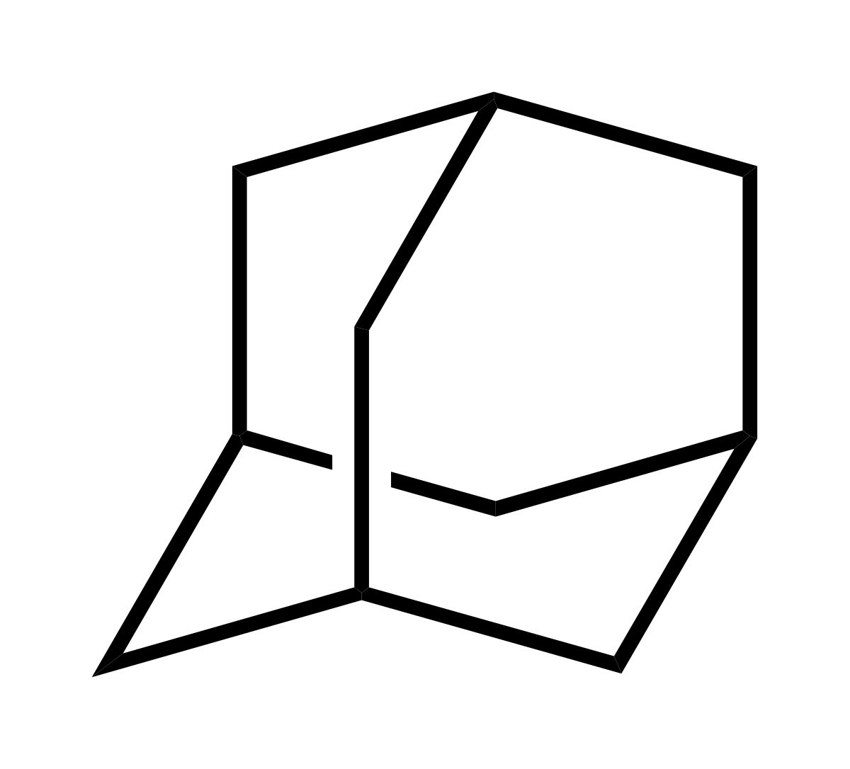
- C₂H₆ (staggered)
- C₂H₆ (eclipsed)
- CH₂Cl₂
- Adamantane
- Chair cyclohexane
- cis-SCl₂F₄
- A tennis ball
- Benzene
- Cyclobutane
- PtCl₄^{2–} (square planar)

What do you notice about the answers to L and M? Relate this to your answers to A and B for exercise 4.

