Interpreting the d⁶ Tanabe-Sugano diagram

The UV-Vis spectrum of a 0.0081 M solution of [Co(en)₃]I₃ is shown below. You will need a copy of the d⁶ Tanabe-Sugano diagram (https://en.wikipedia.org/wiki/Tanabe–Sugano_diagram).
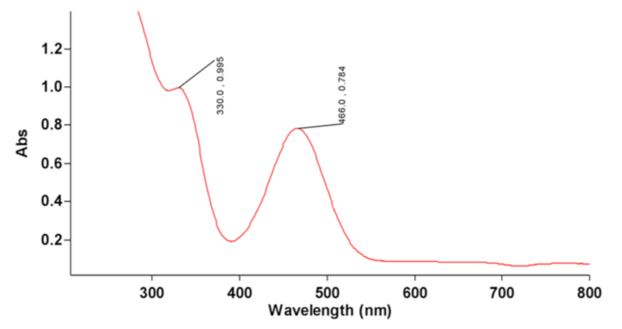
- What are the molar absorptivities of the absorptions at 330 and 466 nm?

- Based on the ε values, are these d-d transitions?

- Is this a high-spin d⁶ or a low-spin d⁶ complex? How do you know?

- What are the energies of the two bands in wavenumbers? What is their ratio (greater than one)?

- Let’s determine ∆_{o} for Co(en)₃³⁺. If you did part c correctly, you should find that the ratio of the two absorptions is 1.41, and the value where this holds is ∆_{o}/B ~ 39
  - What are the E/B values for the two lowest energy transitions (¹A_{1g} to ¹T_{1g} and ¹A_{1g} to ¹T_{2g}) when ∆_{o}/B = 39?

  - Use these values to determine B for each transition (to make sure you do the math correctly, E₁ is 30,300 cm⁻¹ and E₂ is 21,500 cm⁻¹).

  - What is the average B value?

  - Use this B value to determine ∆_{o}

