Activating H₂: Mechanisms for Catalytic Hydrogenation and Hydroborylation

Figure 1: One mechanism for catalytic hydrogenation.
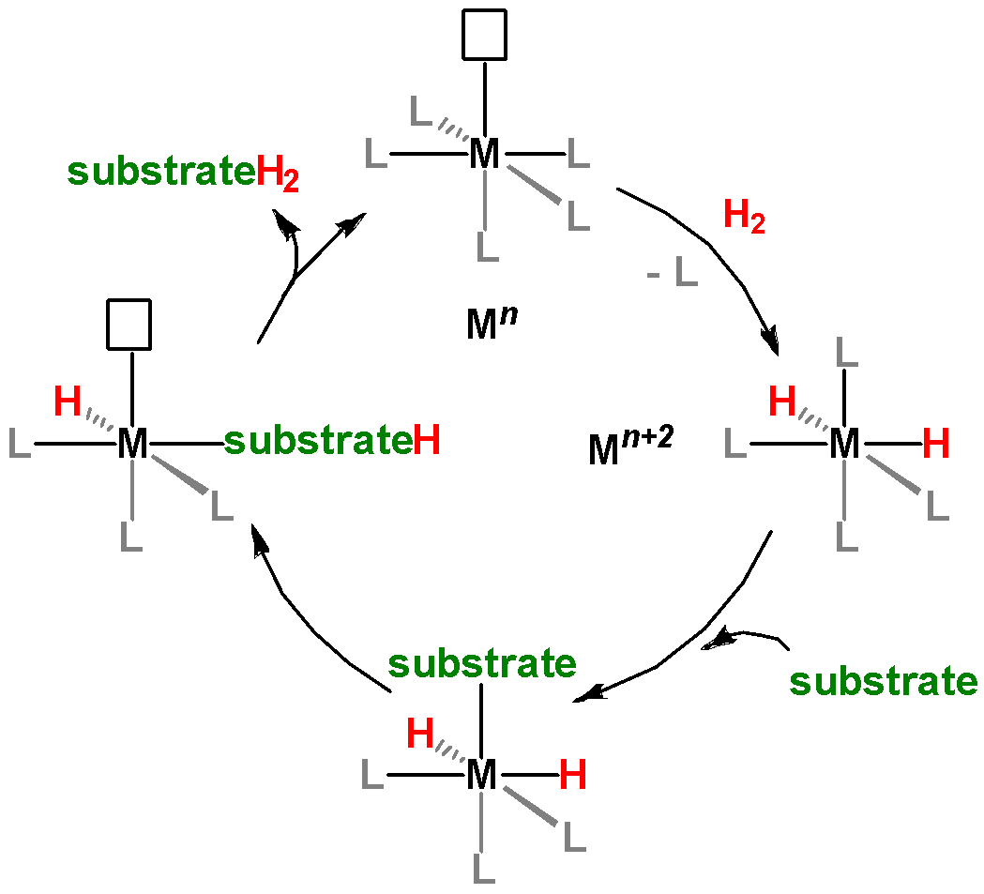
A

D
B

C

Q1. Compare structure A at the top of Figure 1 to structure B on the right (the first step in the cycle). What happens to H₂ upon addition to the metal?

Q2. Specify each of the oxidation states of the metal ion for each compound in Figure 1.

Q3. Based on your answers to Q1 and Q2, what common type of organometallic reaction is shown in the first step of Figure 1?

Q4. To which atom does the substrate bond when it is added in the second step of the cycle?

Q5. What has to happen to the substrate-H complex to regenerate the original compound (the fourth step in the cycle)? List at least two things.

Q6. How many coordination spots are occupied by H on each of the structures in the figure?

Figure 2: An alternative mechanism for catalytic hydrogenation.
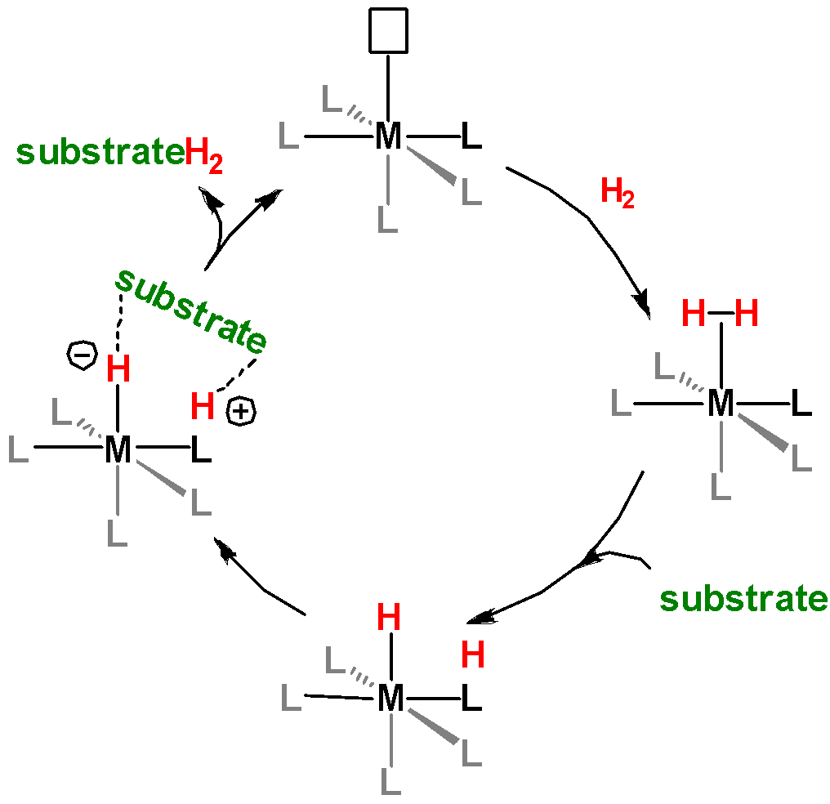
A

B
D

C

Q7: Compare structure A at the top of Figure 2 to structure B on the right (the first step in the cycle). What happens to H₂ upon addition to the metal?
Q8. Specify each of the oxidation states of the metal ion for all compounds in Figure 2.

Q9. Based on your answers to Q7 and Q8, what type of reaction is the first step?

Q10. Does the substrate bond directly to the metal in Figure 2? Explain.

Q11. How many coordination spots are occupied by H₂ in the figure (specifically, structure B)?

Q12. What happens to the M-H₂ substrate adduct to regenerate the original compound (the fourth step in the cycle)? List at least two things.

Q13. Notice that in structure C of Figure 2, partial charges are shown on the H atoms. Draw the interaction between these H atoms and the substrate, including on the substrate the dipole moment that would best interact here.

Q14. Draw a molecule with a double bond that contains the appropriate dipole moment for the interaction shown in the previous answer.

Q15. List the similarities and differences you observed between these two reaction mechanisms. [Hint: Include metal oxidation state, the role of the substrate, the role of the hydrides (M-H), and the coordination of H₂.]

Information: The two reaction mechanisms that you just analyzed are two of the possible ways that hydrogenation catalysts work on substrates. The reaction mechanism on Figure 2 is called an outer-sphere mechanism while that in Figure 1 is called an inner-sphere mechanism. Geoffrey Wilkinson developed an organometallic catalyst for hydrogenation where all of the substrates were coordinated to the metal center. This reaction mechanism is referred to as inner-sphere. Ryoji Noyori was awarded the 2001 Nobel Prize for the development of organometallic catalysts that promote chiral hydrogenation. The mechanism of this is known as outer-sphere. [Ref: http://www.nobelprize.org]

Q16. Given your understanding of the mechanisms which of the two will favor the hydrogenation of more polar substrates and which mechanism will favor less polar substrates? Provide an explanation.

17. For each substrate in the table, indicate which mechanism will be favored and provide a justification for your answer.

Substrate | Mechanism | Justification
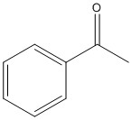
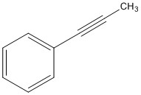
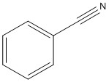
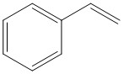

Figure 3. A catalytic hydroborylation reaction mechanism.
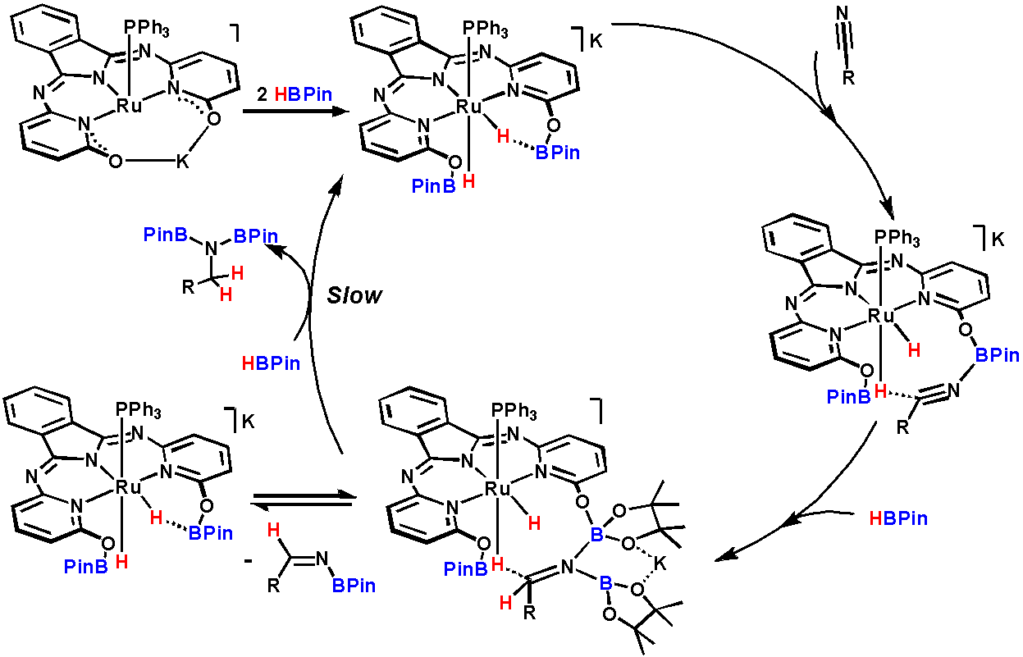

This reaction works very similarly to the hydrogenation reactions you just learned about.

Q18. What molecule in Figure 3. is equivalent to H₂ in the hydrogenation reactions?

Q19. What is the substrate for the reaction shown in Figure 3? (What is being hydrogenated?)

Q20. What is different about the shape of this catalytic cycle compared to the simpler catalytic cycles in Figures 1 and 2? (Don’t get into the details here just note what are the broad differences between the cycles.)

Q21. Describe what is happening in the reaction equilibrium shown at the bottom left of the scheme.

Q22. What do the complexes in brackets represent?

Q23. What type of mechanism is occurring in Figure 3? Give an explanation of how you know this.

Q24. What is the role of the HBPin? What is the analogous molecule for a regular outer-sphere hydrogenation mechanism?

Q25. What is the role of the HBPin during the reaction mechanism? What is the analogous molecule for a regular outer-sphere hydrogenation mechanism?

Q26. Borylated (BR₂) organic substrates can be key synthons for further organic functionalization reactions such as cross-coupling. Boranes and silanes can be similarly activated just like H₂. Assuming the BPin behaves as a proton, which double bond in the substrate molecule shown below do you predict will be reduced (hydroborylated)?
