Evidence of a homogeneous trinuclear Rh^{I}-Cu^{II}-Rh^{I} catalyst for benzene C-H oxidative addition and styrene production
Intro - Questions
1. In your own words, using information from the first paragraph of the Introduction, discuss the importance of C–C bond-forming reactions and the synthesis of alkyl and alkenyl arenes.
2. Using your organic chemistry textbook (specifically, the chapter on electrophilic aromatic substitution reactions), propose a two-step reaction sequence for the synthesis of styrene from benzene and ethylene. This will be a two-step reaction with the second involving the dehydrogenation of ethylbenzene. Name a use of styrene that is relevant to the Introduction of this paper.
3. The preparation of surfactants often requires C–C bond formation between alkyl and arene groups while maintaining linearity. These linear alkyl groups can contain 10-12 carbon methylene units. Suppose you want to make n-propylbenzene as an analogous precursor. a) Using your organic chemistry textbook, propose a reaction mechanism for the synthesis of n-propylbenzene (i.e., 1-phenylpropane) from propene and benzene. Hint: remember an alkyl halide must be generated first. b) Why can you not use the same synthetic approach as for ethylbenzene?
4. For the Friedel-Crafts alkylations and acylations (see question #3), describe some drawbacks (e.g., substrate scope, yield and environmental/sustainability concerns) to these reactions.
5. There are multiple C–C bond forming reactions that involve using Pd as a catalyst. One of these reactions is known as the Heck reaction. Illustrate how the Heck reaction could be used to produce styrene. Name at least one drawback to using this reaction based on your substrates (not catalyst) that you used.
6. What is the broad chemical problem the authors seek to address and what is the motivation?
7. Show the overall reaction between benzene and ethylene to produce styrene in the presence of molecular dioxygen. Use color coded atoms to distinguish what happens to the oxygen atoms and where the hydrogen atoms “move.”
8. Why is aerobic oxidation with dioxygen from air a potential advantage compared to alternative oxidants such as benzoquinone or copper(II) salts?
9. The organic reactions the authors are studying takes benzene and ethylene to form styrene. However, authors also need Rh and Cu(II) carboxylate for the reaction to proceed. What are they roles of the Rh and Cu in the reaction?
10. Draw the structure of complex 4, the proposed catalyst resting state. Define OPiv. How do the authors define complex 4 in the introduction?
11. Define catalyst resting state, olefin, catalyst precursor and active catalyst.
12. This paper is a continuation study on a catalytic system previously published by the Gunnoe group. What conclusions did they derive from this original study (see Summary and Conclusions in Reference 70)? What questions were still unanswered that prompted the experiments presented in the current paper?
15. In the Introduction, the authors state the key steps in the Rh-catalyzed production of styrene from benzene and ethylene: Rh-mediated C-H activation, reductive coupling, ethylene insertion, and β-H elimination. Label each of these steps on the calculated mechanism shown in Scheme 5.
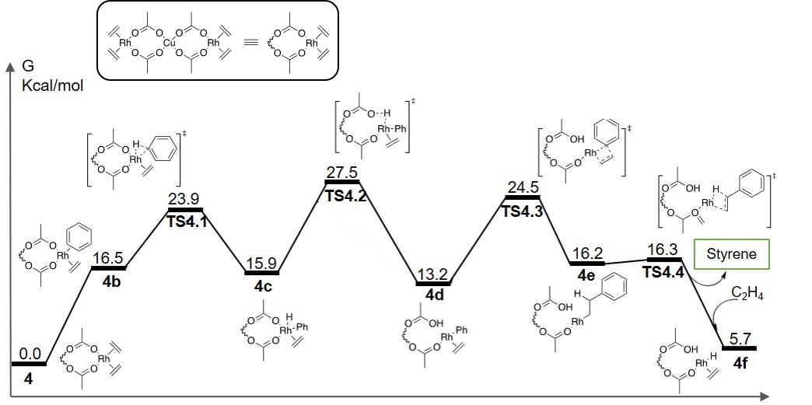

Results/Discussion/Experimental - Questions
1. Define turnover (TO), turnover number (TON), turnover frequency (TOF) and distinguish TO from TON.
2. Why did the authors study the catalytic reaction with complexes 1-3? What did they learn from each?
3. Using CBC to classify and count electrons for both Rh and Cu in 1, 4 and 2. What is the molecular geometry around the transition metals?
4. From your electron counts, which complexes are paramagnetic and which are diamagnetic? How does this impact using NMR spectroscopy for each?
5. Considering the X-ray crystallographic data, why would the C=C bond distance of coordinated ethylene in complex 4 be longer than the C=C bond distance of uncoordinated ethylene?
6. Derive the integrated first and second order rate laws, show how one obtains a rate constant for each respective rate law.
7. Define the Eyring equation (using outside resources). Rearrange the equation to show how activation parameters can be obtained using the plot in Figure 5B.
8. What was learned from the kinetic studies involving the conversion of 1 to 2?

Results/Discussion-Computational - Questions
1. Describe the general differences between a free energy of a reactant/product and free energy of activation.
2. Based on computational results in Scheme 4, what is the most thermodynamically stable complex? How does the experimental data support this?
3. Define rate-determining step and identify it on the free energy profile in Scheme 5.
4. Define oxidative addition and reductive elimination
5. From the paper, draw a reaction for benzene C–H oxidative addition to a square planar Rh(I) complex, similar to the H₂ oxidative addition.
6. Define reductive coupling and describe how it differs from reductive elimination.
7. Define concerted metalation deprotonation (CMD).
8. Compare and contrast oxidative addition and CMD.
9. Define 1,2-insertion and β-H (pronounced beta hydride) elimination.
10. Show the product of 1,2-ethylene insertion into a Rh–Ph bond followed by the product of β-H elimination.
11. What is a Mulliken charge and how was it used to help understand the differences in calculated transition states?
12. In the first step of the calculated mechanism, benzene coordination is described as being endergonic. What does this term mean?
13.The barrier to convert 4d to 4d’ is calculated to be 40.2 kcal/mol. Why does this value seem to disqualify 4d’ as a likely mechanistic step? Using the Eyring equation and the 40.2 kcal/mol barrier, calculate the time required for the reaction to go to completion at 150 °C. Using the excel spreadsheet (VIPEr LO Free Energy of Activation & Reaction Completion Times), calculate completion times at 150 °C using barriers of 10, 20, 30 and 50 kcal/mol.
14. How do the results from DFT modeling in Figure 7 support the proposed mechanism?

Conclusions - Questions
1. Did the authors provide enough data to support their overall claims?
2. Why did the author present the story in the format they chose, what were the benefits? What were the pitfalls?
3. In the present paper the authors are from three institutions/departments, which highlights the interdisciplinary nature of the chemical sciences. Look up the authors: Gunnoe in the Department of Chemistry at the University of Virginia, Goddard in the Department of Chemistry at Caltech, and Ellena in the Biomolecular Magnetic Resonance Facility at the University of Virginia. After reading the paper, how do you believe the authors contributed?
4. Why do you believe the authors chose the journal ACS Catalysis to publish this study?

