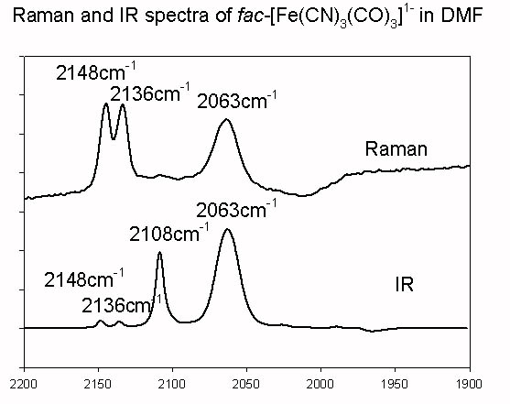
Figure II-19: IR and Raman spectra of fac-Na[Fe^{II}(CN)₃(CO)₃] in DMF

