The synthesis, characterization and catalytic activity of a copper complex containing a new ligand are described in this paper (Dalton Trans. 2020, 49, 6578). The catalyst is very effective in “click chemistry” at very low catalyst loading.

- The copper complex described in this paper is used to catalyze the formation of molecules with a particular structural motif. Draw a general structure for the products of interest in which you use R groups to represent positions that can be varied.

- The authors suggest a variety of reasons for preparing molecules of the general class in your answer to question 1. In your own words, what are significant roles for these products?

- The copper complex is used as a catalyst in “click chemistry”. What is click chemistry (you may need to use an additional source which you should cite).

- The ligand of interest in this study (1) is prepared in good yield in one step (Scheme 2). The ligand is described as being a Schiff base. What structural feature gives it this classification (you may need to use an additional source which you should cite).

- The structure of 1 is shown below. The authors mention that in the ¹H NMR spectrum of 1 “the azomethine proton showed a signal at 9.28 ppm”. Indicate where this proton is in 1. This chemical shift is reminiscent of what organic functionality?

- Also with regard to the ¹H NMR spectrum, the authors state that “The unsubstituted ferrocenyl ring showed the characteristic singlet due to five chemically equivalent protons at 4.00 ppm”. How can the five protons of the bottom five-membered ring be equivalent?

- Formation of the copper complex (2) occurs by the reaction of 1 with copper(II) acetate. Balance the reaction shown below including any additional product(s).

- A slightly different perspective of the crystal structure of 2 is presented below. What is the point group of this molecule?

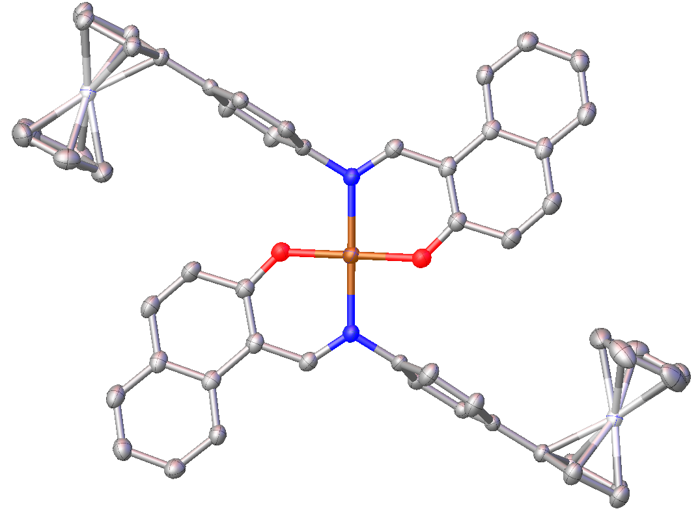

- IR data for compound 2 is given in the experimental section and five total peaks are listed. While not assigned by the authors, the peak at 1599 cm⁻¹ is the C=N vibration. Why is there only one peak for this as there are two C=N groups in the molecule? You should use group theory to contribute to your rationalization of this observation.

- Compounds 1 and 2 were studied by cyclic voltammetry. Both compounds displayed a single wave indicating the removal of a single electron. What is the difference in the redox potential for these two compounds in Volts? Explain the rationale behind the author’s statement that “The higher positive reduction potential of 2 is due to the complexation of 1 with the Cu²⁺ ion”.

- Classify compound 2 using CBC ML_{l}X_{x}Z_{z} classification, determine the ligand bond number, the valence and the d^{n} count for the two different metal centers present in the molecule.

- The d-orbital splitting patterns for the copper and iron centers are shown below. Fill in the diagrams with the proper number of electrons for each metal center. You can assume the complexes are low-spin.

Copper | Iron

- How does your answer to question 12 explain the description of the ¹H NMR spectrum of compound 2?

- The frontier molecular orbitals in this molecule are likely metal based, meaning the oxidation could occur at either the copper or iron center. Based on your answer to the previous question, which electron would be removed if oxidation occurred at the copper center? Which electron would be removed if oxidation occurred at an iron center?

- How did the authors rationalize the oxidation of compound 2 is more iron based?

- The catalytic reaction of benzyl azide and phenyl acetylene was studies under a variety of conditions. In addition to the inclusion of compound 2 in the reaction mixture, sodium ascorbate is added to the reaction. What role does the sodium ascorbate play in the reaction? Specifically indicate how it interacts with compound 2.

- Based on the following Latimer diagram, provide a rationale with numerical support as to why this reduction is conducted in situ as opposed to just isolating the copper(I) compound.

- A total of 21 different catalytic reactions are reported in Table 1. Briefly comment on what the changes being made and the conclusions that can be drawn from the following groups of experiments.

  - Entry 1-15

  - Entry 15-18

  - Entry 19-21

- In Table 2, the authors continue to push the limits of catalyst loading in this reaction. This table presents catalyst loadings from 1000 to 5 ppm. What general trend is observed? What do you think the optimal catalyst loading is and why?

- Table 2 also presents columns labeled TON and TOF. These acronyms are defined in the abstract. Without detailed calculations (although you are welcomed to provide them) describe how these numbers were arrived at and their significance.

- Table 3 presents a substrate scope scheme in which the authors investigated the effectiveness of their catalyst with other reactants. Entry 3a is the same product as was detailed in Tables 1 and 2, so there are 19 new compounds in this list. One of these 19 compounds could be useful in additional studies with this catalytic system. Which compound might that be and what might you consider studying? To be clear, you are not to change R and Rʹ in the reactions presented, although there is certainly the potential to do that.

