**Single Point Energies and Geometry Optimizations**

Students will be able to:

1. Calculate and visualize the potential energy surface of a diatomic molecule.
2. Calculate and visualize the energy changes in a small molecule during bending.
3. Calculate and visualize the changes in energy when a small molecule undergoes conformational changes.

**Exercise 1 – Potential Energy Surface of Bond Stretching in Dinitrogen**

Build a molecule of N2 (triple bond).  Perform a geometry optimization using PM3 (Job Name: N2 PM3) using Gaussian or Mopac. When the calculation is finished, click on the filename name to open the View Job window. Determine the bond length by clicking on the “Adjust” icon on the left (it looks like a cursor arrow), then clicking sequentially on each nitrogen atom. The bond length is displayed at the bottom of the window. Record the bond length: _________ Å (literature, 1.098Å).

Click on New Job Using This Geometry at the bottom of the window. Choose Tools > Edit Z-matrix. To the left of the bond length, select “S” from the pull down menu, then type in the values for Start, Stop, and # Steps shown below. We will calculate the energy of the molecule every 0.05 Å between the limits we have set.

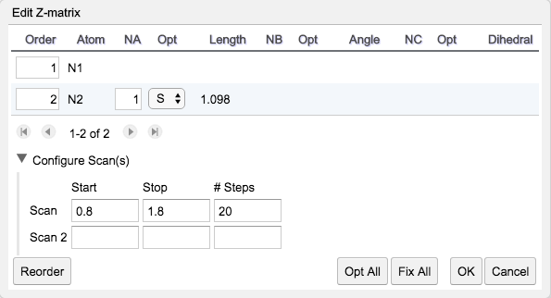

Click OK, which closes the Z-matrix window. You will notice that one of the bonds is now gold colored. That indicates which atoms you have selected for your coordinate scan. Click the blue continue arrow. Choose the same engine used before. Choose/Type in the following:

Job Name: N2 Scan

Calculation: Coordinate Scan

Theory: PM3

Charge: 0

  Multiplicity: Singlet

Click the blue continue arrow. When the job is complete, open the file and scroll down to the Coordinate Scan data. Click on the magnifying glass in the title bar. On the graph that appears, hover the cursor over the lowest energy point. Record the coordinate values shown above the graph (top right). ____________________________

Scroll back down to the Coordinate Scan data. Click on the filmstrip to view a video of the coordinate scan you have performed. At the left of the window there are animation control arrows. Rewind and play the animation again. Practice stepping through the animation and note how the values at the bottom of the window change (Coordinate and Energy). There are tabs at the top of the window where you can toggle back and forth between the Data Viewer and Molecule Viewer.

Describe the curve. Why is it shaped like that? Compare it to the potential energy curve for H2 you learned about in general chemistry.

**Exercise 2 – Potential Energy Surface of Bond Angle Bending in Water**

Build a molecule of H2O.  Perform a geometry optimization using PM3 (Job Name: H2O PM3) using Gaussian or Mopac.  Record the HOH bond angle: ________ (literature, 103.9°).

Click on New Job Using This Geometry. Choose Tools > Edit Z-matrix. To the left of the bond angle, select “S” from the pull down menu, then type in the values for Start, Stop, and # Steps shown below. We will calculate the energy of the molecule every 0.5° between the limits we have set. Click OK. Notice that both of the bonds are now gold, indicating which atoms you have selected for your coordinate scan.

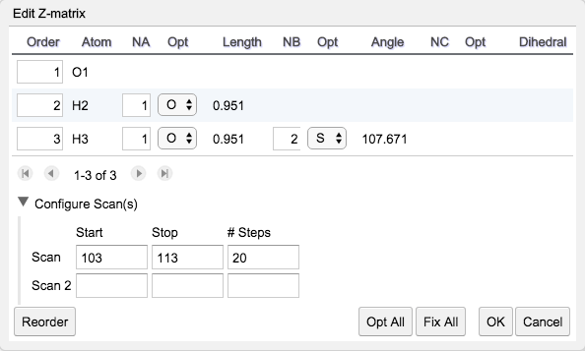

Click the blue continue arrow. Choose the same engine used above.

Choose/Type in the following:

Job Name: H2O Scan

Calculation: Coordinate Scan

Theory: PM3

  Charge: 0

  Multiplicity: Singlet

Click the blue continue arrow. When the job is complete, open the file and scroll down to the Coordinate Scan data. Click on the magnifying glass in the title bar. On the graph that appears, use your mouse and place the cursor on the lowest energy point. Record the coordinate values shown above the graph (top right). __________________________

Describe the curve. Why do you think it has that shape?

Scroll back down to the Coordinate Scan data. Click on the filmstrip to view a video of the coordinate scan you have performed.

**Exercise 3 – Determining the Optimum Structure for Ethenol (Vinyl alcohol)**

Build a model of ethenol by drawing the C=C-O backbone, followed by cleaning up with the paintbrush. The model builder will generate one of the two structures shown.

**I II**



Click the Adjust tool (looks like a cursor arrow). Define a dihedral angle by clicking on the hydroxyl H atom and, in turn, the O-C=C atoms. Choose Tools > Edit Z-matrix. In the pull down menu next to the dihedral angle, chose “S” and type in the Start, Stop, and # Steps as shown below. (Hint: Be sure to use the atom numbers to help find the dihedral angle of interest).

Click OK in the Z-matrix Editor. If you selected the correct angle, the bonds between those atoms should now be gold.

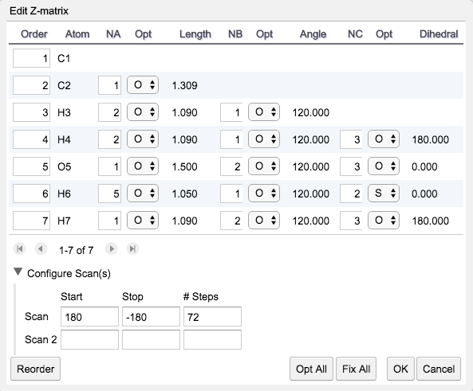

Click the blue continue arrow. Choose Gaussian or Mopac as the engine.  Choose/Type in the following:

Job Name: C2H4O Scan

Calculation: Coordinate Scan

Theory: PM3

Charge: 0

Multiplicity: Singlet

Click the blue continue arrow. When the job is complete, open the file and scroll down to the Coordinate Scan data. Click on the magnifying glass in the title bar.  On the graph that appears, use your mouse to record the energies of (viewing the animation will help you figure this out):

Conformer **I** _________kcal mol-1

Conformer **II** __________ kcal mol-1

and the barrier __________kcal mol-1.

Which conformer is more stable? _______

Vinyl alcohol is not very stable. What molecule does it rearrange to? ­­­­­­­_______________