Guided reading and in-class discussion questions for "High-Spin Square-Planar Co(II) and Fe(II) Complexes and Reasons for Their Electronic Structure"

Prior to coming to class, read the following paper and answer the “Guided Reading Questions”.

Stefanie A. Cantalupo, Stephanie R. Fiedler, Matthew P. Shores, Arnold L. Rheingold, and
Linda H. Doerrer, “High-Spin Square-Planar Co^{II} and Fe^{II} Complexes and Reasons for
Their Electronic Structure”, Angew. Chem. Int. Ed. 2012, 51, 1000 –1005.

https://doi.org/10.1002/anie.201106091

Guided Reading Questions:
- Why are high-spin square-planar complexes rare?

- Draw the complete Lewis Structure for H₂ddfp. All electrons and bonds must be clearly shown.

- (a) What kind of donor properties (π-donor, σ-donor, π-acceptor) do you expect for [ddfp]²⁻ and why?
(b) How will the donor properties in [ddfp]²⁻ compare to the non-fluorinated analog of the ligand?

- Write out the d-electron counts for the Co(II), Fe(II), and Zn(II) metal products shown in equation 1.

- Study the slides on τ parameters.
https://www.ionicviper.org/system/files/ALF_VIPEr_5slides_GeometryIndices_v2.pdf

Explain how the τ ₄ parameter is calculated and why this parameter is important.
Report the τ ₄ values for the four coordinate complexes for complexes 1, {K(DME)₂}₂[Co(ddfp)₂] and 2, {K(DME)₂}₂[Fe(ddfp)₂] and 3, {K(DME)₂}₂[Zn(ddfp)₂] explain what the reported τ ₄ values tell you about the structure.

- Based on the crystal structure of 1, the [ddfp]²⁻ ligands appear puckered while an idealized structure of 1 is planar. Assign the point group of 1 with puckered and planar [ddfp]²⁻ ligands. (trifluoromethyl groups were omitted for clarity).
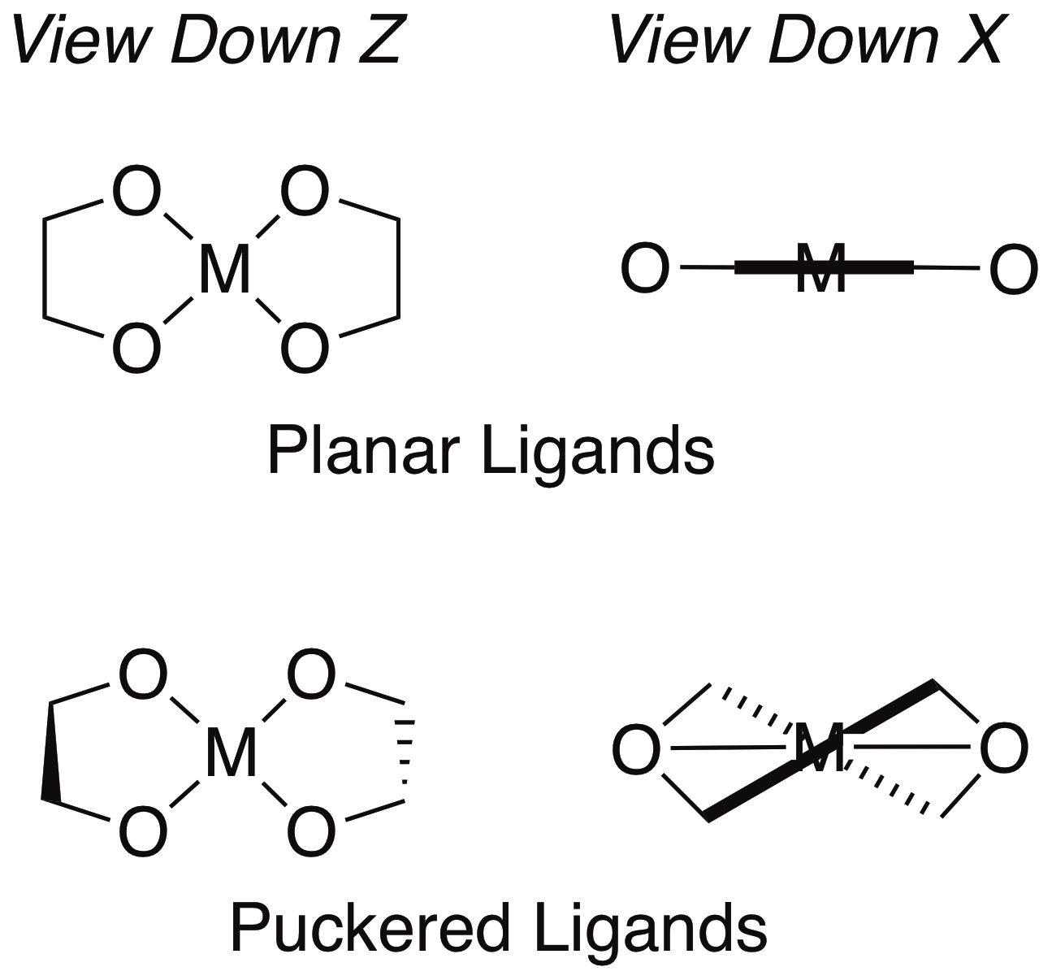

- Based on the solution magnetic moment data for 1, {K(DME)₂}₂[Co(ddfp)₂] and 2, {K(DME)₂}₂[Fe(ddfp)₂] the authors claim that both complexes are high spin, with approximately D_{2h} symmetry. Refer to the d-orbital splitting diagram for D_{2h} symmetry in Scheme 2.

  - Calculate the spin-only magnetic moment values for 1 and 2, assuming a high-spin electron configuration.

  - Calculate the spin-only magnetic moment values for 1 and 2, assuming a low-spin electron configuration.

c. Compare your calculated values to those reported in the paper, and comment on the author’s spin state assignments.

- Consider an octahedral metal complex. Based on ligand field theory, explain why Δ_{o} is significantly larger for a complex with Pi-acceptor ligands than one with Pi-donor ligands.

In-Class Discussion Questions

- Explain the difference between a Laporte-forbidden and Laporte-allowed UV-Visible transition.

- Explain why T_{d} metal complexes have higher molar absorptivities than O_{h} metal complexes?

- Based on the cyclic voltammetry spectra, how do we know that the redox features are metal based?

- Explain and rationalize why there will be a Jahn-Teller distortion for complex B which consists of a Fe(II) complex?

- Consider Scheme 2, which illustrates the change in d-orbital splitting upon reduction of symmetry.
  - Rationalize the change in d-orbital splitting with only σ-donation, upon decreasing the symmetry from O_{h} to D_{4h}, by removal of ligands along the z-axis. (Changing from a six-coordinate, octahedral complex to a four-coordinate, square-planar complex).

  - Why does the energy of the d_{xz} and d_{yz} orbitals increase upon introduction of Pi-donation in the D_{4h} geometry?

  - What causes the d_{xz} and d_{yz} orbitals to become nondegenerate when the symmetry is lowered to D_{2h}?

  - Why is the energy of the d_{xz} higher than the d_{yz} orbital?

7. How do the ligand properties in low spin complex A differ from the other high spin compounds (1, 2, and B)? How does this explain the difference in observed spin states?

8. What are the ligand features which contribute to the tendency of the rare formation of high-spin square-planar complexes?

