***Hydroformylation (Oxo) Catalysis***

Created by George G. Stanley, Department of Chemistry, Louisiana State University (gstanley@lsu.edu) and posted on VIPEr on August 14, 2017. Copyright Geroge G. Stanley, 2017. This work is licensed under the Creative Commons Attribution-NonCommercial-ShareAlike CC BY-NC-SA. To view a copy of this license visit {http://creativecommons.org/licenses/by-nc-sa/4.0/}.



**\* *Largest homogeneous catalytic process***

**\* *> 15 billion pounds of aldehydes (alcohols) per year***

**\* *Commercial catalysts are complexes of Co or Rh***

**\* *Selectivity to linear (normal) or branched (iso)   
products is important***

Insert picture of Otto

Roelen here

[http://lib.convdocs.org/docs](http://lib.convdocs.org/docs/index-269794.html)

[/index-269794.html](http://lib.convdocs.org/docs/index-269794.html)

Otto Roelen (1897-1993)

Hydroformylation was discovered by Otto Roelen in 1938 during an investigation of the origin of oxygenated products occurring in cobalt catalyzed Fischer-Tropsch reactions. Roelen's observation that ethylene, H2 and CO were converted into propanal, and at higher pressures, diethyl ketone, marked the beginning of hydroformylation.

Cobalt catalysts completely dominated industrial hydroformylation until the early 1970's when rhodium catalysts were commercialized. In 2004, ~75% of all hydroformylation processes are based on rhodium triarylphosphine catalysts, which excel with C8 or lower alkenes and where high regioselectivity to linear aldehydes is critical.

Most aldehydes produced are hydrogenated to alcohols or oxidized to carboxylic acids. Esterfication of the alcohols with phthalic anhydride produces dialkyl phthalate plasticizers that are primarily used for polyvinyl chloride plastics -- the largest single end-use. Detergents and surfactants make up the next largest category, followed by solvents, lubricants and chemical intermediates.

**HCo(CO)**4 **Catalyst.** Roelen's original research into hydroformylation involved the use of cobalt salts that, under H2/CO pressure, produced HCo(CO)4 as the active catalyst. In 1960 and 1961 Heck and Breslow[1],[2] proposed what is now accepted as the general mechanism for hydroformylation:

Insert picture of Richard

Heck here.

[https://en.wikipedia.org/wiki/](https://en.wikipedia.org/wiki/Richard_F._Heck)

[Richard_F._Heck](https://en.wikipedia.org/wiki/Richard_F._Heck)

Richard Heck (1931-2015)



An alternate bimetallic pathway was also suggested, but not favored, by Heck and Breslow. The acyl intermediate could react with HCo(CO)4 to do an ***inter***molecular hydride transfer, followed by reductive elimination of aldehyde producing the Co‑Co bonded dimer Co2(CO)8. A common starting material for HCo(CO)4 catalyzed hydroformylation, Co2(CO)8 is well known to react with H2 under catalysis reaction conditions to form two equivalents of HCo(CO)4. The bimetallic hydride transfer mechanism is operational for stoichiometric hydroformylation with HCo(CO)4 and has been proposed to be a possibility for slower catalytic hydroformylation reactions with internal alkenes.[3] The mono­metallic pathway involving reaction of the acyl intermediate with H2, however, has been repeatedly shown to be the dominant mechanism for 1‑alkenes and cyclohexane.[4],[5]



Kinetic studies support the HCo(CO)4 mechanism with a general rate expression given above. The inverse dependence on CO pressure is consistent with the mechanistic requirement for CO dissociation from the various saturated 18e species to open up a coordination site for alkene or H2 binding. When using a 1:1 ratio of H2/CO, the reaction rate is essentially independent of pressure due to the opposing orders of H2 and CO. Increasing the H2/CO ratio is of limited use for increasing the overall reaction rate because HCo(CO)4 is only stable under certain minimum CO partial pressures at a given temperature.

The reaction conditions for HCo(CO)4 hydroformylation are largely governed by the thermal instability of HCo(CO)4, which produces metallic cobalt if the CO partial pressure is **not** kept high enough. As the reaction temperature is increased, the CO partial pressure required to maintain the stability of HCo(CO)4 increases in a logarithmic fashion (Fig. 1). Thus, the temps needed for reasonable reaction rates (110-180° C) require rather high CO partial, and hence, total H2/CO pressures of 200-300 bar.



**Figure 1.** Stability of HCo(CO)4/Co2(CO)8 species with respect to precipitation of cobalt metal (cobalt concentration is 0.4 wt. %).

*Increasing* the CO partial pressure *decreases* the hydroformylation reaction rate and the amount of alkene isomerization side reactions, while *increasing* the aldehyde linear to branched product ratio. Pino proposed that the apparent marked difference between HCo(CO)4 catalyzed hydroformylation at low and high CO partial pressures was due to the existence of two active catalyst species, HCo(CO)4 and HCo(CO)3, formed from the CO association/dissociation equilibrium:

HCo(CO)3 + CO  HCo(CO)4

But the active catalyst is most likely the 16e- HCo(CO)3 complex. The low probability of direct alkene reaction with the 18e- saturated HCo(CO)4 catalyst is consistent with the reduced activity at higher CO partial pressures. One can also explain the lower regioselectivity at lower CO pressure by proposing that alkene isomer­ization is more facile with the resulting 16e- RCo(CO)3 species that results after reaction with alkene as shown below:



Under lower CO partial pressures an unsaturated 16e- RCo(CO)3 will have a long enough lifetime to allow reverse -hydride elimination and increase the possibility for alkene reinsertion to the branched alkyl species, which is slightly more favored thermodynamically. At this point CO addition and insertion will yield a branched aldehyde, or another -hydride elimination can give alkene isomerization. This second mechanistic explanation is in line with more recent results from Rh/PPh3 catalyzed hydroformylation studies.

The regioselectivity of HCo(CO)4 (or HCo(CO)3) for producing the more valuable linear aldehydes varies with reaction conditions and alkene substrates used. With 1-alkenes one can typically get linear to branched aldehyde ratios of 3-4 to 1. There is a trade-off between rate and regioselectivity. High CO partial pressure slows the rate of catalysis, but increases the linear to branched aldehyde product ratio. Higher CO partial pressures also lower alkene isomerization side reactions. Higher temperatures increase the reaction rate, but lower the linear aldehyde product regioselectivity and increase various undesirable side reactions. Some aldehyde hydrogenation to alcohols is usually observed (5-12%), although alkene hydrogenation is usually quite low (~ 1%), particularly under higher CO partial pressures. Aldehyde hydrogenation is *not* considered to be a negative side reaction because the aldehyde products are usually hydrogenated to alcohols in a later reaction step. The aldehyde hydrogenation, however, consumes additional H2, so H2/CO ratios greater than 1:1 are used (1-1.5:1 is common).

High linear product regioselectivity is not, however, the major concern for most HCo(CO)4 catalyzed industrial plants. What is now Exxon Chemical Co. built the first United States hydroformylation plant in 1948 in Baton Rouge, LA using the high pressure HCo(CO)4 technology confiscated from the Germans after WWII. This plant produced over 540 million lbs of alcohols each year, and a new plant came on line in 1994 which pushed the capacity to over 800 million lbs of alcohols a year. Exxon uses propylene dimerization/oligomerization to produce a C7 to C12 mixture of branched internal alkenes. This branched, internal alkene mixture is then hydroformylated and hydrogenated to a C8 to C13 alcohol mixture. The alkene isomerization ability of HCo(CO)4 is quite important in this situation. HCo(CO)4 under the proper reaction conditions is good at isomerizing double bonds to essentially all possible locations. This can be clearly seen from the data shown below that shows the % of aldehyde formed at each site for the HCo(CO)4 catalyzed hydroformylation of 1-octene and 4-octene (150° C/200 bar 1/1 H2/CO).[6]



Under these conditions, the linear to branched aldehyde ratio for the hydroformylation of 1‑octene was 1.9:1. Starting with 4-octene one still gets a 1.2:1 linear to branched ratio. Thus, one can start with a considerably less expensive mixture of terminal and internal alkenes and get a product distribution favoring the linear aldehyde. The product distribution above can be nicely explained by invoking facile alkene isomerization with the fastest hydroformylation occurring for double bonds in the 1-position. Labeling studies have shown that alkene isomerization generally occurs without dissociation of the alkene from the cobalt catalyst.[7]

Alkene branching has a large effect on isomerization and hydroformylation. In a study of various methyheptenes, Haymore found that there was very little hydro­formylation at the carbon center with the branch, even if it was part of the double bond. Data for two methylheptenes and % of aldehyde formed at each site is shown below.[8] Note that isomerization past the branching carbon is not a dominant reaction. Once again, terminal aldehydes are favored.



Side reactions of the product aldehydes to form heavier products generally occur, particularly at higher reaction temperatures, and usually account for ~ 9% of the product distribution. Aldol condensations, aldols, trimerizations, and Guerbet dimerizations of product alcohols are some of the more common ways to form heavy byproducts. These side reactions occur to various extents for all long term hydro­formy­lations (Co or Rh). Although industrial reactors are usually started with high boiling solvents, after a while these heavy “ends” become the main solvent system for the reaction.



One advantage of the HCo(CO)4 technology is that catalyst separation and recycling is well established. BASF oxidizes HCo(CO)4 with O2 to form water soluble Co2+ salts that are extracted from the product stream. These Co2+ salts are recycled and reduced under H2/CO to reform HCo(CO)4. Exxon uses aqueous NaOH to deprotonate HCo(CO)4 after catalysis to make Na[Co(CO)4], which is extracted into an aqueous stream. The active HCo(CO)4 catalyst is regenerated via use of H2SO4 and H2/CO.

**Cobalt Phosphine-Modified Catalysts.** The only variation on HCo(CO)4 hydroformylation catalysis involved research at Shell by Lynn Slaugh and Richard Mullineaux in which the addition of trialkylphosphine ligands caused a dramatic change in the rate and regioselectivity.[9] The electronic effect of substituting an electron donating alkylated phosphine for one of the carbonyl ligands to produce HCo(CO)3(PR3), results in stronger Co-CO bonding. This causes a dramatic reduction in the CO partial pressures required to stabilize the catalyst and prevent formation of Co metal. Instead of 200-300 bars of H2/CO pressure needed for HCo(CO)4, the monophosphine substituted HCo(CO)3(PR3) only needed 50-100 bars of pressure, and could be run at higher temperatures without any decomposition of catalyst to cobalt metal.

Another electronic effect is that the electron-donating phosphine increases the hydridic nature of the hydride ligand (HCo(CO)4 is quite acidic) and dramatically increases the hydrogenation capabilities of the HCo(CO)3(PR3) catalyst. This means that the aldehydes produced are subsequently hydrogenated by HCo(CO)3(PR3) to make alcohols. Less e-rich phosphines, such as PPh3, give less hydrog­enation to alcohol, and lower linear regioselectivities. The better hydrogenation ability, how­ever, also results in increased alkene hydrog­enation side-reactions producing alkanes that can range from 10-20% of the product distribution (depending on the phosphine and rxn conditions). Because of the aldehyde hydrogenation step more H2 is needed, so H2/CO ratios of 2:1 (or slightly higher) are typically used. The proposed hydro­formylation and hydrog­enation mechanisms are both shown below.



The final electronic effect of phosphine substitution is that the higher stability of the HCo(CO)3(PR3) catalyst, due to stronger Co-CO bonding, means that this catalyst is less active than HCo(CO)4 (about 5-10 times slower). Just as with the unmodified cobalt catalyst, CO dissociation from the saturated 18e- species is needed to open up an empty coordination site on the cobalt to allow coordination of alkene and H2. Higher reaction temperatures, therefore, are used in conjunction with longer reaction times and larger reactor volumes.

From a steric viewpoint the bulkier trialkylphosphine ligand favors formation of linear products. While linear to branched ratios of only 2-3:1 are typically found for HCo(CO)4, higher regioselectivities of 7-8:1 occur for HCo(CO)3(PR3). There is a phosphine cone angle cutoff at about 132°, after which the phosphine ligand's steric effects do not increase the product linear regioselectivity any further.

**Table 1. Hydroformylation of 1-hexene using Co2(CO)8/2P as catalyst precursor. 160°C, 70 atm, 1.2:1 H2/CO**

|  |  |  |  |  |  |  |
| --- | --- | --- | --- | --- | --- | --- |
| **PR3** | **pK*a*** | **Tolman  (cm-1)** | **Cone Angle °** | **k*r* x 103 (min-1)** | **%  Linear Prod** | **Aldehyde to alcohol** |
| P(*i*-Pr)3 | 9.4 | 2059.2 | 160 | 2.8 | 85.0 | -- |
| PEt3 | 8.7 | 2061.7 | 132 | 2.7 | 89.6 | 0.9 |
| PPr3 | 8.6 | 2060.9 | 132 | 3.1 | 89.5 | 1.0 |
| PBu3 | 8.4 | 2060.3 | 136 | 3.3 | 89.6 | 1.1 |
| PEt2Ph | 6.3 | 2063.7 | 136 | 5.5 | 84.6 | 2.2 |
| PEtPh2 | 4.9 | 2066.7 | 140 | 8.8 | 71.7 | 4.3 |
| PPh3 | 2.7 | 2068.9 | 145 | 14.1 | 62.4 | 11.7 |

Note that the facile dissociation of PPh3 essentially generates the more active and less regioselective HCo(CO)4 catalyst system in the table above.

Phosphine modified cobalt hydroformylation is only used by Shell. It is tightly coupled to *Shell’s Higher Olefins Process* (SHOP) that produces a C4 through C20 blend of linear, internal alkenes for hydroformylation to detergent grade alcohols. Exact details of Shell’s commercial process have never been published. For example, the specific trialkylphosphine used is not widely known outside of Shell. They do NOT use PBu3 as it is too volatile.

**Rhodium Phosphine Catalysts.** In 1965 Osborn, Young and Wilkinson reported that Rh(I)-PPh3 complexes were active and highly regioselective hydroformylation catalysts for 1‑alkenes, even at ambient conditions. Although Slaugh and Mullineaux had filed a patent in 1961 that mentioned Rh/phosphine combinations for hydroformylation, it was Wilkinson's work that really ignited serious interest in rhodium phosphine hydroformylation catalysts. The initial catalyst system was derived from Wilkinson's catalyst, RhCl(PPh3)3, but it was rapidly discovered that halides were inhibitors for hydroformylation. It was best, therefore, to start with halide-free rhodium starting complexes. HRh(CO)(PPh3)3 and Rh(acac)(CO)2 (acac = acetoacetonate) are two commonly used starting materials for hydroformylation. The currently accepted mechanism for Rh/PPh3 hydro­formylation is shown below. The steps are directly analogous to Heck’s mechanism for HCo(CO)4.

**Rh/PPh3 Hydroformylation Cycle**



Wilkinson noted that HRh(CO)(PPh3)2 was very selective to aldehyde products (no alcohol formation, no alkene hydrogenation or isomerization) and that very high linear to branched aldehyde selectivities of 20:1 for a variety of 1‑alkenes could be obtained under ambient conditions (25° C, 1 bar 1:1 H2/CO). At higher temperatures, the rate increased, but the regioselectivity dropped (9:1 at 50° C). Running under 80-100 bars of H2/CO decreased the linear to branched aldehyde selectivity to only 3:1.

Roy Pruett (at Union Carbide) quickly provided the next critical discovery that, along with the work of Booth and coworkers at Union Oil, allowed commercialization of the HRh(CO)(PPh3)2 technology. They found that the use of rhodium with excess phosphine ligand created an active, selective, and stable catalyst system at 80-100 psig and 90° C.[10] Union Carbide, in conjunction with Davy Powergas and Johnson Matthey, subsequently developed the first commercial hydroformylation process using rhodium and excess PPh3 in the early 1970's. The need for excess phosphine arises from the facile Rh-PPh3 dissociation equilibrium shown below. Loss of PPh3 from HRh(CO)(PPh3)2 generates considerably more active, but ***less*** regioselective hydroformylation catalysts. The addition of excess phosphine ligand shifts the phosphine dissociation equilibrium back towards the more selective HRh(CO)(PPh3)2 catalyst. This explains why higher CO partial pressures lower the product regioselectivity, in marked contrast to what is observed for HCo(CO)4-catalyzed hydroformylation.



The regioselectivity of HRh(CO)(PPh3)2 is strongly related to the concentration of PPh3 in solution (up to a certain point) and the H2/CO ratio used. Commercial hydroformylation reactions are run using solutions that have PPh3 concentrations of 0.3 M or higher (typical Rh concentration around 1 mM). This corresponds to PPh3 weight percentages of 8-50% of the total solution in commerical reactors. The effect of PPh3 concentration on the rate and selectivity for the hydroformylation of 1-hexene can be seen in Table 2.

**Table 2.** Rate constants and Regioselectivities for the Hydroformylation of 1-Hexene using Rh(acac)(CO)2 with Different PPh3 Concentrations. Reaction Conditions: 90 psig (6.2 bar), 1:1 H2/CO, 90° C.

|  |  |  |  |  |
| --- | --- | --- | --- | --- |
| **[Rh] (mM)** | **[PPh3] (M)** | **PPh3/Rh ratio** | **k*obs*  (min-1 mM Rh-1)** | **l:b  ratio** |
| 0.5 | 0.41 | 820 | 0.032 | 11 |
| 1 | 0.82 | 820 | 0.016 | 17 |

Note that doubling the PPh3 concentration cuts the rate constant in half, even though the rhodium concentration was also doubled! The selectivity, on the other hand, increases to 17:1 for the C7 aldehyde linear to branched ratio. The "ultimate" experiment of running HRh(CO)(PPh3)2 in molten PPh3 has been done with propylene giving a 16:1 linear to branched aldehyde ratio. Commercially, propylene is run with PPh3 concentrations around 0.4 M with a catalyst concentration of about 1 mM (400 fold excess of PPh3), which gives a linear to branched selectivity of ~8-9:1. Lower CO partial pressures also would be expected to favor higher regioselectivities, and this is indeed the case. Rh/PPh3 reactions are often run with an excess of hydrogen (1.2:1 H2/CO ratios are common). Too high a hydrogen partial pressure, or too low a CO partial pressure, however, will increase the alkene hydrogenation and isomerization side reactions to an unacceptable level.

The rate determining step in Rh/PPh3 not fully understood. It was assumed early on in analogy to the HCo(CO)4 catalyst system, that the rate determining step was H2 addition to the Rh(I)-acyl species. This has been disputed by several authors in more recent studies. Kastrup and coworkers concluded from 31P NMR studies that the rate determining step could be the initial coordination of alkene to the HRh(CO)(PPh3)2 catalyst species.[11] Moser and coworkers, in a similar vein, proposed that the rate determining step is CO dissociation from HRh(CO)2(PPh3)2 to once again generate the 16e species HRh(CO)(PPh3)2.[12] Combining both of these proposals, Unruh concluded that several of the fundamental steps in Rh/PPh3 hydroformylation appear to have similar rate constants, making it difficult to specify one overall rate determining step, as they may probably vary with the exact reaction conditions. The complexity of the phosphine/CO ligand dissociation/association processes and the many catalytically active rhodium complexes present was most clearly pointed out by Tolman and Faller who presented a 3-dimensional mechanistic scheme for the hydroformylation of alkenes by Rh/PPh3 complexes.[13] The mechanism shown here only indicates the core catalytic cycle that is believed to give the highest product aldehyde regioselectivity.

The other important reason for adding excess phosphine ligand is to minimize ligand fragmentation reactions that lead to catalyst deactivation. If a 14e, highly unsaturated species such as HRh(CO)(PPh3) is formed the very electrophillic metal center can attack the PPh3 ligand (either intra- or intermolecularly). This leads to cleavage of the P-Ph bond and formation of either alkyldiphenyl phosphines or, in the worst case, phosphide-bridged dimers which are inactive for hydroformylation:



This fragmentation process has been studied and proceeds by oxidative addition of the P-Ph bond to an unsaturated Rh center.[14],[15] A separate PPh3 activation process involving ortho-metallation of the phenyl group can also occur. Triarylphosphine ligands and phosphite ligands are particularly susceptible to this fragmentation because of the availability of - or lone-pair electron density on the ligands that can interact with an empty Rh orbital. The fact that they are moderate to poor electron-donating ligands also enhances the electrophillicity of the rhodium center.[16] Trialkylphosphine ligands should be relatively inert to these types of Rh-induced fragmentations due to the lack of any -electron density on the ligand. The considerably stronger -donation ability of alkylated phosphines also works to decrease the electrophillicity of the rhodium center. Unfortunately, trialkylphosphine ligands usually dramatically lower both the rate and selectivity of rhodium hydroformylation catalysts.

Chelating phosphines have interesting effects on hydroformylation. R2P(CH2)­xPR2 (*x* = 2-4) ligands with alkyl or aryl substituents generally form terrible catalysts that give poor rates and selectivities, as well as extensive alkene isomerization and hydrogenation side reactions. Tridentate tripodal phosphine ligands, such as MeC(CH2PPh2)3, also generate catalysts with very poor rates and regioselectivities.[17] High pressure NMR studies have shown that an arm-on, arm-off equilibrium is operational to generate the active unsaturated 16e- catalyst species HRh(CO)(2-MeC(CH2PPh2)3).[18]

Matsumoto and Tamura (at Kuraray Co.) have demonstrated that the combination of simple bis(diphenyl­phosphino)­alkane ligands and PPh3 can have a very positive effect on catalyst stability and the reduction of unwanted side reactions.[19] This is most evident in the hydroformylation of a reactive alkene such as allyl alcohol. The use of HRh(CO)(PPh3)2 in the presence of excess PPh3 as a catalyst for allyl alcohol leads to relatively rapid catalyst deactivation to unidentified species. The addition of just over 1 equivalent of Ph2PCH2CH2CH2CH2PPh2 (dppb), however, leads to a stable, active hydroformylation catalyst.[20] Use of dppb either by itself, or in quantities higher than 2 equivalents, leads to catalyst deactivation and/or poor activities and selectivities. ARCO Chemical licensed the Kuraray technology to build the first plant in 1990 for the hydroformylation of allyl alcohol to produce 1,4-butanediol:



It is not exactly understood how the mixed ligand Rh/dppb/PPh3 catalyst system functions. Matsumoto proposed that the arm-on, arm-off equilibrium shown below is operational. A species such as (2) would function much like a normal HRh(CO)(PPh3)2 catalyst, but the ability to reform the chelate to form a slightly more electron-rich complex (3) would tend to inhibit alkene isomerization and/or degradation reactions which require 16e- unsaturated species.



**Aqueous-Phase Rh Hydroformylation**

One important variant of Rh/PPh3 catalysis is the water-soluble catalyst system developed by Emile Kuntz at Rhone-Poulenc in 1981. By using a sulfonated PPh3 ligand, P(Ph-*m*-SO3 Na+)3 (TPPTS), a highly water soluble catalyst is generated: HRh(CO)[P(Ph-*m*-SO3 Na+)3]3. In aqueous solution the catalyst essentially has a 9 charge, making it totally *in*soluble in all but the most polar organic solvents. Excess phosphine ligand is required for good L:B selectivities, as with conventional Rh/PPh3 catalysts, but lower concentrations are required because the TPPTS phosphine dissociation equilibrium in water is shifted towards the Rh-phosphine coordinated complexes.



Shorter chain alkenes (C2-C4) are water soluble enough that migration into the aqueous catalyst phase occurs to allow hydroformylation. Remigration of the aldehyde product back into the more soluble organic phase allows easy separation of product from catalyst. Rather high linear to branched regioselectivities of 16-18:1 for propylene can be obtained via this water soluble catalyst. Rates are slower than with conventional Rh/PPh3 catalysts due to lower alkene concentrations in the water phase and higher amounts of the inactive tris-phosphine Rh complex. The process is limited to the shorter chain alkenes that have some appreciable water solubility. Alkenes higher than 1-pentene are not soluble enough in water. Celanese-Ruhrchemie currently operates several hydroformylation plants based on this water soluble rhodium catalyst technology.

**2-ethyl-1-hexanol Product**

Rh/PPh3 catalyzed hydroformylation is responsible for just over 50% of all oxo alcohols produced. Propylene is the largest single alkene hydroformylated to produce butylaldehyde, which can be hydrogenated to produce butanol, or dimerized by an aldol condensation and then hydrogenated to form 2-ethyl-1-hexanol (2EH), the largest single product produced by hydroformylation (over 5 billion lbs a year). 2-ethyl-1-hexanol is usually reacted with phthalic anhydride to produce dialkyl phthalic esters that are used as plasticizers to keep polyvinyl chloride plastics soft and flexible.



**New Generation Rh Catalysts.** Union Carbide (now Dow), Eastman Chemical, and Prof. Piet van Leeuwen (University of Amsterdam) have independently developed a new generation of chelating bisphosphine rhodium catalysts that show remarkably high product regioselectivities and good to high activities.

Two of the best Eastman bisphosphine ligands, developed by Devon, Phillips, Puckette and coworkers are called BISBI and BISBI* that form 9-membered chelate rings with the Rh center. Rh catalysts based on these phosphines are highly regioselective, giving linear to branched (L:B) aldehyde product ratios for propylene of > 30:1 (commercial Rh/PPh3 catalysts give around an 8:1 ratio) with rates about twice that of Rh/PPh3.



A closely related bisphosphine ligand used by Herrmann and Beller (independently) for hydroformylation studies is Naphos (not to be confused with the Binap bisphosphine ligand that has the PPh2 groups directly bonded to the naphthalene rings).

Prof. Piet van Leeuwen at the University of Amsterdam developed the Xantphos family of ligands that also show high L:B regio­selectivities and activities similar to that of Rh/PPh3. Some catalytic comparisons between Rh/PPh3, Bisbi, Naphos and Xantphos for the hydroformylation of 1-hexene are shown below (90ºC, 6.2 bar 1:1 H2/CO, 1000 eq. 1-hexene, acetone solvent, iso = isomerization):

|  |  |  |  |
| --- | --- | --- | --- |
| Catalyst (1 mM) | Init TOF (min1) | Aldehyde L:B | % iso |
| Rh/PPh3 (1:400) | 13(1) | 9:1 | < 0.5 |
| Rh/Bisbi (1:5) | 25(2) | 70:1 | < 0.5 |
| Rh/Naphos (1:5) | 27(1) | 120:1 | 1.5 |
| Rh/Xantphos (1:5) | 13(2) | 80:1 | 5.0 |

The Union Carbide (now Dow) ligand system, UC-44, developed by Billig and co-workers is a bulky bisphosphite ligand that also forms a 9-membered chelate ring to the rhodium center. This generates a highly regioselective hydroformylation catalyst that, like BISBI/Naphos, has linear to branched aldehyde product ratios for the hydroformylation of propylene of well over 30:1. Due to the presence of the poorly -donating **phosphite** ligands, however, the rhodium center is highly active, giving hydroformylation rates for 1-alkenes that are about 5 times faster than Rh/PPh3 catalysts. Indeed, the catalyst is active enough and a good enough isomerization catalyst to give high linear regioselectivities for the hydroformylation of some internal alkenes, particularly, 2-butene (25:1 linear to branched aldehyde ratio). This could form the basis of a new fourth generation hydroformylation technology.

Rh-induced ligand fragmentation problems, however, may well limit the commercialization of these active and selective catalyst systems. Phosphite ligands, in particular, are sensitive to Rh-induced and organic cleavage reactions.

Casey and van Leeuwen have proposed and presented good evidence that *part* of the regioselectivity in rhodium bisphosphine catalysts is related to the ability of the chelating phosphine to favor an equatorially chelated trigonal bipyramidal structure, i.e., maintain a metal chelate bite angle around 120°. This is refered to as the “Bite Angle Hypothesis.” All the new generation bulky chelating ligands are indeed capable of doing this, while “normal” chelating ligands, such as bis(diphenyl­phosphino)­ethane (dppe), cannot and give very poor selectivities.

**Bimetallic Hydroformylation**

A unique bimetallic rhodium complex that provides a very strong example of bimetallic cooperativity in homogeneous catalysis has been reported by Stanley and coworkers.[21] They designed a novel binucleating tetraphosphine ligand (*racemic*- and *meso*-et,ph-P4) that can both bridge and chelate two transition metal centers, producing bimetallic complexes that only have a single, conformationally flexible bridging group.



[*Rac*-Rh2(nbd)2(et,ph-P4)](BF4)2 (nbd = norbornadiene) is a catalyst precursor to a highly active and regioselective hydroformylation catalyst for 1-alkenes under mild conditions (the *meso*-Rh2 complex is far less active and has much higher side reactions). A comparison between [*rac*-Rh2(nbd)2(et,ph-P4)](BF4)2 and some of the best monometallic catalysts is shown in the table below (90ºC, 6.2 bar 1:1 H2/CO, 1000 eq. 1-hexene, acetone solvent). It was also discovered that adding 30% water to the acetone solvent dramatically reduces catalyst degradation rxns, increasing both the rate and selectivity.[22]

|  |  |  |  |
| --- | --- | --- | --- |
| Catalyst (1 mM) | Init TOF (min1) | Aldehyde L:B | % iso |
| [*rac*-Rh2P4]2+ | 20(1) | 25:1 | 2.5 |
| [*rac*-Rh2P4]2+ **(30% H2O)** | 30(1) | 33:1 | < 0.5 |
| Rh/PPh3 (1:400) | 13(1) | 9:1 | < 0.5 |
| Rh/Bisbi (1:5) | 25(2) | 70:1 | < 0.5 |
| Rh/Naphos (1:5) | 27(1) | 120:1 | 1.5 |
| Rh/Xantphos (1:5) | 13(2) | 80:1 | 5.0 |

Since the *rac*-Rh2(nbd)2(et,ph-P4)2+ precursor complex does not have a Rh-Rh bond it was straight forward to prepare mono- and bimetallic model systems to test whether the two metal centers were working independently or if the complex was fragmenting to generate active monometallic species. The hydroformylation activity of a series of monometallic complexes and spaced bimetallic complexes (shown below) were studied. These were all found to be ***terrible*** hydro­formylation catalysts, giving extremely poor rates and selectivities.



This led to the initial proposal of a bimetallic cooperativity mechanism involving ***neutral*** bimetallic complexes. When one started with a neutral bimetallic complex like *rac*-Rh2(3-allyl)2(et,ph-P4) a very poor hydroformylation catalyst formed. Subsequent *in situ* FT-IR spectroscopic studies on *rac*-Rh2(nbd)2(et,ph-P4)2+ and *rac*-Rh2(3-allyl)2(et,ph-P4) under H2/CO pressure and catalytic conditions clearly revealed that the active bimetallic catalyst complex has high frequency terminal CO stretching frequencies, leading to the conclusion that it is a dicationic hydrido-carbonyl complex.[23] Furthermore, the catalyst activity appears to track with the intensity of the bridging CO bands around 1835 cm1, leading the the following proposed active catalyst structure.

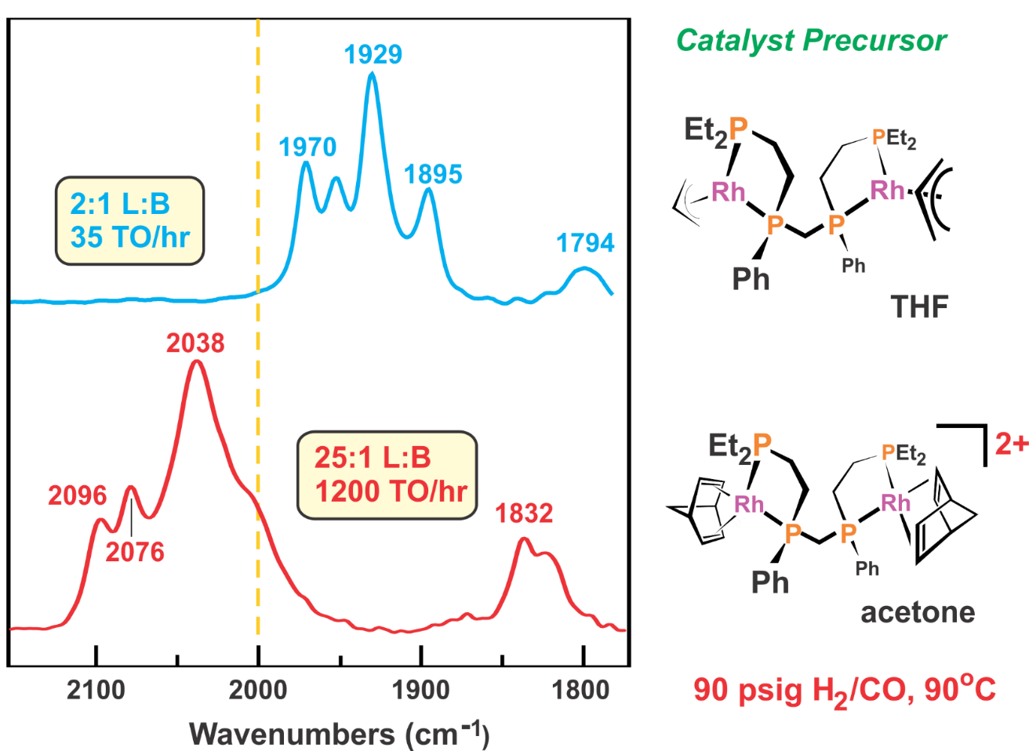

The currently proposed active dirhodium catalyst based on spectroscopic and DFT computational studies has two bridging hydrides, but is in equilibrium with the bimetallic complex with a bridging and terminal hydride:

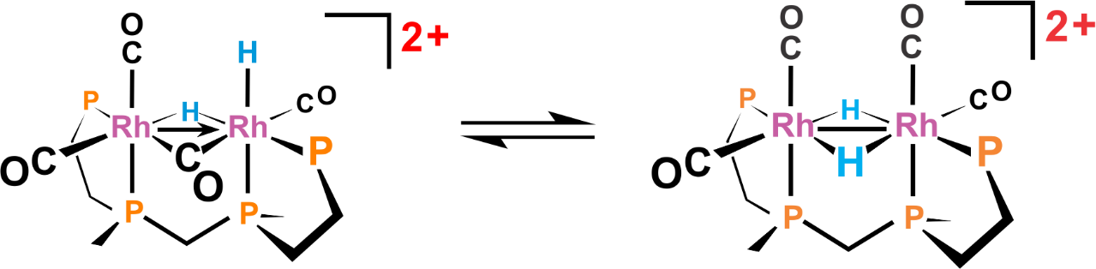

There is a facile terminal CO dissociation equilibrium on the species above (each Rh is 18e-) to generate complexes with one or two fewer terminal CO ligands.

**Problem:** **Why is the dicationic charge so important on this catalyst?**

The proposed mechanism for this dicationic bimetallic catalyst in acetone solvent is shown below:

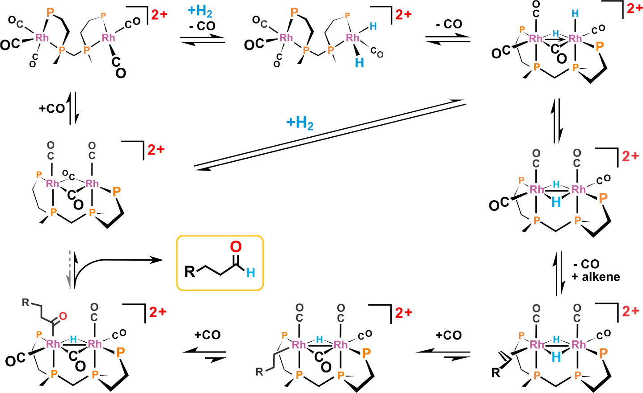

Unfortunately, the dicationic system falls apart readily by dissociating a rhodium and losing the highly effective bimetallic cooperativity.

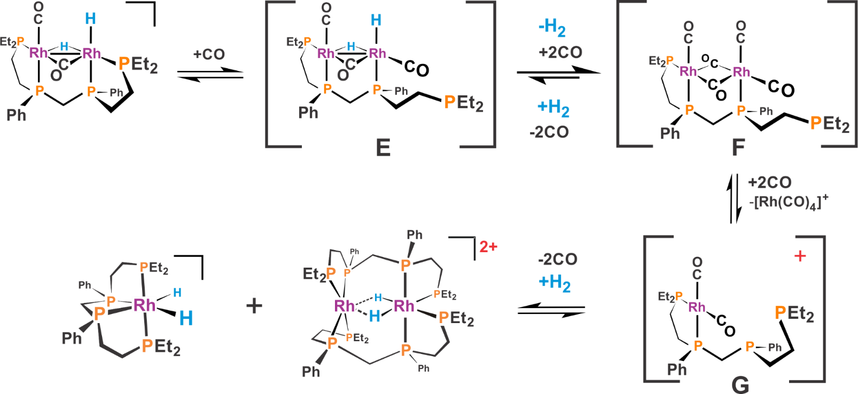

When water is added to the acetone solvent (30% by volume) the dicationic [Rh2H2(-CO)2(*rac*-P4)]2+ complex dissociates a proton to generate the more stable and selective monocationic bimetallic system: [Rh2H(-CO)(CO)3(*rac*-P4)]+. This species also works by bimetallic cooperativity via the following mechanism calculated by DFT. Note that one of the Rh centers is usually formally cationic (highlighted in yellow), which should make any CO ligands coordinated more labile to allow alkene and H2 to coordinate and keep the catalyst working.

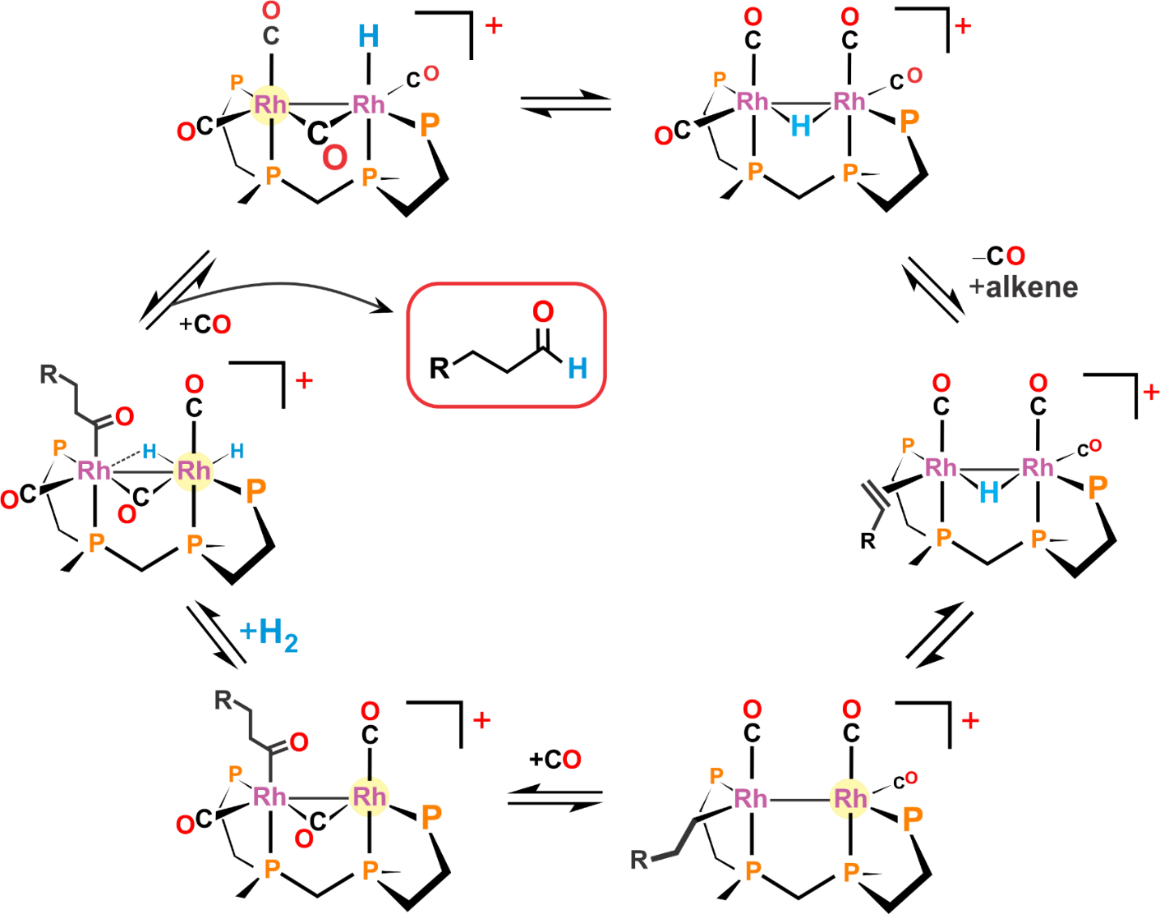

We believe that the monocationic Rh2 catalyst is less active on a per-molecule basis compared to the dicationic catalyst, but fragments and deactivates far more slowly. Thus, there is a higher concentration of the monocationic bimetallic catalyst yielding higher overall rates of reaction.

1. ) D. S. Breslow and R. F. Heck, *Chem. Ind. (London)*, 1960, 467.
2. ) R. F. Heck and D. S. Breslow, *J. Am. Chem. Soc.*, 1961, **83**, 4023.
3. ) R. Wyman, *J. Organomet. Chem*., 1974, **66**, C23.
4. ) M. F. Mirbach, *J. Organomet. Chem*., 1984, **265**, 205.
5. ) W. R. Moser, in 'ACS Advances in Chemistry Series', eds. W. R. Moser and D. W. Slocum, ACS, Washington, D.C., 1992, Vol. 230, Chapter 1, p. 14.
6. ) B. Fell, W. Rupilius, and F. Asinger, *Tetrahedron Lett*., 1968, 3261.
7. ) M. Bianchi, F. Paicenti, P. Frediani, and U. Matteoli, *J. Organomet. Chem.*, 1977, **137**, 361.
8. ) B. L. Haymore, A. van Asselt, and G. R. Beck, *Ann. New York Acad. Sci*., 1984, **415**, 159.
9. ) L. H. Slaugh and R. D. Mullineaux, *J. Organometal. Chem.*, 1968, **13**, 469.
10. ) R. L Pruett and J. A. Smith, *J. Org. Chem.*, 1969, **34**, 327.
11. ) R. V. Kastrup, J. S. Merola, A. A. Oswald, in 'ACS Advances in Chemistry Series', eds. E. L. Alyea and D. W. Meek, ACS, Washington, D.C., 1982, Vol. 196, Chapter 3, p. 43.
12. ) W. R. Moser, C. J. Papile, D. A. Brannon, R. A. Duwell, and S. J. Weininger, *J. Mol. Catal.*, 1987, **41**, 271.
13. ) C. A. Tolman and J. W. Faller, in 'Homogeneous Catalysis with Metal Phosphine Complexes', ed. L. H. Pignolet, Plenum, New York, 1983, Chapter 2, p. 93.
14. ) A. G. Abatjoglou, E. Billig, and D. R. Bryant, *Organometallics*, 1984, **3**, 923.
15. ) M. Lewin, Z. Aizenshtat, and J. Blum, *J. Organomet. Chem.*, 1980, **184**, 255.
16. ) W. R. Moser, C. J. Papile, and S. J. Weininger, *J. Mol. Catal*., 1987, **41**, 293.
17. ) C. Bianchini, A. Meli, M. Peruzzini, and F. Vizza, *Organometallics*, 1990, **9**, 226.
18. ) G. Kiss and I. Horváth, *Organometallics*, 1991, **10**, 3798.
19. ) M. Matsumoto and M. Tamura, *J. Mol. Catal.*, 1982, **16**, 209.
20. ) M. Matsumoto and M. Tamura, *J. Mol. Catal.*, 1982, **16**, 195.
21. ) M. E. Broussard, B. Juma, S. G. Train, W.- J. Peng, S. A. Laneman and G. G. Stanley, *Science*, **1993**, **260**, 1784.
22. ) D. A. Aubry, N. N. Bridges, K. Ezell, and G. G. Stanley, *J. Am. Chem. Soc.*, **2003**, *125*, 11180.
23. ) R. C. Matthews, D. K. Howell, W.-J. Peng, S. G. Train, D. W. Treleaven, G. G. Stanley, Angew. Chem. Int. Ed., 1996, 35, 2253.