**Oxidative Addition**

Created by George G. Stanley, Department of Chemistry, Louisiana State University (gstanley@lsu.edu) and posted on VIPEr on August 14, 2017. Copyright Geroge G. Stanley, 2017. This work is licensed under the Creative Commons Attribution-NonCommercial-ShareAlike CC BY-NC-SA. To view a copy of this license visit {http://creativecommons.org/licenses/by-nc-sa/4.0/}.

An ***oxidative addition*** reaction is one in which (usually) a neutral ligand adds to a metal center and in doing so oxidizes the metal, typically by 2e-. The transferring of the two electrons from the metal to the incoming ligand breaks a bond in that ligand forming two new anionic ligands. At least one of these new anionic ligands ends up bonded to the metal center.



There are three main classes of molecules (substrates) that can perform oxidative additions to metal centers: non-electrophillic, non-electrophillic “intact”, and electrophillic.

***Non-electrophillic:*** these molecules do NOT contain electro­negative atoms and/or are not good oxidizing agents. Aside from H2, they are often considered to be *“non-reactive”* substrates. These molecules generally require the presence of an **empty orbital** on the metal center in order for them to pre-coordinate prior to being activated for the oxidative addition rxn.

**H2, C-H bonds, Si-H bonds, S-H bonds,**

**B-H bonds, N-H bonds, S-S bonds, C-C bonds, etc.**

**H2** is by far the most important for catalytic applications, followed by Si-H bonds, B-H, N-H, and S-H bonds. C-H bond activation and functionalization is very important, but still not practical.

***Non-electrophillic “Intact”:*** these molecules may or may not contain electronegative atoms, but they do need to have a **double** or **triple bond** present. One needs a metal center with an **empty orbital** (16e- or lower count) in order to pre-coordinate the ligand before the oxidative addition occurs.

Unlike most of the other substrate molecules that break a single bond and form two separate anionic ligands upon the oxidative addition, these ligands have double or triple bonds and only one of the -bonds is broken leaving the -bond intact. The ligand does pick up two electrons from the metal and becomes a **dianionic** ligand.

Typical “intact” ligands that can perform an oxidation addition without fragmenting apart are (O2 can also act as an **electrophillic** substrate):

**alkenes, alkynes, and O2**

One often needs to have electron withdrawing functional groups on the alkenes or alkynes in order to ***“soup-up”*** their electron-withdrawing ability in order to help promote the transfer of electrons from the metal to the ligand.



In this case we have oxidized the Pt center from Pt(0) d10 to Pt(+2) d8 and generated a new dianionic unsaturated alkenyl ligand. Note that we have broken one of the alkyne -bonds.

***Electrophillic:*** these molecules ***do*** contain electro­negative atoms and are good oxidizing agents. They are often considered to be *“reactive”* substrates. These molecules do ***NOT*** require the presence of an **empty orbital** (18e- is OK) on the metal center in order to perform the oxidative addition rxn.

**X2 (X = Cl, Br, I), R-X, Ar-X, H-X, O2, etc.**

The most common substrates used here are **R-X (alkyl halides)**, **Ar-X (aryl halides)**, and **H-X**. An example of the *oxidative addition* of CH3Br to IrCl(CO)(PPh3)2 is shown below. Note that the starting metal complex in this case is 16e-:



Note that the H3C-Br bond is broken on the *oxidative addition* reaction generating two new anionic ligands: **CH3** and **Br**. If the starting metal complex is **16e-** (as shown above) both ligands will usually end up coordinated to the metal to make an **18e-** complex.

In the case of a starting **18e-** complex (shown below) only ***one*** of the two anionic ligands (usually the strongest binding) generated from the oxidative addition will end up coordinated to the metal unless a separate substitution reaction occurs.



In this case the alkyl anion is the best donor ligand and easily “beats out” the more electronegative and poorly donating Cl anion. Note that the alkyl ligand (-CH2CH=CH2) initially coordinated to the Re after the oxidative addition is an **1-allyl** ligand and that it can convert to the generally more stable **3-allyl** on **CO** ligand dissociation.

**General Features of Oxidative Additions**

Because oxidative addition involves oxidation (removal of electrons) of the metal center, the more **electron-rich** the metal is the easier the oxidative addition to the metal center will be. So in comparing two or more metal complexes to see which will be the most reactive towards a particular substrate for oxidative addition you would pick the metal center with the strongest donor ligands, fewest -acceptor ligands, or most negative charge. Also remember that the non-electrophillic ligands (Class A) and “intact” ligands (Class C) usually require that there is an empty orbital (16e- or lower) on the metal center in order to react.

**Kinetic Data for Oxidative Addition Reactions of MX(CO)(PR3)2**

|  |  |  |  |  |  |  |
| --- | --- | --- | --- | --- | --- | --- |
| **M** | **X** | **PR3** | **Reactant** | **Rate Const** (M1 sec1) | **H**‡(kcal/mol) | **S**‡(J/mol K) |
| **Ir** | **Cl** | **PPh3** | **H2** | **0.67** | **10.8** | **23** |
|  | **Br** |  |  | **10.5** | **12.0** | **14** |
|  | **I** |  |  | **> 100** |  |  |
| **Ir** | **Cl** | **PPh3** | **O2** | **3.4** x **102** | **13.1** | **21** |
|  | **Br** |  |  | **7.4** x **102** | **11.8** | **24** |
|  | **I** |  |  | **30** x **102** | **10.9** | **24** |
| **Ir** | **Cl** | **PPh3** | **CH3I** | **3.5** x **103** | **5.6** | **51** |
|  | **Br** |  |  | **1.6** x **103** | **7.6** | **46** |
|  | **I** |  |  | **0.9** x **103** | **8.8** | **43** |
| **Ir** | **Cl** | **P(***p***-C6H4-OMe)3** | **CH3I** | **3.5** x **102** | **8.8** | **35** |
|  |  | **P(***p***-C6H4-Cl)3** |  | **3.7** x **105** | **14.9** | **28** |
| **Rh** | **Cl** | **PPh3** | **CH3I** | **12.7** x **104** | **9.1** | **44** |
|  |  | **P(***p***-C6H4-OMe)3** |  | **51.5** x **104** | **10.2** | **43** |

Data adapted from “Principles and Applications of Organotransition Metal Chemistry”, Coleman, Hegedus, Norton & Finke, University Press, **1987**; refs: Chock & Halpern, *JACS*, **1966**, *88*, 3511; Ugo, Pasini, Fusi, Cenini, *JACS*, **1972**, *94*, 7364; Douek & Wilkenson, *J. Chem. Soc. (A)*, **1964**, 2604. Rxns generally run in benzene at 25ºC.

Notice the trends in the table above. The more electron-rich the metal center (better donating ligands) the faster the oxidative addition reactions. The one exception is the oxidative addition of CH3I with the Ir-Cl, Br, I series of complexes. The slow down is caused by steric factors caused by the increase in size of the halide affecting the nucleophillic attack of the metal dz2 orbital on the CH3I to start the oxidative addition reaction.

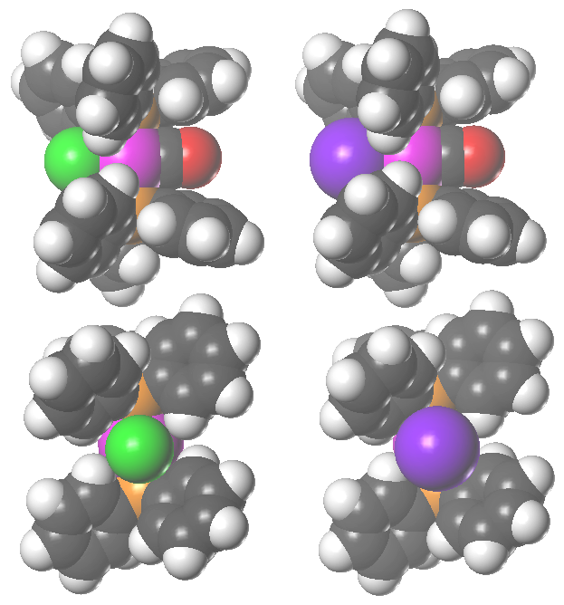

The space-filling figures show two different views of the Ir-Cl (left) and Ir-I (right) complexes. The top view is looking down on the square plane with the halide oriented to the left. The bottom view is looking down the halide-Ir axis and illustrates how the larger size of the iodide causes more steric interactions with the phenyl rings on the PPh3 restricting their rotation. The PPh3 phenyl rings as shown in the top view partially block the axial coordination site. The larger size of the iodide causes pushes the phenyl rings more towards the metal causing more steric hindrance for incoming substrates.

**WARNING:**  **d0** metals can ***NOT*** do ***oxidative additions***!! So always electron count the starting and final metal complexes to check out the overall electron-count, metal oxidation state and *d*-electron count!

***Oxidative additions*** are easy to identify **IF YOU ELECTRON COUNT** the metal complexes. When an oxidative addition rxn occurs the metal will be oxidized, usually by 2e-. So, if you start with a metal in the 0 oxidation state (d8), after the oxidative addition the metal will be in the +2 oxidation state (d6). Once you get used to looking at organometallic rxns you will be able to identify common oxidative additions quite quickly. **H2, R-X, and H-SiR3 are three of the most common substrates that perform oxidative addition reactions in catalytic cycles.**

**Problem: H2 will do an oxidative addition most readily to which of the following complexes. Why?**



**Problem: Cl2 will do an oxidative addition most readily to which of the following complexes. Why?**



**Problem: CH3Br will do an oxidative addition most readily to which of the following complexes. Why?**



**Oxidative Coupling**

Consider the following reaction:



The Cr on the right now has two new anionic alkyl ligands forming a metallocyclopentane ring system. We have done an oxidative addition, but in forming a new bond between the two ethylene ligand (and losing the original double bonds) we have coupled the two ligands together.

While this is an oxidative addition, there is a special term for this type of reaction called **oxidative coupling**. The metal is being oxidized to create two new anionic ligands, but the original two neutral ligands also form a new bond between them, instead of fragmenting apart to make two new independent anionic ligands.

The driving force for this reaction is the formation of a new C-C -bond (stronger than a -bond) and the creation of two new strongly donating anionic ligands that can better donate to the metal even though one has technically lowered the electron count.

**Hydrogenolysis**

Theonly way that early transition metals with d0 counts can activate H2 is via a metathesis-like reaction called hydrogenolysis. Lanthanides and actinides also typically use hydrogenolysis for these types of reactions. As with oxidative addition, the metal center needs to have an empty orbital to bind the H2 and an anionic ligand (e.g., alkyl, halide) that can be protonated off. Note that there is no change in oxidation state of the metal, so this is *not* an oxidative addition reaction.



The key is polarization of the H2 -bond to build up – charge on the hydrogen atom closer to the positively charged metal center and + charge on the hydrogen closer to the anionic ligand. If enough polarization occurs one can protonate off the anionic ligand replacing it with a stronger donating hydride ligand.

**Reductive Elimination**

A ***reductive elimination*** reaction is the reverse of an oxidative addition. It is a reaction in which **two cisoidal anionic ligands** on a metal center couple together. Each anionic ligand pushes one electron back onto the metal center (in the case of a monometallic complex) to reduce it by 2e-. The coupled anionic ligands then usually fall off the metal center as a **neutral** molecule.



Since ***electron-rich*** metal complexes favor **oxidative addition**, the reverse is true for reductive elimination. Since **reductive elimination** involves pushing electrons back onto the metal center from two anionic ligands that are usually more electronegative than the metal center, it is best if the metal center is ***electron deficient***. This can be accomplished by having electron-withdrawing ligands (e.g., CO), cationic charge(s), and/or coordinative unsaturation (sub-18e- counts).

While reductive elimination can occur from saturated 18e- complexes (so long as the two ligands that you want to reductively eliminate are **cisoidal** to one another), it has been shown that reductive elimination can be promoted by a ligand dissociation generating an unsaturated and more electron-deficient metal center.



In studying the above system, it was also found that one could have reductive elimination of CH3I from the starting 18e- complex. This reaction, however, is very reversible due to the high reactivity of CH3I for doing an oxidative addition back reaction with the electron-rich neutral Pt(+2) complex to make the Pt(+4) octahedral compound.



**Problem: Which of the following compounds will be most likely to do a reductive elimination of ethane (CH3-CH3)? Why?**



Binuclear Systems

Complexes with two (or more) adjacent metal atoms can also participate in oxidative addition and reductive elimination reactions. This often involves both metal centers. If so, then each metal changes its oxidation state by only **±1**, instead of **±2** as occurs with single metal centers.

This also often involves the making or breaking of a M-M bond, depending on what is present in the starting complex.



Below is a somewhat usual case of a C-C bond oxidative addition to a dimetal unit. The reverse reaction could also be considered a *reductive coupling* instead of a reductive elimination since the ligand stays coordinated to the metal center:



The next two examples involve reductive eliminations across a bimetallic unit:



In general bimetallic reductive eliminations occur across two metals when there is a M-M bond and when one can have good overlap of the two groups orbitals. Notably, there are very few if any examples of two alkyl groups performing a bimetallic reductive elimination.



This is due to the very poor overlap of the directed sp3 hybrid orbitals on the alkyls used to bond to the metal centers. Alkyl and hydride eliminations have been observed, no doubt due to the spherically symmetric orbital on the hydride that can overlap with the carbon sp3 hybrid orbital promoting the reductive elimination. The reductive elimination of two hydrides is well known and quite common. Stanley’s proposed hydride-acyl bimetallic reductive elimination (below) is also reasonable due to favorable overlap of the *sp*2 acyl and hydride orbitals. DFT studies, however, show that the aldehyde reductive elimination is most likely occurring from a bridging hydride, which is cisoidal to the acyl group.

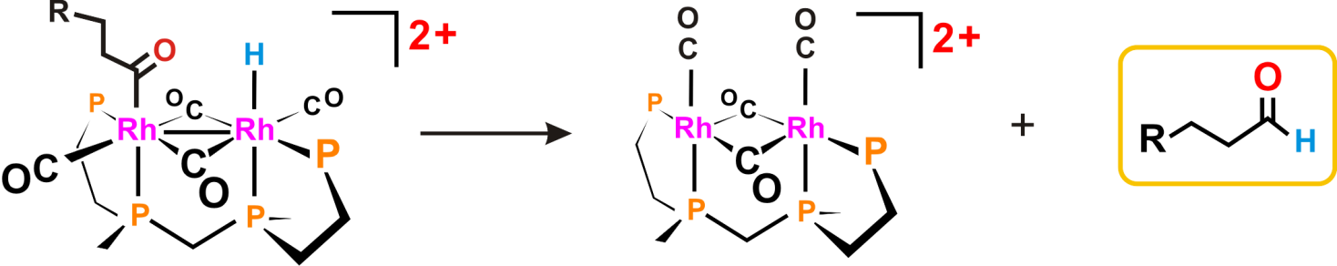

**Problem: Which of the two bimetallic complexes shown below will be most likely to do a reductive elimination of H2? Why?**

4571-bimetallic-red-elim-stanley