Understanding Hypervalency
In the world of quantum chemistry, there are two prevailing theories that explain chemical bonding: valence bond (VB) theory and molecular orbital (MO) theory. By this point in time, you have had exposure to both. The concepts of equivalent hybrid orbitals and resonance structures are part of VB theory, and VB orbitals generally only sit between two atoms. MO theory, on the other hand, uses orbitals that are delocalized; that is, they can span multiple atoms, or even the entire molecule. The interesting thing about these two theories is that they are both equally valid, and make the exact same predictions. Which one you use depends on the situation.
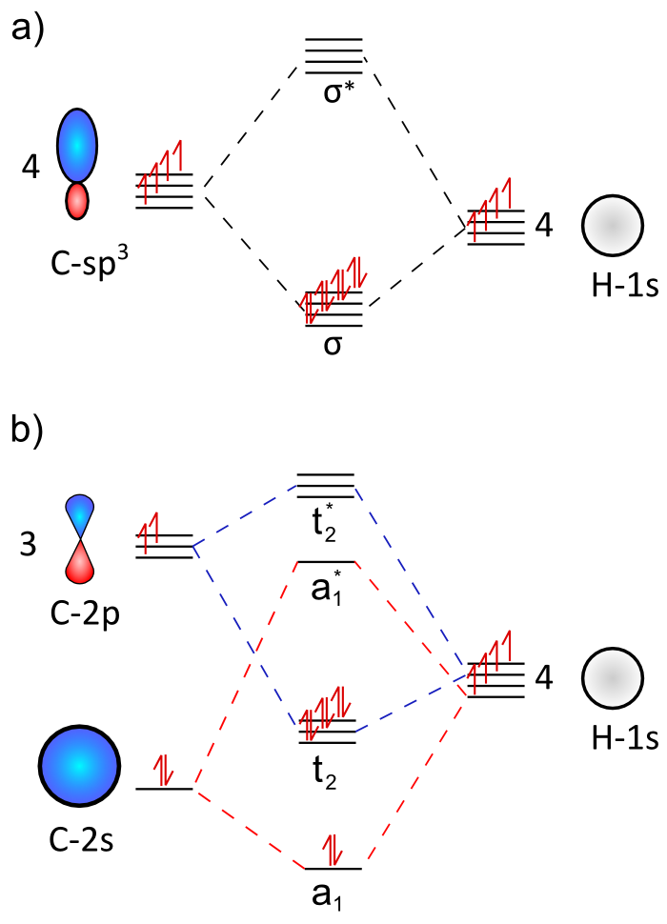
Figure 1. Orbital diagrams of the predicted energy schemes using valence bond theory (a) and molecular orbital theory (b).
The utility of VB hybrid orbitals lies in their simplicity in explaining structural features such as the four equivalent C-H bonds of methane (as does MO theory in a more complex manner). However, when one looks at the electronic spectrum of methane, two major peaks are observed. Hybrid orbital theory and molecular orbital theory predict very different orbital energy levels for methane (Figure 1). Using MO theory, it is very easy to see why there would be two peaks; electrons jump from the HOMO to each of the two higher energy levels (Figure 1b). With VB theory, it takes a lot of extra math to explain how there could be two peaks. So far in class, we have seen the ways that we can use group theory and molecular orbital theory to describe the bonding in a given molecule, but we haven’t given much time to talking about what orbitals are allowed to engage in bonding.
Scheme 1. Resonance structures of PF₅ showing partial ionic character that avoids expanded octet. From ref [1]
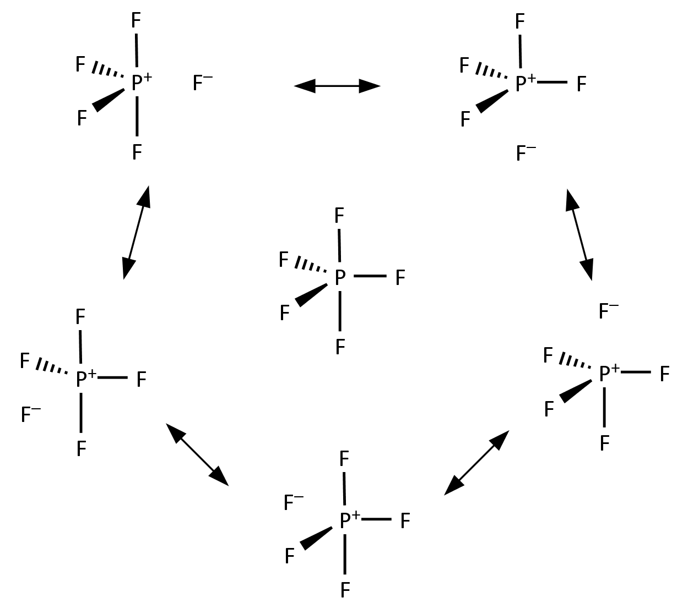
One topic that still stirs up controversy in chemistry circles is the concept of expanded octet, or hypervalency. In Freshman chemistry, you were told that an atom must have accessible d-orbitals in order to form more than four bonds; second row atoms lack those orbitals. In truth, third row elements are probably unable to form bonds with their d-orbitals because the 3d set is much too high in energy to overlap well with other atoms’ orbitals. How do we reconcile this fact with the concept that you need one atomic orbital per molecular bond?
There are several ways to describe the bonding in hypervalent molecules. The first is to invoke partial ionic character to the bonding. This approach has been used successfully to describe the bonding in PF₅ (Scheme 1).¹ However, resonance structures are a VB theory method to use localized Lewis structures to describe bonding, while molecular orbital theory can describe the same bonding scheme with just one picture.
In order to better describe the bonding in hypervalent molecules, we will be using the concept of multicenter bonding. The LGOs that you predict for a molecule using the generator orbital method (from the last activity) are just the central atom’s orbitals that group theory says have the correct symmetry to overlap with the orbital lobes on the outer atoms. That doesn’t necessarily mean that the central atom can actually use all of those orbitals. A good example of this situation is the square planar CH₄ molecule you constructed LGOs for. Obviously, the carbon doesn’t have a $d_{x^{2}-y^{2}}$ orbital available for bonding.
When an atom has fewer atomic orbitals available than the number of bonds drawn to it in the Lewis structure, multicenter bonding is likely involved. The example you saw in class was for the [FHF]⁻ anion. The Lewis structure has two bonds, but hydrogen only has the 1s orbital available for bonding. The result is a 3-center-4-electron bond (3c4e). This bonding scheme is also present in the hypervalent molecule XeF₂.
In terms of Lewis Structures, the 3c4e bond can be understood as depicted in Scheme 2. The actual distribution of electrons in XeF₂ can be better understood as 2 electrons that are delocalized in a single bonding orbital between the xenon and two fluorine atoms, and another orbital in which the electrons belong exclusively to the fluorine atoms. What we need now is a way to combine these concepts with molecular orbital theory. There is a relatively simple process to construct the multi-center bonding scheme, and much of it is identical to what you did in the LGO activity. The main idea behind multi-center bonding is that you actually have fewer bonding orbitals than expected based on the Lewis structure, even though the number of electrons is the same.
Scheme 2. Resonance description of the 3c4e bond.
Most of the procedure is the same as the one you used to generate LGOs, but you will take it one step further and construct a MO diagram when you are done:
- Determine the symmetry of the molecule and assign the z-axis.
- Determine the orbitals on the central atom that will engage in bonding with the ligand atoms and those that will form lone pairs. Draw the MOs for these (the combination of LGO and central atom’s atomic orbital).
- If hypervalency is involved, you will end up using at least one orbital on the central atom that it shouldn’t be able to use for bonding. Circle the corresponding MO(s) you drew and set it aside for later.
- Of the bonding LGOs that you have left, draw the corresponding antibonding molecular orbitals. This is accomplished by simply inverting the phase of the ligand lobes, creating more nodes.
- Go back to the “fake” MOs that you set aside before in Step 3. To make these more realistic, erase the central orbital, leaving the ligand lobes behind. You have now created a nonbonding molecular orbital.
- Arrange all the orbitals into an energy diagram and fill in the electrons. You can easily determine the order by looking at the number of nodes in the bonding and antibonding MOs. The nonbonding orbitals will sit in the middle of the diagram between the bonding and antibonding MOs. Lone pairs, if they exist, will usually be placed around the same energy as the nonbonding MOs.
Example procedure for constructing 4e3c bonding scheme:

Electron pair geometry: Trigonal Bipyramidal
Molecular Shape: Linear ($D_{∞h}$)
Hybridization: $sp^{3}d (d_{z^{2}})$
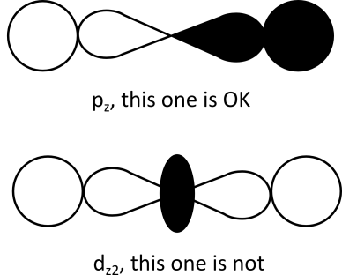
Orbital | Bond? | LP? | Chosen Role²
$$s$$ | y | y | LP
$$p_{x}$$ | n | y | LP
$$p_{y}$$ | n | y | LP
$$p_{z}$$ | y | n | bond
$$d_{z^{2}}$$ | y | y | bond

Bonding/Antibonding/Nonbonding Molecular Orbitals (I’ve left out the lone pair orbitals):

$$N.B.$$
$$σ_{p_{z}}$$
$$σ_{p_{z}}^{*}$$

Full Molecular Orbital Diagram:

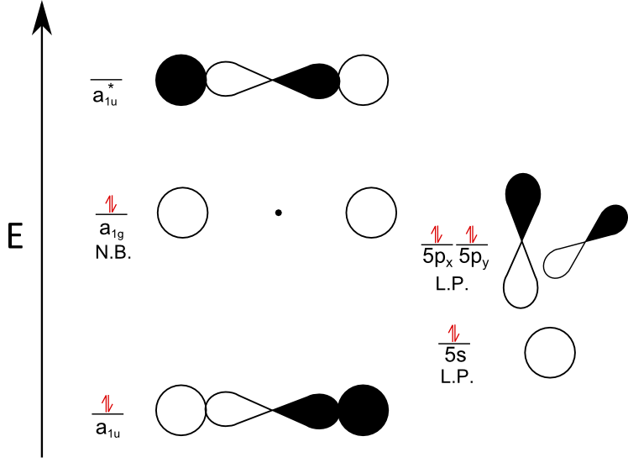

Group Activity (your assignment is actually easier than the worked example because there are no lone pairs):

- Draw the Lewis Structure for SF₅⁺.
- Come up with a multicenter bonding scheme for SF₅⁺ and draw its MO diagram. You will be making a 10e6c manifold.
- What is the average S-F bond-order for SF₅⁺?
- What do the non-bonding electrons in the multi-center bonding scheme for SF₅⁺ actually represent (see Scheme 1 for a hint)?
- PF₅, SF₅⁺, and SF₆ are all stable species, but PH₅, SH₅⁺ and SH₆ are not. Why aren’t the hydride compounds stable? Think about what the multi-center bonding concept actually means (and your answer to question 4).
- It is notable (but tough to explain) that the difference in bond lengths for PF₅’s axial P-F bonds (1.577 Å) and equatorial P-F bonds (1.543 Å) is so small. If you were to ask a freshman who had just been taught hybrid orbital theory and VSEPR, which set of P-F bonds would she tell you should be longer? Explain.

References

1. Mitchell, T. A.; Finocchio, D.; Kua, J. "Predicting the Stability of Hypervalent Molecules." Journal of Chemical Education. 2007, 84, 629.

2. The choice to make xenon’s 5s orbital a lone pair instead of the 5d is kind of complicated, and isn’t one you will have to make on your own. This example doesn’t really work the other way.

