Procedure:
1. Ask for 8 volunteers who are comfortable touching each other (holding hands, touching foot to foot)
2. Start with the shortest pair of students, and proceed through all four pairs having them do the following:
- Sigma bond: have two students face each other at a comfortable distance, holding both hands. The held hands represent electron density along the internuclear axis. This is dz2
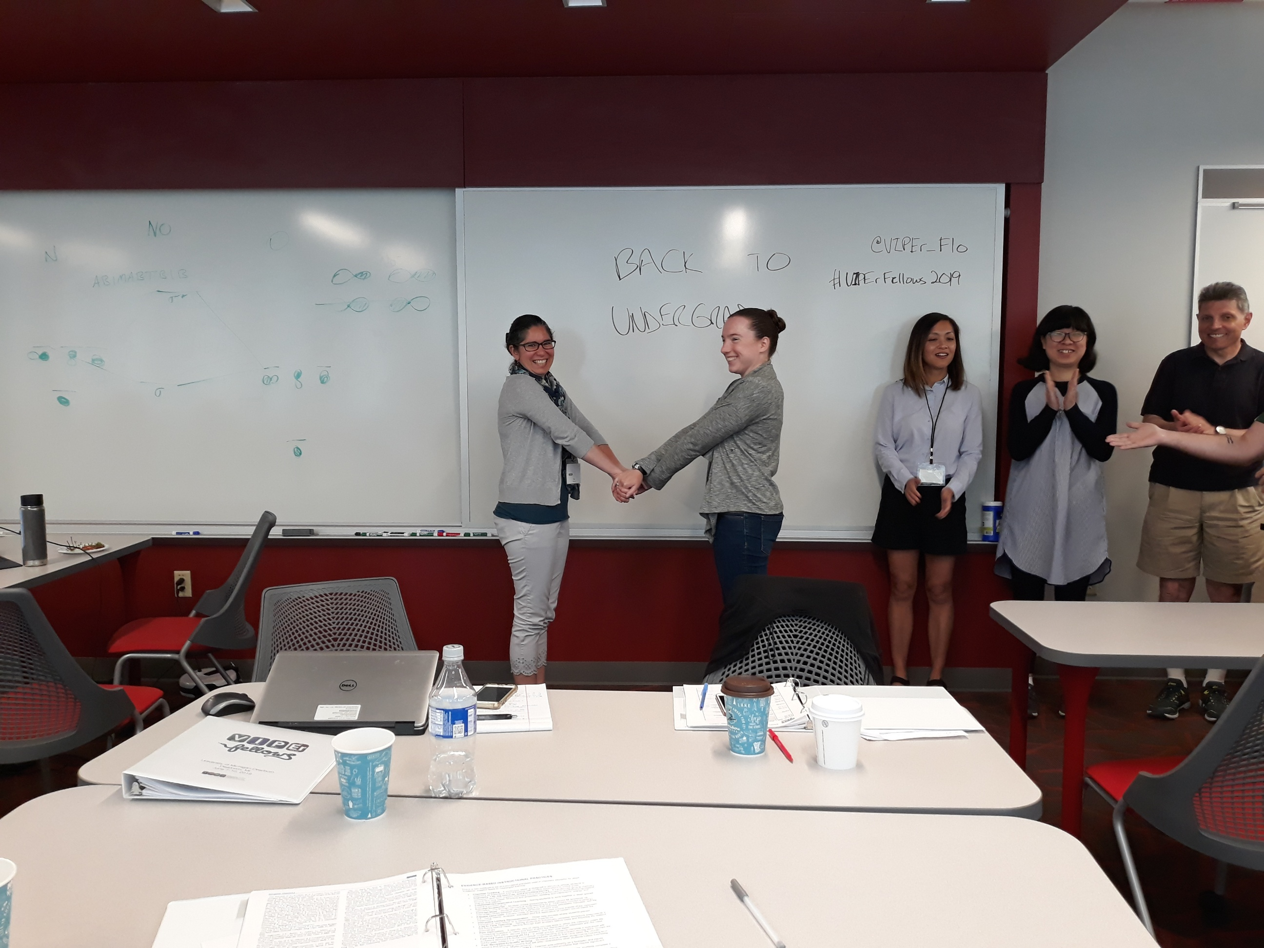
- Pi bonds: have two pairs of students form the dxz and dyz bonds by having two students stand behind each of the first pair. They will represent pi electron density above and below the internuclear axis by touching hands together on either side (dxz) or a hand and foot above and below the axis respectively (dyz), where the y axis points toward the ceiling. Unless your students can levitate, one foot must remain on the floor at all times--so the dxz orbital interaction is challenging, and one "lobe" (represented by the foot stick out toward the back) will not be properly represented.
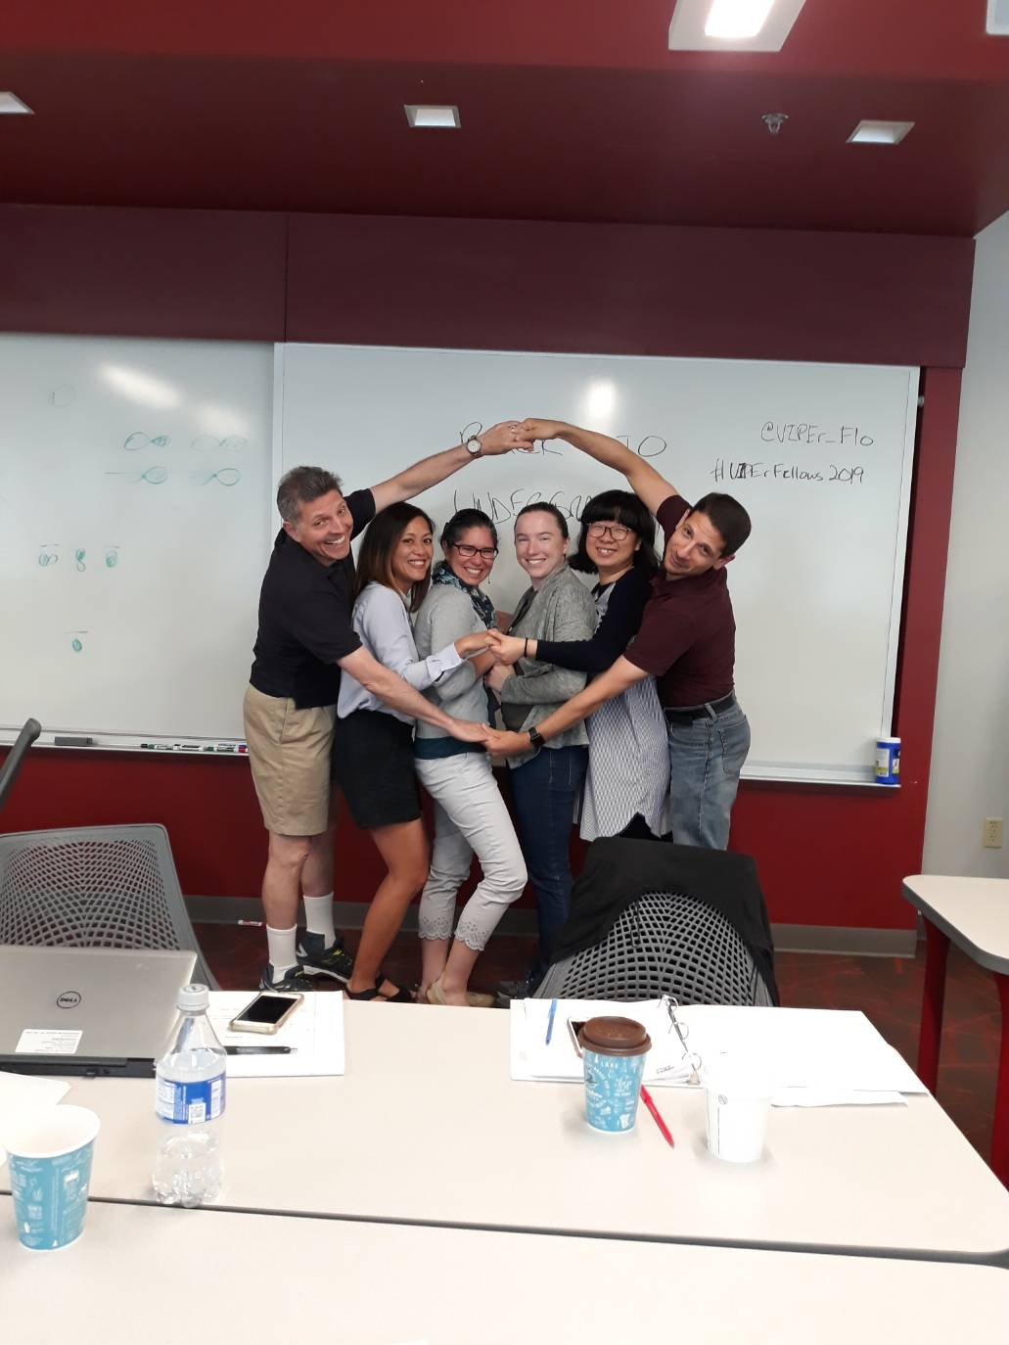
- Delta bond: have the tallest students face each other, one behind each of the previous three students on their side. Have them spread out their feet and hands at approximate right angles to eac other, and then touch both hands palm to palm together above the z axis, and both feet together below th z axis. To do this, the previous pairs of students will have to move even closer together, and the dxy orbitals will need to "bend" toward each other. Students will observe that it's difficult to make good contact palm to palm. Quadruple bonds are weaker!
- 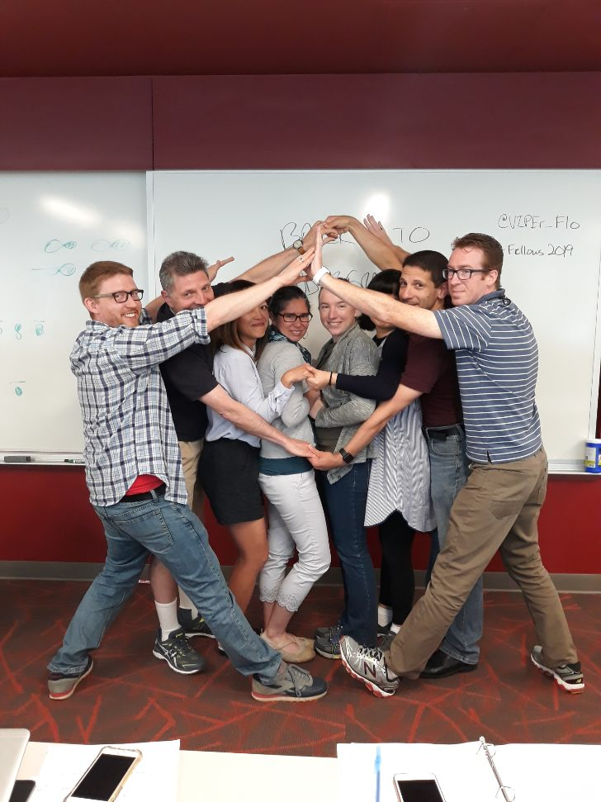
3. Let the class dissolve into giggles, and then debrief. How did each group of students have to move? Which orbital was "left out"? How would be expect incoming ligands to bind? Why? Could you have quintuple bonds? (Hint: yes) What would happen if the incoming ligands were too large to be eclipsed? (Hint: will tend to form staggered, triple bonded metal-metal complexes instead).
4. Give the class time to sketch out all four orbitals involved in a metal-metal quadruple bond in their notes.

