Iron Cross-Coupling Catalysis
Adapted from: J. Am. Chem. Soc., 2002, 124, 13856-13863 and Fürstner, A.; Leitner, A. Angew. Chem., Int. Ed. 2002, 41(4), 609.

INTRODUCTION

One of the hallmarks of synthetic chemistry is the ability to create carbon-carbon (C-C) and C-heteroatom bonds. These bonds, with high bond dissociation energies and diverse utility, are critical in building the framework of complex molecules. Organic chemistry courses tend to focus on the manipulation of functional groups and limit the scope of carbon-carbon bond formation reactions to alkyne carbanions, Grignards, organolithiates/cuprates, and the Diels-Alder. Modern techniques are rarely discussed due to the vast amount of material required by the course.

The 1970s and 80s marked the development of efficient methods for forming C-C- and C-heteroatom bonds. This boom in research and discovery became a part of the chemists’ reaction toolbox. Specifically, the advent of ‘coupling’ reactions revolutionized how chemists synthesized C-C- bonds.

Coupling reactions directly connect two functionalized carbon atoms. You can think of the two carbon atoms like legos, which can be easily connected. In this experiment, you will bring together two small molecules to build a larger molecule via a C-C bond. One may ask, how is this related to inorganic chemistry? The development C-C bond forming reactions lies on the crossroads of organic chemistry and inorganic chemistry. Specifically, inorganic catalysts often facilitate reactions that form carbon-carbon bonds.

Catalysts are compounds that speed up a reaction without being consumed themselves. This allows for a very small amount of catalyst to have a very large effect on chemistry. Most of your effective catalysts are used on the order of 5-10 mol% (~0.05-0.1 equivalents). One aspect of this field is determining the scope (limits of effectiveness) of a particular catalytic reaction. An ideal catalyst would be designed to have a wide scope, i.e. viable under a wide variety of reaction conditions and substrates.

The reaction that we will be exploring will be an iron catalyzed Kumada Coupling (Scheme 1). R₁ can be either aryl or alkeneyl halides or triflates (triflate = CF₃SO₃⁻), where R₂ can be aryl, alkenyl, allyl, 1° alkyl or 2° alkyl Grignards. For the sake of simplicity, we will be exploring three aryl chlorides (2-chloropyridine, 4-chlorotoluene, 4-chlorobenzonitrile) and the Grignard n-hexylmagnesium bromide.

Scheme 1. Generic Kumada coupling

Because we will be using Grignard reagents, this reaction will be sensitive to moisture in the atmosphere. As such, we will have to take precautions to keep water out of the reaction until it is finished. The first step to make sure we have dry glassware. This can be ensured by either drying your flask in an oven at 135°C overnight before you use it, or by flame-drying it immediately before use. Before you can use it, though, you need to let it cool under an inert atmosphere. This can be accomplished by attaching an inert gas source (either directly to an N₂ tank or via a Schlenk line) to one neck and allowing the air to flow out the other (Figure 1). Once the flask is cooled, you can introduce the reactants, solvent, etc. by removing the outlet septa and adding the components via this neck.

Figure 1. An inert gas setup with the gas inlet on the left (w/hose) and outlet on the right.
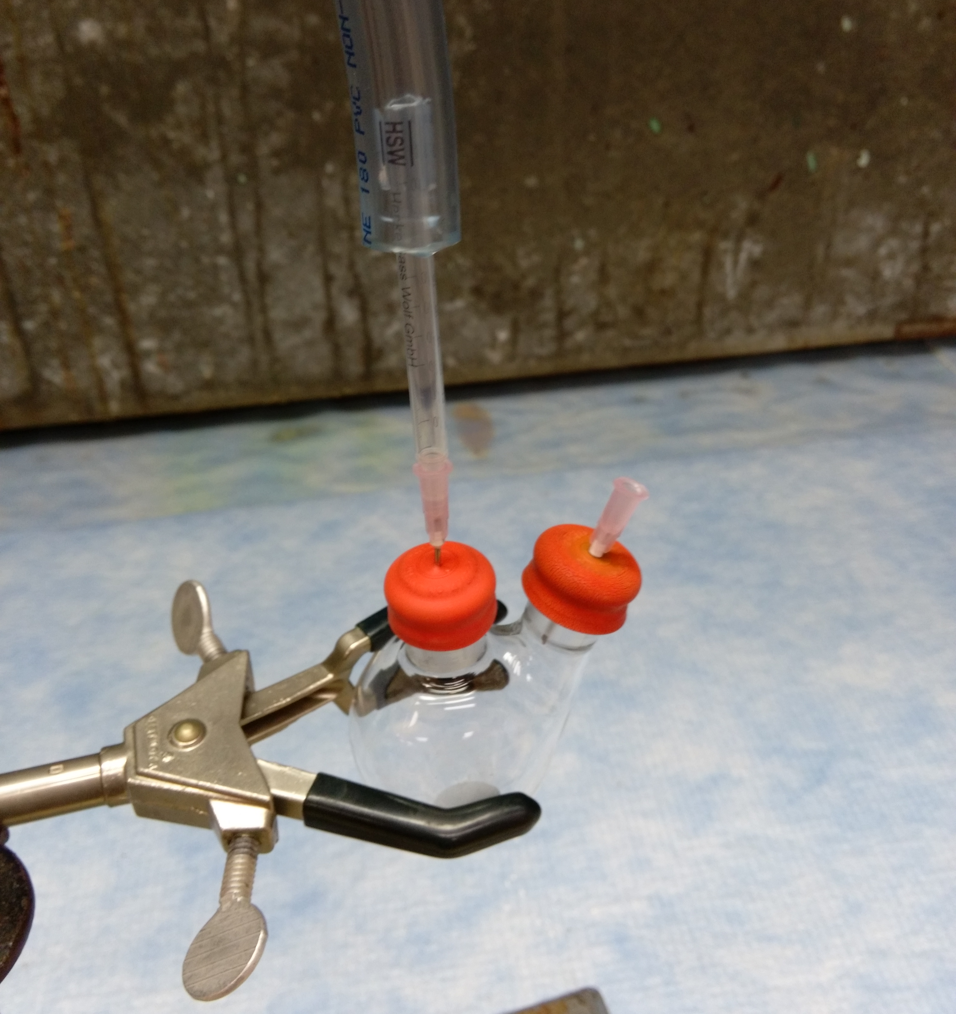

Once the reaction is complete, we will analyze the components by gas chromatography (GC). The main product of this reaction should be the alkylated aryl compound (Scheme 2); however experimental chemistry is rarely as clean as we would like it to be. The most common side reaction for these conditions will be the protonation reaction, but aryl-aryl coupling is also possible (but not likely). The area under the curve associated with a compound in GC can, with certain adjustments (see below), be used to compare the relative amounts of each component in the reaction mixture.
Scheme 2. Reactions and products for this lab.

You will be using a flame ionization detector (FID) as your GC detector. Essentially, the detector burns the sample and a signal is received based on the number of ions formed. For organic compounds, this strength of this signal depends on the concentration of the sample and number of carbons in the molecule. For example, hexane would show a stronger signal (larger response factor) than ethane at the same concentration. As such, the response factor of each compound is needed to compare the GC signals received. In the experimental section, I have provided scaling factors for you to use to compensate for the different response factors for each molecule. You will also be provided with a GCMS spectrum of each component to identify the peaks in your chromatograms.

CHEMICALS/HAZARDS
Note: Grignard reagents are highly reactive and can combust upon exposure to moisture. Iron(II) is easily oxidized to iron(III) upon exposure to air. Handle with care.

Chemical | Hazard/Note
FeCl₃ | corrosive, irritant
FeCl₂ | corrosive, irritant
FeCl₃∙6H₂O | corrosive, irritant
2,4-pentanedione | flammable, toxic if swallowed
Ethylenediamine | flammable, toxic, corrosive, hazardous to health
Salicylaldehyde | irritant, harmful to aquatic life
2-chloropyridine | toxic if swallowed
4-chlorotoluene | flammable, irritant, harmful to aquatic life
4-chlorobenzonitrile | harmful if swallowed
4-chlorotrifluorotoluene | irritant
n-hexylmagnesium bromide (2.0 M in Et₂O) | highly flammable, corrosive, irritant
tetrahydrofuran (THF) | highly flammable, irritant, hazardous to health
N-methyl-2-pyrrolidone (NMP) | irritant, hazardous to health
diethyl ether (Et₂O) | highly flammable, irritant
Celite

PROCEDURE

Synthesis of Fe(acac)₃
To 6 mL of water in a 100 mL beaker, add 2.7g (0.010 mol) of FeCl₃∙6H₂O. To a separate beaker, dissolve 5.0 g (0.037 mol) of NaC₂H₃O₂∙3H₂O in 10 mL water. Slowly add the sodium acetate solution to the stirring iron(III)chloride solution. In a 150 mL beaker, dissolve 4 mL (0.039 mmol) of 2,4-pentanedione (acetylacetone, Hacac) in 10 mL of methanol. Add the FeCl₃/NaOAc solution to the stirring Hacac solution; once completed stir for approx 5 min. Collect the solid via vacuum filtration, and wash with distilled water. To recrystallize, add the solid to a clean 250 mL beaker, dissolve in ~30 mL of methanol. While stirring, add ~25 mL of water slowly to the solution. Stir for about 5 min and collect the solid via vacuum filtration. Allow to air dry. IR spectroscopy may be used to confirm tris(2,4-pentanedionato)iron(III) as the product.

General Catalytic Procedure
Remove your two-necked flask from the oven (the flask can be also be flame dried that day) and immediately cap both necks with septa. Make sure the nitrogen gas is flowing and place the needle in the gas hose into one septa. Place the other needle in the other septum as an outlet (Figure 1), and allow to cool under nitrogen. While the nitrogen is still flowing, remove the outlet septum and add 0.15 mmol of your catalyst, 3.0 mmol of your aryl chloride, and your stirbar. Replace the septum and transfer—via syringe—20 mL of dry THF, 1.7 mL of dry NMP, and 1.8 mL of 2.0 M n-hexylmagnesium bromide. Remove the needles (outlet first) and transfer the flask to a stirplate. Allow to stir for 5 min under nitrogen; then add 10 mL of diethyl ether and 2 mL of aqueous 1 M HCl . Allow to stir open to the atmosphere for 5-10 minutes, then filter the reaction through Celite or silica to remove the solids. Analyze the resulting mixture by GC analysis or by NMR (CDCl₃)

GC Analysis
We will be comparing the ratios of our starting aryl halides and two possible products: the alkylated and protonated aryl compounds. To do this, we will have to scale the area under each curve to account for differing response factors. In the table below are each compound and their scaling factor (SF). Note that directions to calculate your own SFs may be provided by your instructor instead of the values below. For your data, take the area under the curve and multiply it by the scaling factor to compare.

Starting material | SF | Alkylated | SF | Protonated | SF
2-chloropyridine | TBA | 2-hexyl  pyridine | TBA | pyridine | TBA
4-chlorobenzonitrile | TBA | 4-hexyl  benzonitrile | TBA | benzonitrile | TBA
4-chloro  trifluorotoluene | TBA | 4-hexyl trifluorotoluene | TBA | trifluorotoluene | TBA

RESULTS

You will write a formal lab report in the style of an Inorganic Chemistry communication. The template for this can be found via http://pubs.acs.org/page/inocaj/submission/templates.html

Some questions/ideas to address:

- Which catalyst gave the better yields? Why?
- How could you change the reaction conditions to give better yields?
- Did every substrate work? Why or why not?
- What is the effect of Fe(II) vs Fe(III)?
- Discuss the difference between “percent yield” and “percent conversion” in relation to the catalysts.
- Possible future directions (in conclusions)
- Any other questions/observations you want to address.
- Remember, you’re telling me the story of why you did this experiment, what happened during it, and why it happened the way it did.

