Discussion Questions:

- What is the overall goal and conclusion of the research presented in the paper?

2. What is a non-innocent ligand? Give an example of a non-innocent ligand identified in the paper.

3. Which orbitals in Table 1 comprise the metal-ligand bond? What do the MO composition values for these orbitals indicate about Fe-N bonding?

4. The nitrosyl ligand can bind a metal center and be either bent or linear. What characteristics of the metal center would drive NO to be bent? What characteristics of the metal center would drive NO to be linear?

5. Construct the molecular orbitals diagram between Fe^{II} and NO below. Draw the molecular orbitals formed to show σ donor interactions between Fe-NO and π interactions between Fe-NO, if applicable. NO is bent and the Fe-N bond is on the z-axis.

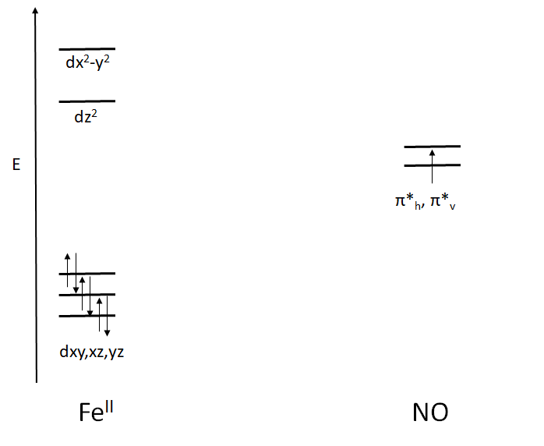

6. Discuss how Enemark-Feltham notation is used to describe an iron-NO complex. Why is it commonly used for nitrosyl complexes?

7. What is the spin state of NO? Fe²⁺ high spin? Fe³⁺ high spin? How does this relate to the overall spin state of the complex?

8. On Pg 4253, paragraph 2, the authors note that {FeNO}⁷ consists of an S = 5/2 high-spin iron(III) center antiferromagnetically coupled (spins cancel out) to a triplet NO– (S = 1) to give an overall S value of 3/2. List four other electronic configurations that will result in the same spin of S = 3/2. Remember that besides shifting charge between the ligand and the metal, iron can be high or low spin, and the coupling between the ligand and the metal can be ferromagnet (spins add together) or antiferromagnetic. (LO 8)

9. What is the electron count of cobaltocene? Why is cobaltocene a good reductant?

10. Figure 10 displays the MO diagram of the semi-reduced complex. Given that the z axis is defined as pointing towards the NO ligand, why does occupation of the Fe_{dxz} π* (shown in red) make the [Fe(NO)] more reactive rather than occupation of the Fe_{dxy} π*? (Hint: Are the respective Fe d orbitals antibonding or nonbonding with respective to NO?)

