Binding of Metal Ions by Tropocoronand Ligands

Tropocoronands are a class of macrocyclic ligands and their general structure is shown below. The ligand is abbreviated using (TC-n,n), where n is the number of carbon linkers in each chain.

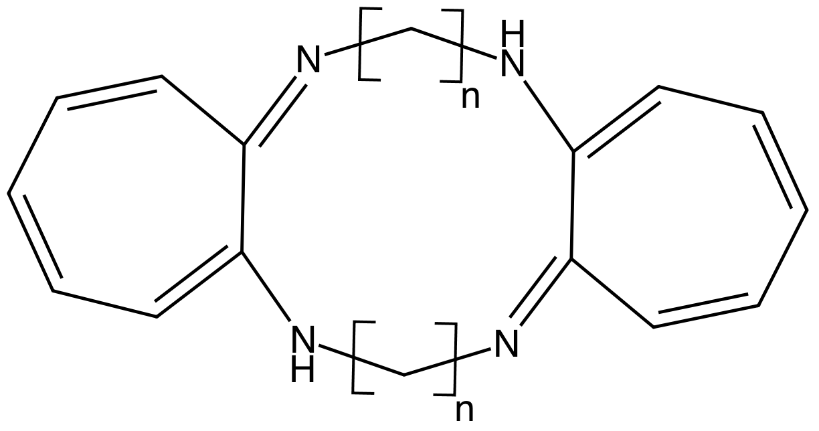

These tetradentate ligands adopt a -2 charge when the two amines are deprotonated. The size of the metal-binding cavity can be varied by changing the number of carbons in the chain that links the two aminotroponeimine portions together. The coordination geometry about the metal center and the electronic spin state (high or low spin) of the metal can also vary as the number of linking carbons is changed.

Crystal structures of the Ni²⁺ complexes of a variety of tropocoronand ligands are available in the Cambridge Structural Database. Alternatively you can access these structures directly from the Cambridge Crystallographic Data Centre (https://www.ccdc.cam.ac.uk/structures/). The structures and CCDC identifiers are listed in the table below.

Structure | CCDC Identifier | #C in Ring 1 | #C in Ring 2
[Ni(TC-3,3)] | BURBUL10 | 3 | 3
[Ni(TC-4,4)] | BURCAS10 | 4 | 4
[Ni(TC-4,5)] | DAHCAQ | 4 | 5
[Ni(TC-5,5)] | BURCEW10 | 5 | 5
[Ni(TC-6,6)] | BURCIA10 | 6 | 6

Based upon your examination of these crystal structures, please answer the following questions.
- Measure the bond angles around the Ni center in each complex.
- For each metal center, please calculate the τ₄′ value for the observed geometry.
$$τ_{4}^{'}=\frac{β-α}{250.5}+\frac{180-β}{70.5}$$
- How does the geometry vary as the number of atoms in the linker chains increases?
- Please calculate the ligand field stabilization energy for the Ni²⁺ center in each of the four possible geometries provided in the table below. Do the calculated LFSE values show a preference for one geometry over the others?

 |  |  | d-orbital energies^{a,b,c}
C.N. |  | Structure | d(z²) | d(x²-y²) | d(xy) | d(xz) | d(yz)
4 | Tetrahedral |  | -0.267 | -0.267 | 0.178 | 0.178 | 0.178
4 | Square planar^{d} |  | -0.428 | 1.23 | 0.228 | -0.514 | -0.514
4 | Triangular pyramid |  | 0.193 | 0.232 | 0.232 | -0.329 | -0.329
4 | Compressed tetrahedron |  | -0.411 | -0.068 | 0.571 | -0.046 | -0.046
ª This table is adapted from Table 11.5 (pg. 405) from J.E. Huheey, E.A. Keiter, and R.L. Keiter Inorganic Chemistry (4th ed.) HarperCollins, New York, ©1993.
^{b} Krishnamurthy, R.; Schaap, W.B. J. Chem. Educ. 1969, 46, 799.
^{c} All energies are in Δ units.
^{d} Ligands lie in the xy plane.

- Based upon your answers to the previous questions, what do you think determines the geometry of the coordination complex - the metal or the ligand? Please provide a short explanation for your answer.

