**Electron Densities, Electrostatic Potentials, and Reactivity Indices**

After completing this exercise, students will be able to:

1. Calculate and visualize electron densities, electrostatic potentials, HOMO/LUMO, and reactivity indices.
2. Use these visualizations to predict or understand reactivity.

**Exercise 1 - Visualizing Different Bond Types**

Build H2, clean up with the paintbrush, and perform a geometry optimization (Mopac) using the choices shown below:

Job Name: H2 PM3 Geom Opt

Calculation: Geometry Optimization

Theory: PM3

Charge: 0

Multiplicity: Singlet

Once the job is complete, view the molecule and click New Job Using This Geometry, click the blue continue arrow, choose Mopac, then type in/Choose the following:

Job Name: H2 PM3 MO

Calculation: Molecular orbitals

Theory: PM3

Charge: 0

Multiplicity: Singlet

Click on the blue continue arrow. You should now see your job listed. Once the job is complete, open the file, scroll down to the Molecular Orbitals table, and click on the magnifying glass next to Electron Density. You will need to adjust the isosurface value. Click on File and select Preferences. Click on the isosurfaces tab and set the Density isosurface value to 0.015 e−/Å3. Click OK.

You should now see a gray blob. You should be able to see the atomic positions inside the surface, but if not, you can adjust the transparency in Preferences. Rotate the displayed electron density and describe the distribution of electron density relative to the atomic positions. Does the electron density distribution make sense? Why or why not?

Click on the magnifying glass next to Electrostatic Potential (or click on Properties in the Molecule Viewer window and select Electrostatic Potential). The blue color represents relative (+) charge, while red represents (−). Does the charge distribution make sense? Explain.

Build HF, clean up with the paintbrush, and perform a geometry optimization as described above for H2. Follow the above steps to calculate the molecular orbitals. As before, scroll down to the Molecular Orbitals table and view the Electron Density. Change the isosurface values as above if necessary. Describe the distribution of electron density relative to the atomic positions. Does the electron density distribution make sense? Why or why not?

Now look at the Electrostatic Potential. Does the charge distribution make sense? Explain.

Build LiH and repeat the above procedures. Change the isosurface value if necessary. View and rotate the displayed electron density and describe the distribution of electron density relative to the atomic positions. Does the electron density distribution make sense? Why or why not?

Look at the Electrostatic Potential. Does the charge distribution make sense? Compare/contrast the various surfaces for H2, HF, and LiH. Are they what you expected?

**Exercise 2 - Charge Distribution in Aromatic Compounds**

Build a molecule of benzene. (It is fastest to get benzene from the fragment menu found under Build in the “rings” Category.) As you did in Exercise 1, perform a geometry optimization using Mopac (PM3), then calculate the molecular orbitals using Mopac and PM3. View the Electron Density and Electrostatic Potential. Based on the Electrostatic Potential, draw a sketch of how you believe benzene molecules would stack together in the solid state.

Build a molecule of pyridine and clean up the structure with the paintbrush. As you did in Exercise 1, perform a geometry optimization using Mopac (PM3), then calculate the molecular orbitals using Mopac and PM3.

View the Electron Density and Electrostatic Potential. Describe the differences between the benzene and pyridine charge distribution. What causes this difference?

**Exercise 3 - Electrophilic Aromatic Substitution**

The electronic nature of substituents on aromatic rings will govern the site of attack of incoming, electrophilic reagents. In this exercise we will build some simple molecules and also investigate the differences between semiempirical and DFT results.



methoxybenzene thiophene

**A. Methoxybenzene**

Build a molecule of methoxybenzene and clean up the structure. Perform a geometry optimization using Mopac > PM3, then calculate the molecular orbitals using Mopac > PM3.

View the Electrophilic (HOMO) Frontier Density. If you need to, adjust the transparency Preferences so that you can see the atoms. Electrophilic attack will occur at those positions in the rings that are more yellow/green/blue. (This may not intuitively seem like the right color.) Attack will NOT occur at the ring carbon where the methoxy group is attached.

What position(s) on the ring will electrophilic attack occur? _____________

**B. Thiophene**

Build a molecule of thiophene and clean up the structure. Perform a geometry optimization using Mopac > PM3, then calculate the molecular orbitals using Mopac > PM3.

Repeat the experiment with thiophene, but use Gaussian > B3LYP > 6-31G(d) for both the geometry optimization and molecular orbital calculation. View the Electrophilic (HOMO) Frontier Density. Where will attack occur? Is this different than the PM3 result above? Which result do you think is correct? Why?

**Exercise 4 - The Diels-Alder Reaction**

α,β-unsaturated carbonyl compounds (such as maleic anhydride) undergo an exceedingly useful reaction with conjugated dienes known as the Diels-Alder reaction. In this *cycloaddition* reaction, C-1 and C-4 of the conjugated diene become attached to the doubly-bonded carbons of the unsaturated carbonyl compound to form a six-membered ring. The reaction involves systems with 4 electrons (diene) and 2 electrons (dienophile), and is therefore a [4+2] cycloaddition.

The frontier molecular orbital approach is a good way to understand this reaction. We will look at a simple Diels-Alder reaction involving butadiene and maleic anhydride:

1,3-butadiene maleic anhydride

(diene) (dienophile)

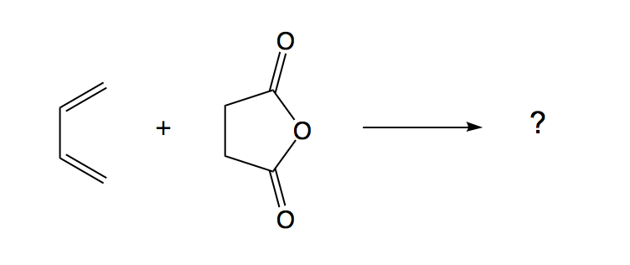

Draw *cisoid*-butadiene (as pictured above) and clean up with the paintbrush. Your butadiene may have turned into the *transoid* form, as this form is more stable. To lock the geometry into the *cisoid* form, first click on the Adjust tool (the cursor-like button on the left). Then click on the four carbon atoms in order. Choose Adjust > Dihedral angle and type in the new value of 0°. Click OK. You should have the *cisoid* form displayed.

Next, choose Tools > Edit Z-matrix. In the pull-down menu next to the C4-C3-C2-C1 dihedral angle display box, select “F” as shown below. This will *fix* this angle at 0°. Click OK.

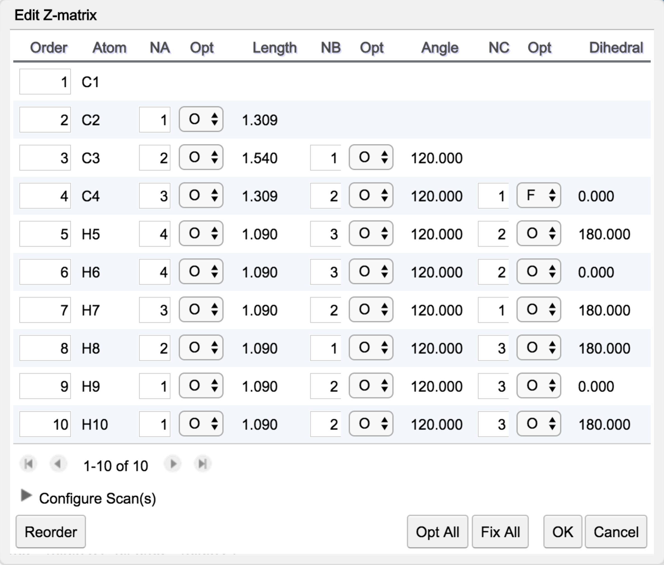

Perform a geometry optimization using Mopac (PM3), then calculate the molecular orbitals using Mopac and PM3 as you did in Exercise 2, above. Once the molecular orbital calculation is complete, open the file and scroll down to the molecular orbitals table. View the HOMO and LUMO. Note the HOMO is red/blue, while the LUMO is green/yellow.

Does the shape of these two orbitals make sense? On which atoms are the largest lobes of the HOMO located? Record the energies of both the HOMO and LUMO.

Build a molecule of maleic anhydride and clean up the structure with the paintbrush. As you did in Exercise 2, perform a geometry optimization using Mopac (PM3), then calculate the molecular orbitals using Mopac and PM3. View the HOMO and LUMO.

On which atoms do the largest lobes of the LUMO lie? Record the energies of both the HOMO and LUMO**.**

In the space below, sketch the relative energies of the HOMO and LUMO of butadiene on the left and the HOMO and LUMO of maleic anhydride on the right. (Recall that more negative energies are more stable and are *lower* on the vertical axis:

The HOMO on one molecule nearest in energy to the LUMO of the other molecule are the orbitals that will be involved in the reaction. What two orbitals will interact on these molecules?

Alternately view the interacting orbitals (HOMO of butadiene, LUMO of maleic anyhydride) by clicking on the magnifying glass next to those orbitals. Remember, the *largest lobes of the HOMO* will interact with the *largest lobes of the LUMO*. Bonds will be formed between the atoms where these largest lobes are located. It may help to rotate the separate molecules in each window.

Assuming that the blue lobe of the HOMO and the yellow lobe of the LUMO are both (+) in sign, make a sketch in the space below of how these two molecules will approach one another to react. The largest lobe of the HOMO will overlap with the largest lobe of the LUMO. Also draw the structure of the resulting product.