**Infrared, Thermochemistry, UV-Vis, and NMR**

Students will be able to:

1. Calculate an IR spectrum. Visualize the normal modes. Use appropriate scale factors to “correct” the calculated values.
2. Calculate NMR spectra and average the chemical shift values for the static structures (in 1H NMR) to approximate the experimental spectrum.
3. Calculate UV-Vis spectra.

**Exercise 1: Method Dependence and Scaling for the Infrared Spectrum of Formaldehyde**

Build a molecule of formaldehyde, H2CO. Perform a geometry optimization using Mopac and AM1.



formaldehyde

Job Name: CH2O AM1 Geom Opt

Calculation: Geometry Optimization

Theory: AM1

Charge: 0

Multiplicity: Singlet

Click on the blue continue arrow. When the job is complete, open the file and click on New Job Using This Geometry. Type in/Choose the following:

Job Name: CH2O AM1 IR

Calculation: Vibrational Frequencies

Theory: AM1

Charge: 0

Multiplicity: Singlet

Click on the blue continue arrow. When the calculation is finished, open the file and scroll down to the Vibrational Modes window.

How many transitions are shown (count the number of frequencies)? _____

Is this the number expected? Explain.

Click on the filmstrip next to one of the frequencies and observe the corresponding vibrational motion. Try to identify the type of motion for each transition. (The molecule can be rotated if needed). In the table below, record the frequencies and type of motion for each. **Note:** You will eventually be multiplying all of these values by scale factors, so you are encouraged to skip this table and the next table, and instead enter your results into a spreadsheet.

|  |  |  |  |  |  |
| --- | --- | --- | --- | --- | --- |
| Mode | Symmetry | AM1 freq. cm-1 | PM3 freq. cm-1 | DFT freq. cm-1 | Description of mode |
| 1 |  |  |  |  |  |
| 2 |  |  |  |  |  |
| 3 |  |  |  |  |  |
| 4 |  |  |  |  |  |
| 5 |  |  |  |  |  |
| 6 |  |  |  |  |  |

Repeat the process described above, but use PM3 in place of AM1. Observe the vibrational motions and record the frequency data in the appropriate column in the table. (Note: The vibrations will likely be in a different order. Make sure the frequency value you record matches the correct symmetry.)

Start a New Job, and build a molecule of formaldehyde. Choose Gaussian or GAMESS as the computational engine. Type in/Choose the following:

Job Name: CH2O DFT Geom Opt

Calculation: Geometry Optimization

Theory: B3LYP

Basis Set: 6-31G(d)

Charge: 0

Multiplicity: Singlet

Click on the blue continue arrow. When the calculation is finished, open the file and click on New Job Using This Geometry. Type in/Choose the following:

Job Name: CH2O DFT IR

Calculation: Vibrational Frequencies

Theory: B3LYP

Basis Set: 6-31G(d)

Charge: 0

Multiplicity: Singlet

Click on the blue continue arrow. When the calculation is finished, open the file and scroll down to the Vibrational Modes window.

As before, click on the filmstrip next to one of the frequencies and observe the corresponding vibrational motion. In the previous table (or in your spreadsheet), record the frequencies. Which method seems to give the best results?

Due to the approximations implicit in these calculations, calculated vibrational frequencies are often higher than the experimental values. For better comparison with experimental results, the calculated frequencies are often multiplied by a scaling factor (fudge factor!). The scaling factors are listed below. Perform the corrections and list the new results in the appropriate columns. Do the scaled values give a better comparison with the experimental values?

Use the scaling factors (AM1 = 0.9532; PM3 = 0.9761; B3LYP/6-31G(d) = 0.9614)

|  |  |  |  |
| --- | --- | --- | --- |
| Scaled AM1 | Scaled PM3 | Scaled B3LYP/6-31G(d) | Experimental Values (cm-1) |
|  |  |  | 1167 CH2 wag |
|  |  |  | 1249 CH2 rock |
|  |  |  | 1500 CH2 scis |
|  |  |  | 1746 CO str |
|  |  |  | 2783 s-str |
|  |  |  | 2843 a-str |

**Exercise 2: ΔHr** **for an Isodesmic Reaction:**

An isodesmic reaction is one in which the total number of each type of chemical bond is the same in both reactants and products. Because of this equality in bond type, results of

calculations using such a reaction should benefit from cancellation of errors.



acetaldehyde ethane acetone methane

Build each of the molecules shown above and perform a geometry optimization using: (1)

Mopac/AM1, (2) Mopac/PM3, (3) Gaussian with HF/6-31G(d) and (4) Gaussian with B3LYP/6-31G(d). You will want to put all of your results in a spreadsheet in order to easily complete the calculations.

For AM1 and PM3 methods, you will see the Heat of Formation (ΔHf) value listed in the

Calculated Quantities window. To find the ΔHf value, take the sum of the product ΔHf values, and subtract the sum of the reactant ΔHf values:

$$∆H_{r}=\sum{∆H_{f}\left(prod\right)-\sum{∆H_{f}(react)}}$$

The HF and DFT results are given in units of hartrees and must be converted. For the HF/631G(d) you will see the RHF Energy listed in the Calculated Quantities window. For the B3LYP/6-31G(d) values, you will see the R-B3LYP energy listed in the Calculated Quantities window. Find **Δ**Hr and in the second table, convert the energy units from hartrees to kcal mol-1 using the conversion factor 1 hartree = 627.51 kcal mol-1.

|  |  |  |  |  |
| --- | --- | --- | --- | --- |
|  | AM1 (kcal/mol) | PM3 (kcal/mol) | HF/6-31G(d)  (hartree) | B3LYP/6-31G(d) (hartree) |
| acetaldehyde |  |  |  |  |
| ethane |  |  |  |  |
| acetone |  |  |  |  |
| methane |  |  |  |  |
| **Δ**Hr |  |  |  |  |

Place your results in the table below and compare with the experimental value.

|  |  |  |  |  |
| --- | --- | --- | --- | --- |
| AM1 (kcal/mol) | PM3 (kcal/mol) | HF/6-31G(d) (kcal/mol) | B3LYP/6-31G(d) (kcal/mol) | Experimental (kcal/mol) |
|  |  |  |  | -9.9 ± 0.3 |

Which method seems to give the best results? Explain.

**Exercise 3: Electronic Transitions of Phenolphthalein at Various pH**

Phenolphthalein is a widely used acid-base indicator. Two forms of the molecule, shown below, will be constructed and the UV-Vis spectrum of each will be calculated. Each optimized structure will be investigated to determine the correlation between structure and absorbance of light. We will be using the PM3 method for geometry optimizations and ZINDO for UV-Vis calculations, so the results will not be quantitative. We should see the correct qualitative changes in the spectra of the two forms.



pH < 8.0 8.0 < pH < 11

It can be challenging to draw chemical structures in three dimensions using tools that only work in two dimensions. In order to avoid overlapping atoms and other troubles, we will use a stepwise approach in constructing phenolphthalein. This approach may serve you well for building other molecules.

Building the low pH form of phenolphthalein

In the WebMO Build Molecule window, build the following fragment of phenolphthalein:

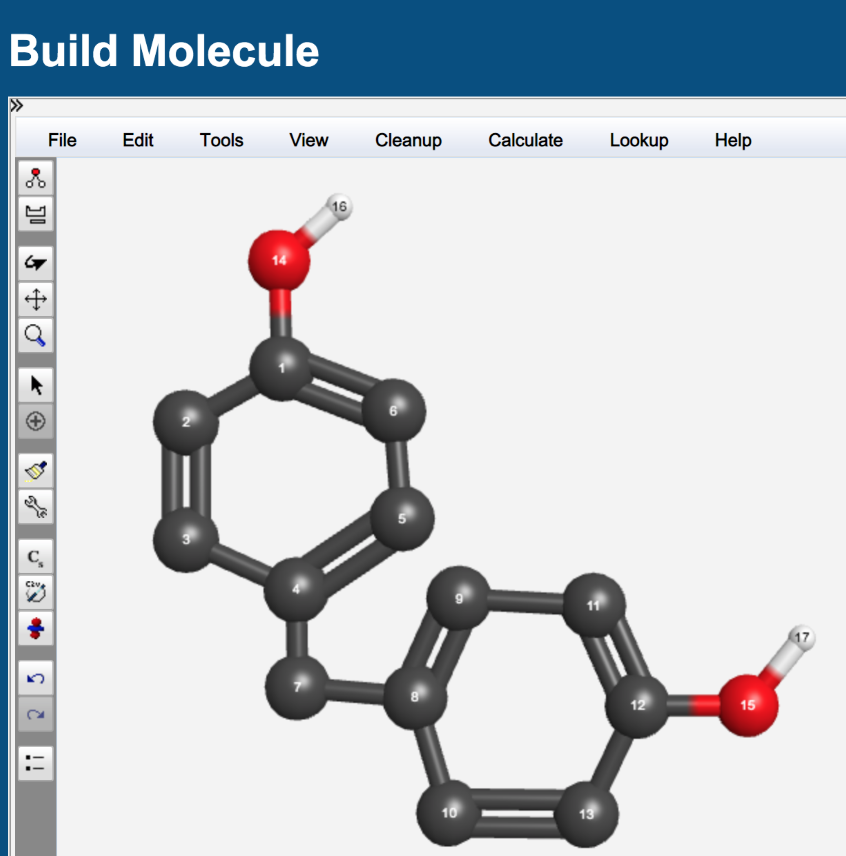

Be sure you have alternating double bonds in both rings, and include the H atoms (white) on the two oxygen atoms (red). (Note: You could use phenyl fragments from the fragment library, but it is probably faster just to sketch it as described.)

Clean up using “Cleanup > Comprehensive Mechanics” (not the paintbrush). You should now have:

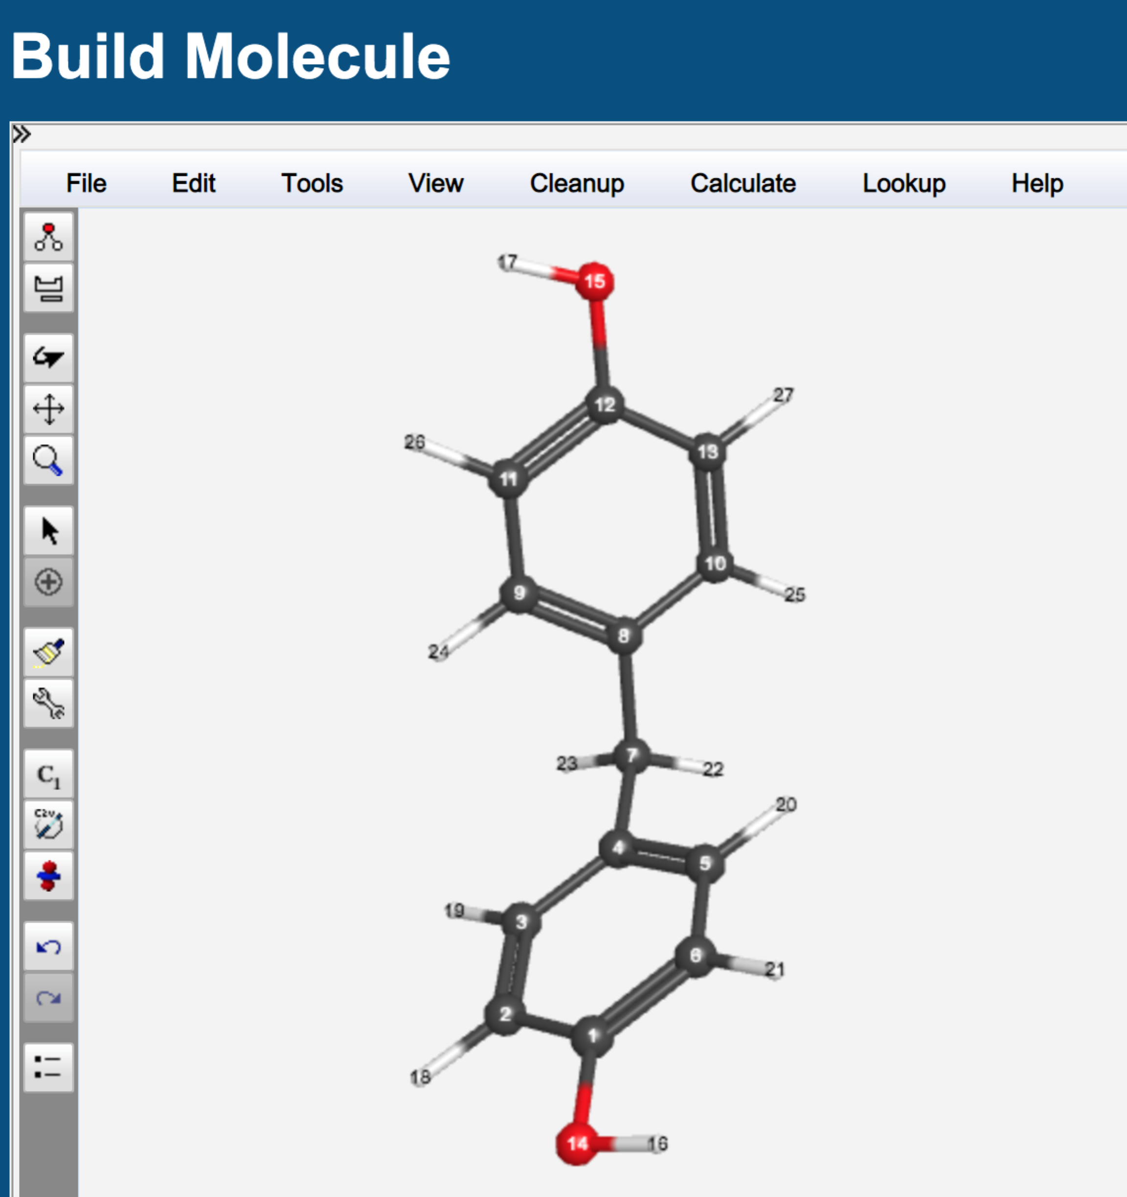

Use the rotate tool (curved arrow, left tool bar) to turn this structure so that the “CH2” group that connects the two rings is in the plane of your screen, as shown below:

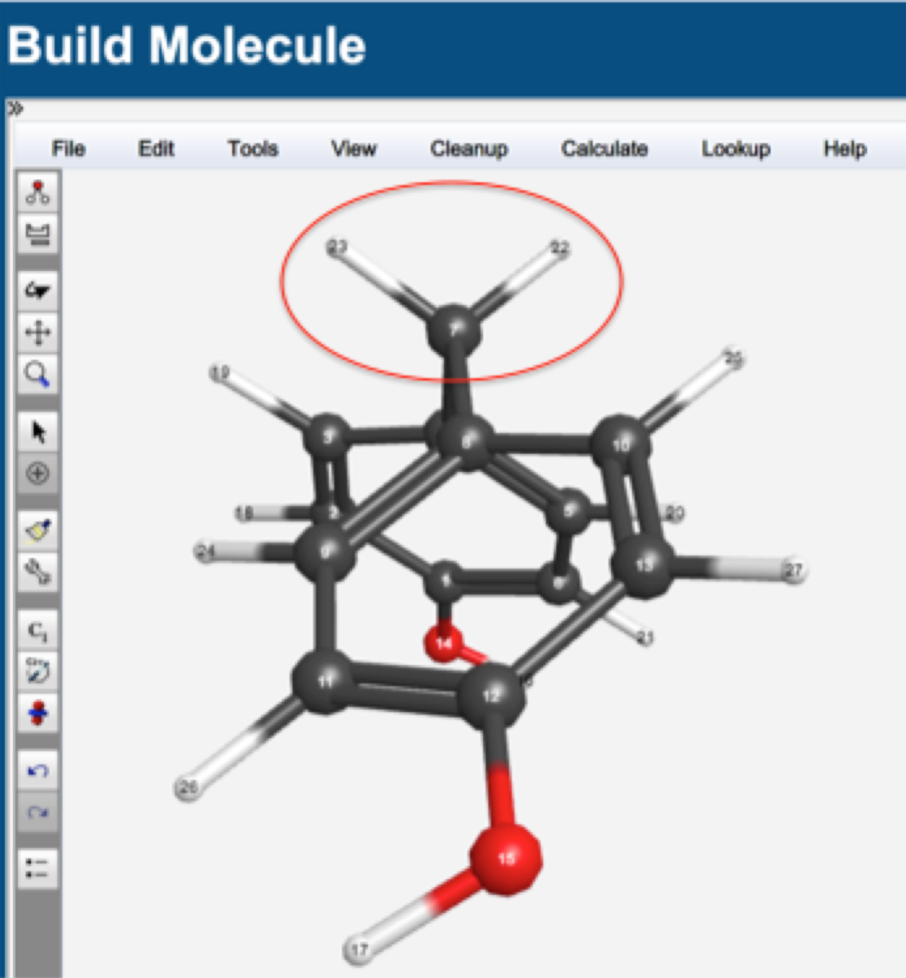

Click on the “Adjust” icon (the straight, short arrow on the left). Click on the two hydrogen atoms circled above so that they are highlighted, then hit delete on your keyboard.

Build the remaining ring system (lower left of low pH structure, previous page). Clean up with the paintbrush. You should now have the structure shown here:

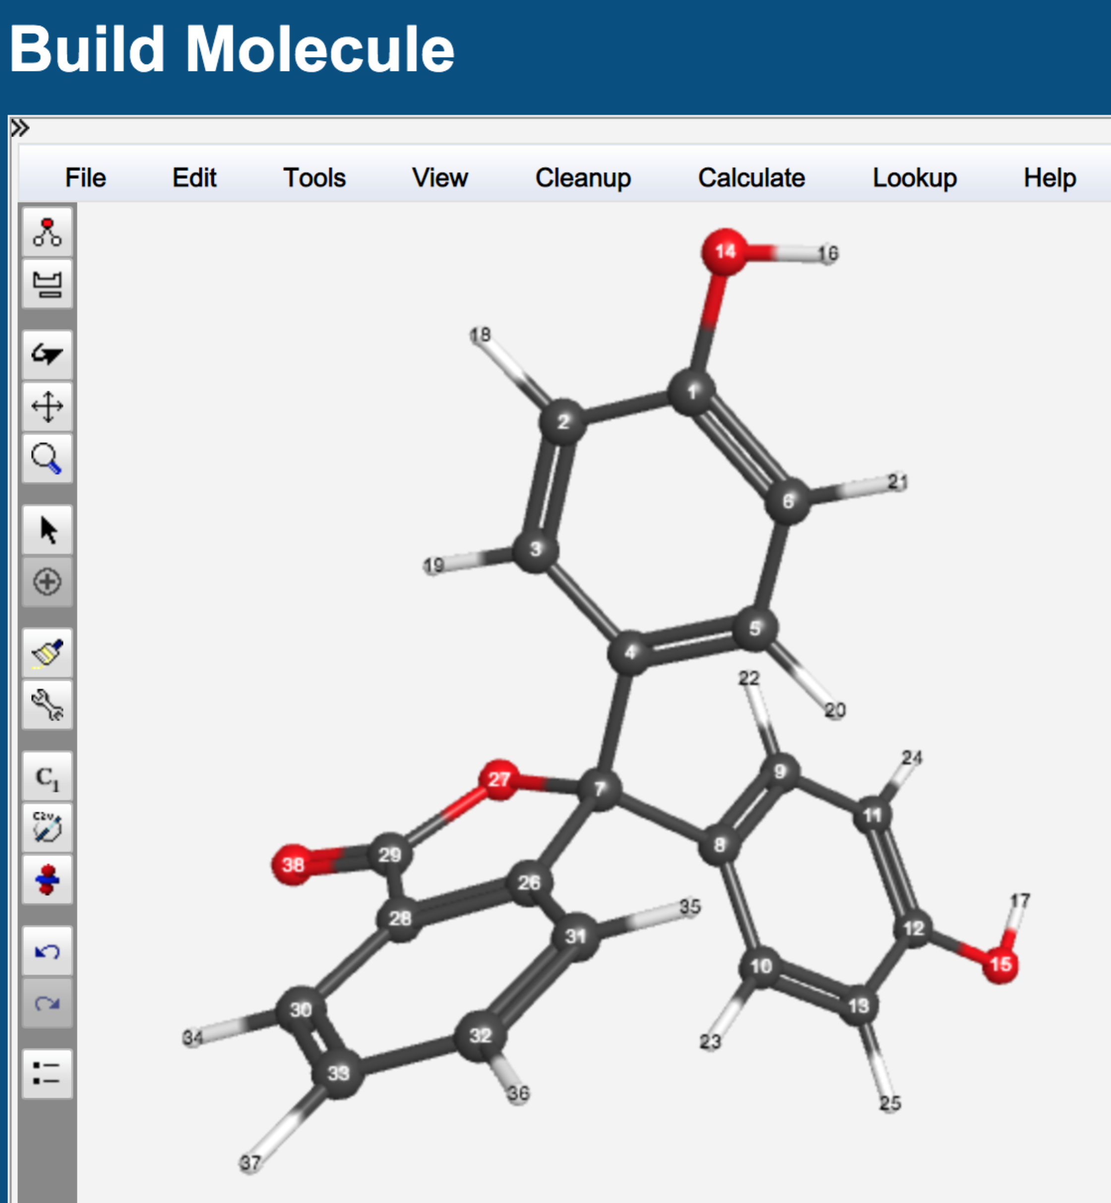

Click on the blue “continue” arrow. Select Mopac as the computational engine. Click again on the blue arrow and select/type in the following:

Job name: C20H14O4lowpH PM3

Calculation: Geometry Optimization

Theory: PM3

Charge: 0

Multiplicity: Singlet

Submit the job by clicking on the blue continue arrow.

When the job is complete, click on the filename and use the rotate tool to investigate the

structure. Look carefully at the orientation of the planes of the three rings relative to one another.

Click on “New Job Using This Geometry”. Click the blue “continue” arrow and select Gaussian as the computational engine. Click the arrow again and select/type in:

Job name: C20H14O4lowpH Spec CIS

Calculation: Excited States and UV-Vis

Excited State Method: CIS

Basis Set: Routine: Other

Charge: 0

Multiplicity: Singlet

A window will pop up and ask you to enter a basis set. Type in ZINDO and select OK.

Submit the job by clicking on the blue continue arrow.

When the job is complete, click on the filename and scroll down to view the “Excited States” table. Near the bottom of the table, click on the magnifying glass to view the calculated spectrum. In the Spectrum Viewer window, use your mouse and place the cursor on the top of the peak and record the wavelength at maximum absorbance (λmax displayed in the upper right of the “Spectrum Viewer” window) value here: ______ nm.

Building the mid pH form of phenolphthalein

Go to “Job Manager” and open the “C20H14O4lowpH” file from above. Click on “New Job Using this Geometry.” Use the Rotate tool to position the molecule so that you can clearly see the five-member ring (see next image below).

Click on the “Adjust” icon (the straight arrow), then click on the C-O bond to the central carbon atom to highlight it. Hit “delete” on your keyboard to remove the bond. Click on the O atom to highlight it. Choose “Adjust > Charge” and type in “-1”. Click “Apply” followed by “OK”. You should now have the structure shown below:

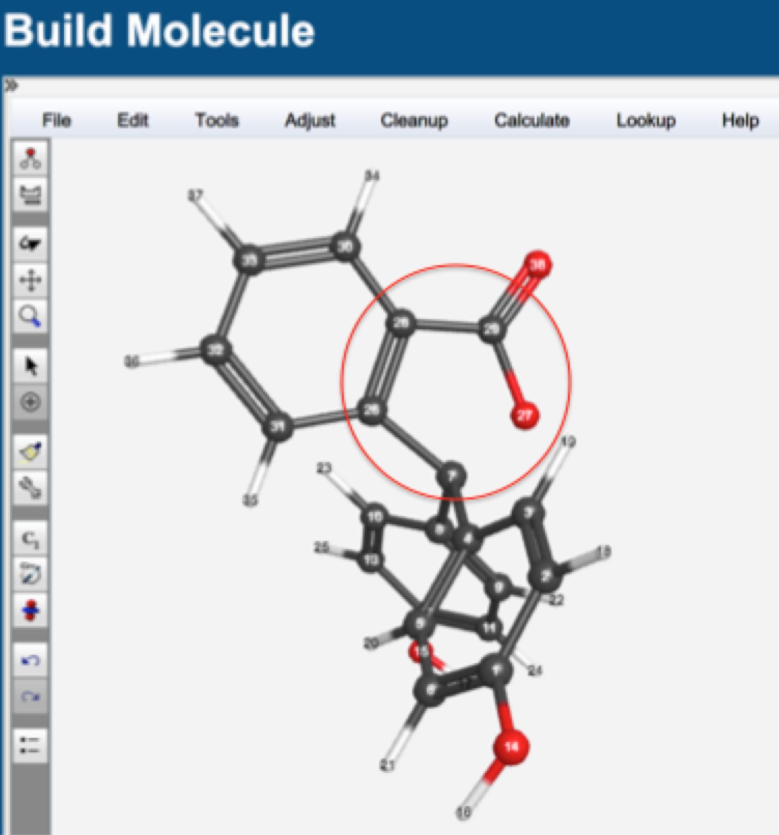

The O atom is still too close to the central carbon. We will adjust the C-C-C-O dihedral angle to move it further away. Click the “Adjust” icon. Click on the O atom, click on the attached C atom, the next C atom in the ring, and the final C atom (see circled atoms above). Choose “Adjust > Dihedral Angle”, and type in “90” in the Adjust Dihedral Angle window. Click “Apply” followed by “OK”.

Use the Rotate tool to turn the molecule so that one of the rings with an O-H is clearly visible. Click on the “Adjust” tool, then click on the hydrogen atom of the O-H group to highlight it. Hit “delete” on your keyboard to remove the atom. Click on the O atom to highlight it. Choose “Adjust > Charge” and type in “-1”. Click “Apply” followed by “OK”. You should have the structure shown below:

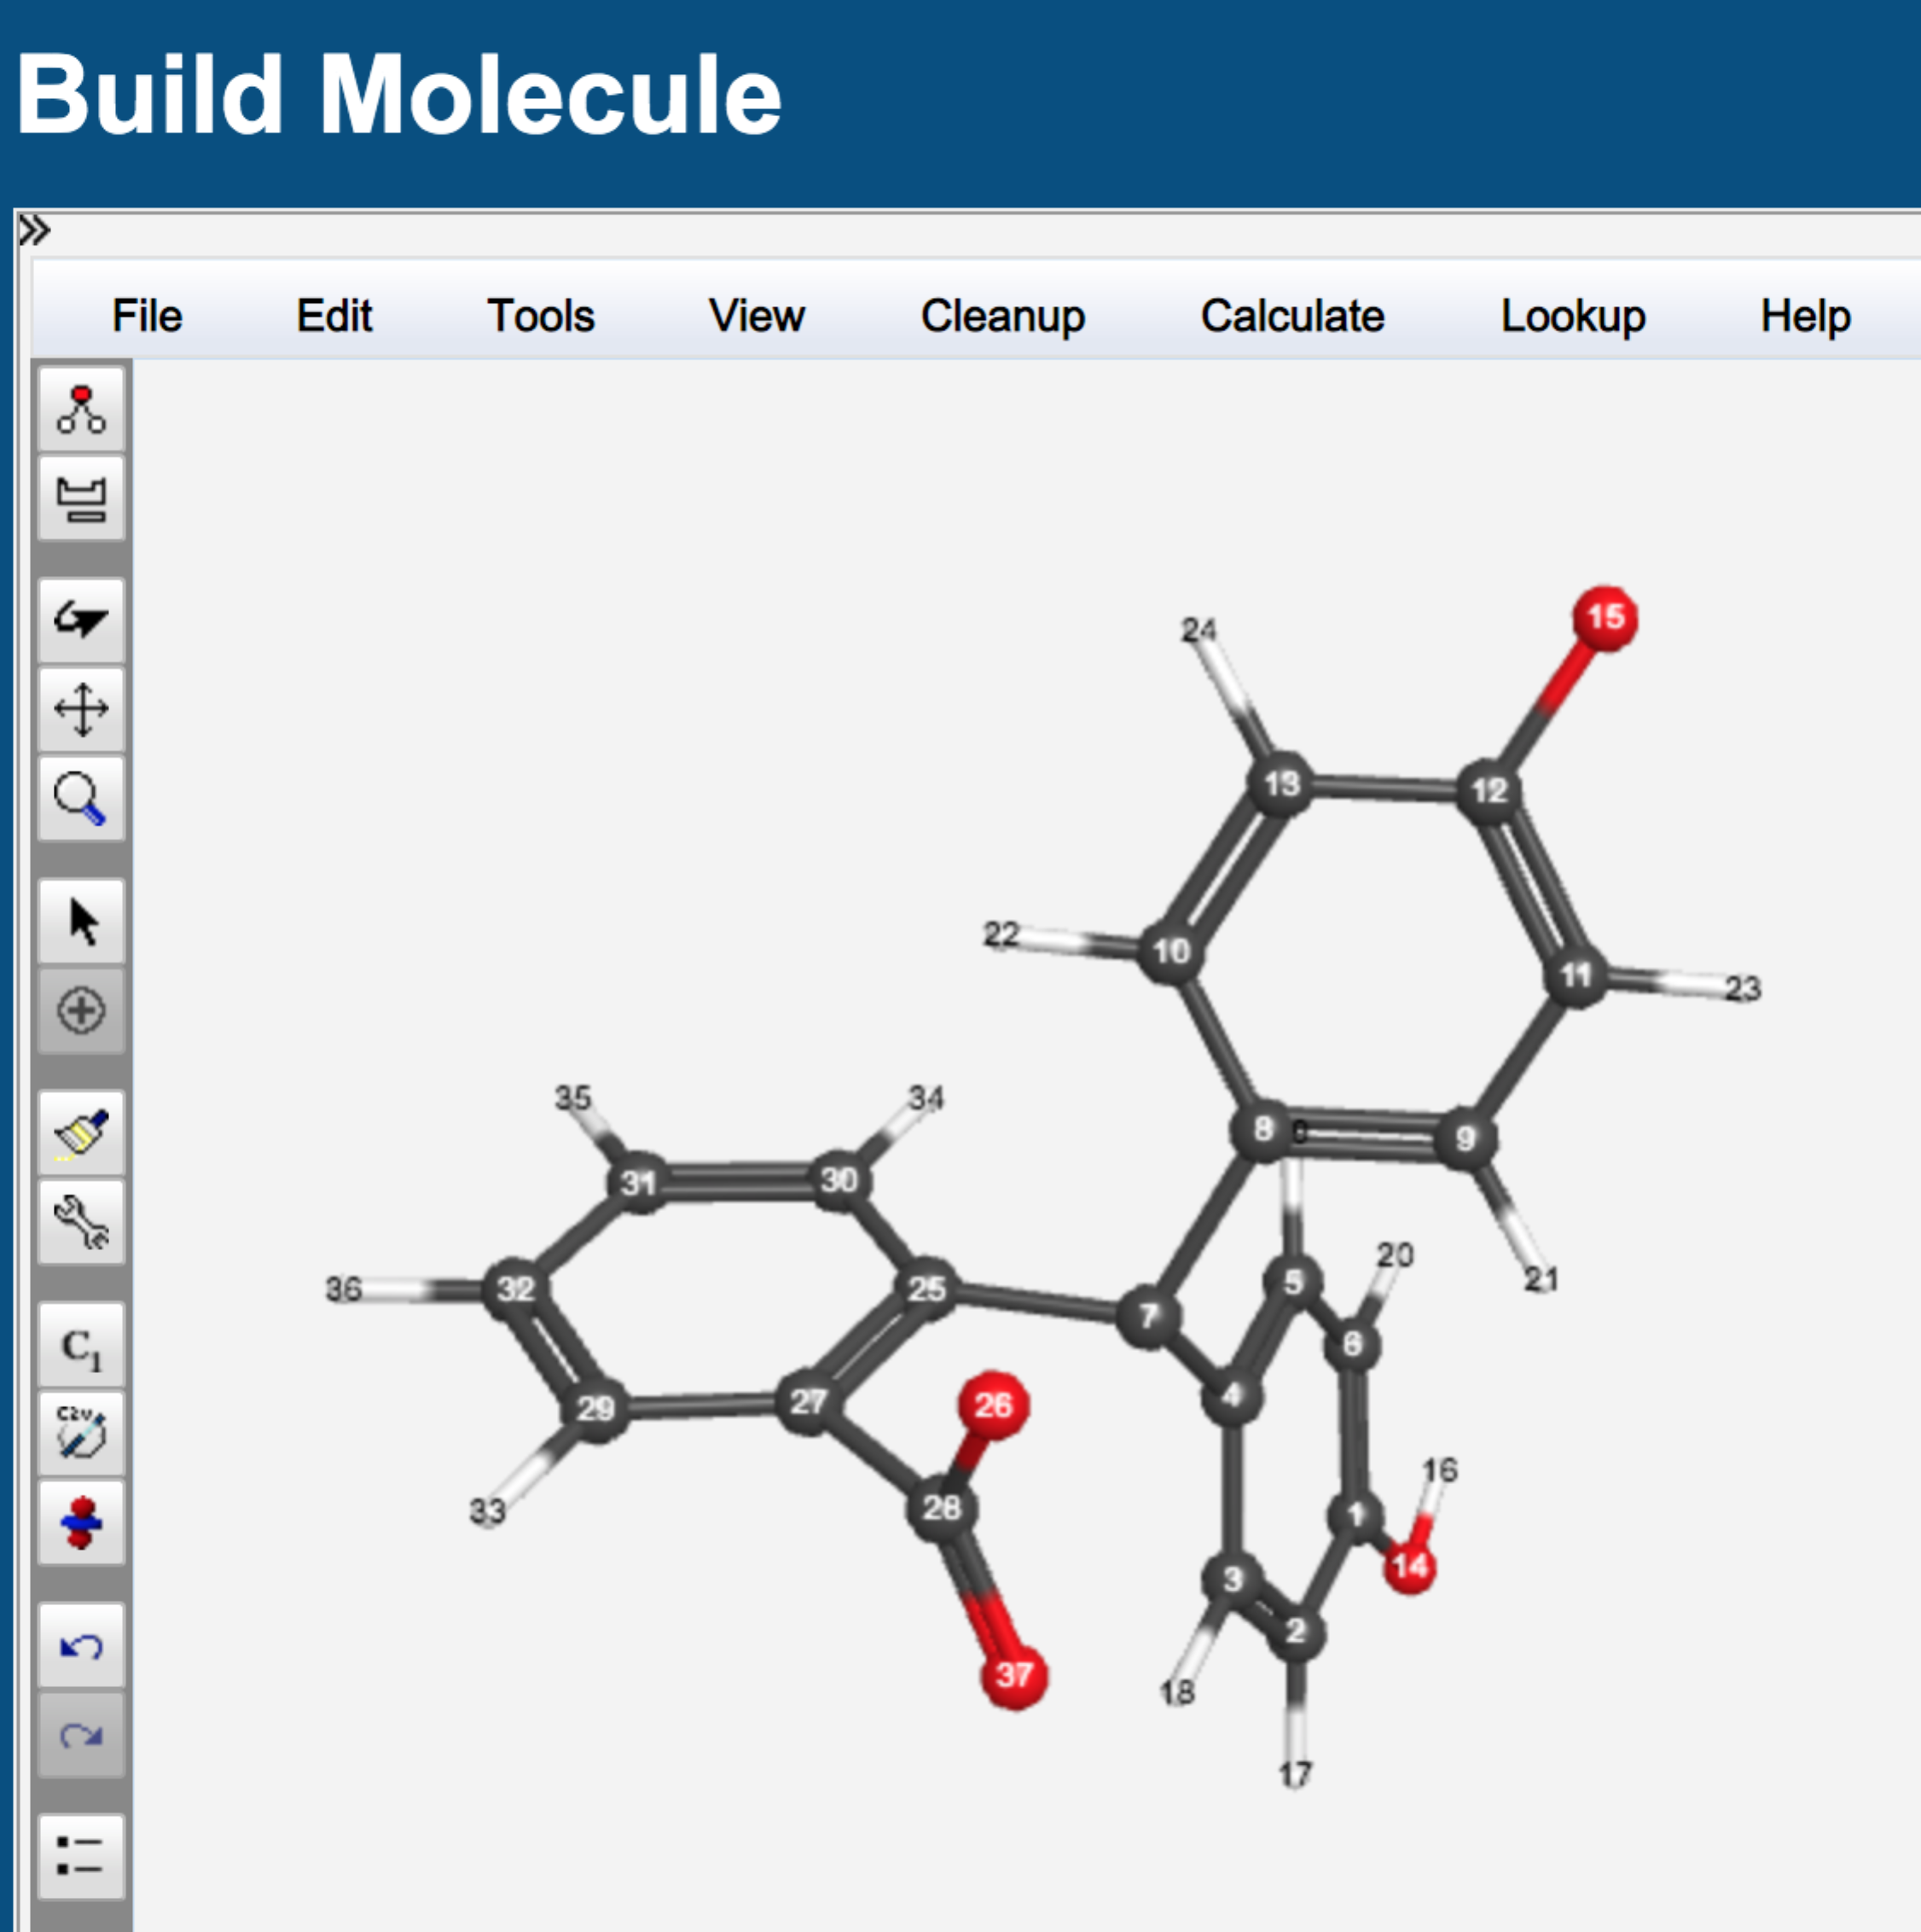

Use the Rotate tool to turn the molecule so that the other ring with the O-H is flat on the screen. Follow the above steps to remove the hydrogen atom. Click on and delete the double bonds in the ring. Click on the “Build” tool. Redraw the bonds on the ring as shown in the next image:

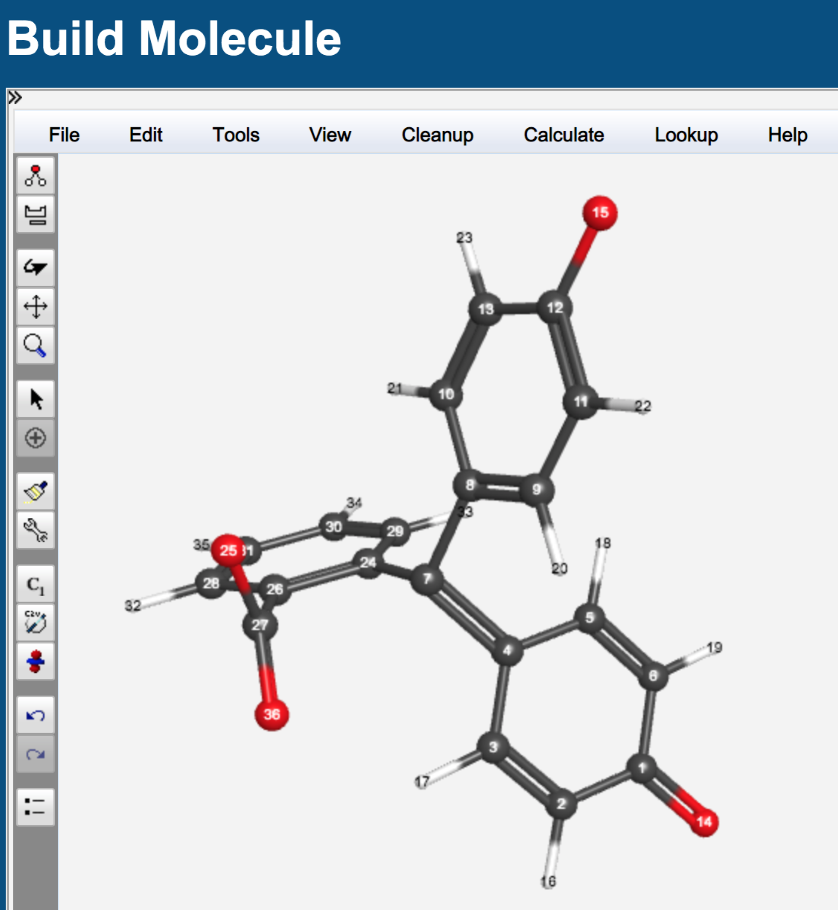

Click the blue “continue” arrow. Perform a geometry optimization as you did for the low pH structure (Mopac/PM3).

When the job is complete, click on the filename and use the rotate tool to investigate the structure. Look carefully at the orientation of the planes of the three rings relative to one another. Pay close attention to the two rings that have oxygen atoms attached.

Click on “New Job Using This Geometry”. Click the blue “continue” arrow and select Gaussian as the computational engine. Click the arrow again and select/type in:

Job name: C20H14O4(-2)midpH Spec CIS

Calculation: Excited States and UV-Vis

Excited State Method: CIS

Basis Set: Routine: Other

Charge: -2

Multiplicity: Singlet

A window will pop up and ask you to enter a basis set. Type in ZINDO and select OK.

Submit the job by clicking on the blue continue arrow.

When the job is complete, click on the filename and scroll down to view the “Excited States” table. Near the bottom of the table, click on the magnifying glass to view the calculated spectrum. In the Spectrum Viewer window, use your mouse and place the cursor on the top of the most intense peak and record the wavelength at maximum absorbance (λmax displayed in the upper right of the “Spectrum Viewer” window) value here: ______ nm.

Has the λmax shifted relative to the low pH structure? _______ Which direction did λmax shift?

Which of these two structures is expected to absorb visible light? __________________

Does the shift in absorption wavelength you calculated make sense? Focus on the phenolic rings of each structure. Explain.

**Exercise 4: NMR Chemical Shift Calculations**

Build the following molecules, clean up each structure by clicking on the paintbrush, and perform a geometry optimization using Gaussian > B3LYP/6-31G(d).



benzene 1-chloroethane ethanol

Once the geometry optimization is complete, open one of the files and choose “New Job Using This Geometry”. Click the blue “continue” arrow, choose Gaussian and Type in/Choose the following:

Job Name: (Use an appropriate name of your choice)

Calculation: NMR

Theory: B3LYP

Basis Set: 6-31G(d)

Charge: 0

Multiplicity: Singlet

NMR calculations compute the absolute NMR shifts of *each atom* in the static molecule. This means, for example, that in a 1H NMR spectrum, the chemical shifts of the three protons in a methyl group will not be averaged. Note that WebMO gives you the NMR shifts of H and C *relative to TMS* for the *default basis sets*. Therefore, in this example, the chemical shifts will already be corrected. When you visualize your spectra, you will observe that spin-spin coupling is not accounted for, and proton spectra will not be split into multiplets. (However, spin information is calculated and can be found in the output file.)

Record your chemical shift values in the table below. They are found in the “Isotropic” column in the Absolute NMR Shifts table. Note that the atoms in the molecule are numbered, so you can use the numbers to determine which shifts go with which atoms.

|  |  |  |
| --- | --- | --- |
|  | **Calc** | **Exp.** (CDCl3) |
| **Benzene** |  |  |
| H’s |  | 7.34 |
| C’s |  | 128.4 |
|  |  |  |
| **CH3CH2Cl** |  |  |
| Methyl H’s | (calculate average) | 1.49 |
| Methylene H’s |  | 3.51 |
| Methyl C |  | 18.7 |
| Other C |  | 39.9 |
|  |  |  |
| **CH3CH2OH** |  |  |
| Methyl H’s | (calculate average) | 1.22 |
| Methylene H’s |  | 3.69 |
| Hydroxyl H |  | 2.92 |
| Methyl C |  | 18.1 |
| Other C |  | 57.8 |

Compare your results with the experimental values.